U.S. Department of Health and Human Services
Public Health Service
SF424 (R&R)
SBIR/STTR
Application Guide for NIH
and Other PHS Agencies
A guide developed and maintained by NIH for preparing and submitting SBIR/STTR applications via Grants.gov to NIH and other PHS agencies using the SF424 (R&R)
Adobe Forms Version B Series (to be used with FOAs specifying
use of Adobe-Forms- B-1 and B-2 application packages)
Updated November 1, 2013

Table of Contents
Part I. Instructions for Preparing and Submitting an Application
1. Foreword I-2
1.1 Application Guide Format I-3
1.2 NIH Extramural Research and Research Training Programs I-4
1.3 Program Guidelines I-4
1.3.1 Three-Phase Program I-4
1.3.2 Fast-Track Applications I-5
1.3.3 Supplemental Applications I-6
1.3.4 SBIR/STTR Program Eligibility I-6
1.4 Interactions with PHS Staff I-10
1.5 Grants Policy Statements I-15
1.6 References I-15
1.6.1 Other Resources I-17
1.7 Authorization I-18
1.7.1 Collection of Personal Demographic Data I-18
1.8 Paperwork Burden I-19
2. Process for Application Submission via Grants.gov I-19
2.1 Overview I-19
2.2 Registration Processes I-20
2.2.1 Grants.gov Registration I-20
2.2.2 eRA Commons Registration I-21
2.2.3 SBA Company Registration I-24
2.3 Software Requirements I-24
2.3.1 Adobe Reader I-24
2.3.2 Creating PDFs for Text Attachments I-25
2.3.3 Special Instructions for Macintosh Users I-25
2.4. Funding Opportunities I-25
2.4.1 NIH Guide for Grants and Contracts I-26
2.4.2 Funding Opportunity Announcements I-26
2.4.3 Finding a Funding Opportunity Announcement (FOA) for Grants.gov Submission I-27
2.5 Forms for Application to NIH or Other PHS Agencies I-31
2.6 Format Specifications for Text (PDF) Attachments I-32
2.7 “Resubmission” Applications I-34
2.8 “Revision” Application I-36
2.9 Similar, Essentially Identical, or Identical Applications I-36
2.10 Submitting Your Application Via Grants.gov I-37
2.11 After You Submit Your Application Via Grants.gov I-37
2.12 Correcting Errors I-40
2.13 Post-Submission Application Materials I-42
2.14 Application Submission Dates I-43
2.15 Submission, Review and Award Cycles I-45
2.16 Resources for Finding Help I-46
2.16.1 Finding Help for Grants.gov Registration or Submissions I-46
2.16.2 Finding Help for the eRA Commons Registration or eRA Commons Validation Processes I-47
2.16.3 Finding Help for Application Preparation I-47
2.16.4 Finding Help for SBIR/STTR Specific Inquiries I-48
2.16.5 Finding Help for the SBA Company Registry I-48
3. Using the Grant Application Package I-48
3.1 Verify Grant Information I-48
3.2 Enter the Name for the Application I-49
3.3 Open and Complete Mandatory Documents I-49
3.4 Open and Complete Optional Documents I-50
3.5 Submitting the Application via Grants.gov I-50
4. Completing the SF424 Research and Related (R&R) Forms I-51
4.1 Overview I-51
4.2 Cover Form I-52
4.3 Project/Performance Site Locations Form I-70
4.4 Other Project Information Form I-75
4.5 Senior/Key Person Profile (Expanded) Form I-83
4.6 R&R Budget Form I-92
4.6.1 Section A and B I-93
4.6.2 Sections C through E I-100
4.6.3 Sections F through K I-103
4.6.4 Cumulative Budget I-110
4.7 Special Instructions for Preparing Applications with a Subaward/Consortium I-112
4.8 SBIR/STTR Information Form I-115
5. Completing PHS 398 Forms I-121
5.1 Overview I-121
5.2 Cover Letter Form I-121
5.3 Cover Page Supplement Form I-124
5.4 PHS 398 Research Plan Form I-128
5.5 Checklist Component I-144
5.6 (Reserved) I-149
5.7 Planned Enrollment Report and Cumulative Inclusion Enrollment Report I-149
5.7.1Planned Enrollment Report I-150
5.7.2 Cumulative Inclusion Enrollment Report I-152
6. Peer Review Process I-155

PART I
Instructions for Preparing and Submitting
an Application

1. Foreword
Adobe B Application Guide – Released January 15, 2010
This application includes changes to SF424 Research & Related (R&R) form instructions necessitated by the June 2008 OMB renewal of the forms, which includes changes to assist agencies implementing the Federal Funding Accountability and Transparency Act. Changes have also been made to various PHS 398 forms as part of the NIH initiative to enhance peer review. Changes to the PHS 398 forms were approved by OMB in June 2009. Parts II (Supplemental Instructions for Preparing the Human Subjects Section of the Research Plan) and III (Policies, Assurance, Definitions, and Other Information) of the previous version of the application guide have been moved to a stand-alone document titled, “Supplemental Grant Application Instructions.”
Modifications related to changes in the SF424 (R&R) forms include:
- System for Award Management (SAM) Registration. A change from the requirement to register with the Central Contractor Registry Database (CCR) to the System for Award Management (SAM).
- Inclusion of the SBIR/STTR Information form as an SF424 form and no longer as a PHS 398 agency-specific form. Although this has changed the “ownership” of the form it is not expected to have any impact on applicants.
- A new Agency Routing Identifier field has been added to the Cover Form.
- A document upload field has been added to the Cover Form for attaching the SFLLL or other explanatory documents.
- A new field has been added to the Project/Performance Site Location(s) form for the Congressional District of the project. The Areas affected by Project and Congressional Districts of Project fields on the Cover Forms have been deleted.
- Fields requesting the type and year of degree have been added to the senior/key personnel forms.
- Questions on Human Subjects Research on the Other Project Information form have been re-ordered and a new question, whether the project is exempt from Federal regulations, has been added.
The PHS 398 application forms have been modified by realigning the structure and content of applications with new review criteria. Additionally, page limits for many applications have been shortened to help reduce the administrative burden placed upon applicants, reviewers, and staff. Specific modifications related to changes in the PHS 398 forms include:
- Three sections of the previous Research Plan (Background and Significance, Preliminary Studies/Progress Report, and Research Design and Methods) have been consolidated into a new single section within the Research Plan entitled Research Strategy. The new Research Strategy section will be sub-divided into three parts: Significance, Innovation, and Approach, although this will now be a single upload.
- The Facilities and Other Resources section has been changed to require a description of how the scientific environment will contribute to the probability of success of the project, unique features of the environment, and for Early Stage Investigators, the institutional investment in the success of the investigator (e.g., resources, classes, etc.).
- A new Personal Statement requirement has been incorporated into the Biographical Sketch.
- Added new Planned Enrollment Report & PHS 398 Cumulative Inclusion Enrollment Report Forms
Additional details on all the form changes noted above can be found at: http://grants.nih.gov/grants/ElectronicReceipt/files/Adobe_Forms_B_Summary.pdf.
A description of how these application changes relate to the enhancement of peer review can be found at http://enhancing-peer-review.nih.gov/docs/application_changes.pdf. Additional information on NIH’s efforts to enhance peer review can also be found at http://enhancing-peer-review.nih.gov.

This application guide contains instructions and other useful information for preparing SBIR/STTR grant applications to the National Institutes of Health (NIH) and other Public Health Service (PHS) agencies for:
Small Business Innovation Research (SBIR) Grants
Small Business Technology Transfer (STTR) Grants
This application guide is used as a companion document to the SF424 Research and Related (R&R) application forms. In addition to the SF424 (R&R) forms, applications to NIH and other PHS agencies will include agency-specific form components, titled “PHS 398.” These PHS 398 components were developed to continue the collection of agency-specific data required for a complete application. While these agency-specific forms are not identical to the PHS 398 application form pages, the PHS 398 reference is used to distinguish these additional data requirements from the data collected in the SF424 (R&R) forms. A complete SBIR/STTR application to NIH and other PHS agencies will include SF424 (R&R) forms and PHS 398 forms. Instructions for all application forms, SF424 (R&R) and PHS 398, are found in this document.
The use of these new forms also involves electronic submission of completed applications through Grants.gov. Specific Funding Opportunity Announcements (FOAs) will clearly indicate which forms and submission process an applicant should use. NIH will continue to use Requests for Applications (RFAs) and Program Announcements (PAs) as categories of FOAs. See Section 2.4.2 for definitions.
For purposes of this document, any references to “NIH” may also mean “NIH and other PHS agencies” such as the Centers for Disease Control and Prevention (CDC), the Food and Drug Administration (FDA), and the Administration for Children and Families (ACF).

1.1 Application Guide Format
This application guide is organized into three distinct parts:
Part I: Instructions for Preparing and Submitting the Application. Part I includes specific instructions for completing the application forms as well as information on electronically submitting applications through Grants.gov.
Part II: Supplemental Instructions for Preparing the Human Subjects Section of the Research Plan. Part II is to be used if your proposed research will involve human subjects. These instructions assist in determining whether human subjects are involved and include scenarios and detailed instructions for completing Items 6-9 of the PHS 398 Research Plan form.
Part III: Policies, Assurance, Definitions, and Other Information. Part III includes information on policies, assurances, definitions, and other information relating to submission of applications to the PHS. Applicants should refer to this document as well as the instructional materials, Grants Information (GrantsInfo), and the relevant Grants Policy Statement for additional sources of information. The NIH Grants Policy Statement applies to all NIH awardees; other PHS agencies use the HHS Grants Policy Statement.

1.2 NIH Extramural Research and Research Training Programs
The NIH Office of Extramural Research Grants homepage (http://grants.nih.gov/grants/oer.htm) provides an array of helpful information. Applicants are encouraged to bookmark this site and visit it often.
The Division of Communications and Outreach (DCO) is the central source for general information about NIH extramural research and research training programs, funding activity codes, the peer review system, and application procedures. Grants Information (GrantsInfo) is a communication service within the DCO. Information about the NIH extramural research and research training programs, funding opportunities, and the grant application process, can be obtained by e-mailing your request to: GrantsInfo@nih.gov or by calling (301) 435-0714.

1.3 Program Guidelines

1.3.1 Three-Phase Program
Both the SBIR and STTR programs are structured in three phases, the first two of which are supported using SBIR/STTR funds. The stated Phase I and Phase II award levels and project periods are statutory guidelines, not ceilings. Therefore, applicants are encouraged to propose a budget and project duration period that is reasonable and appropriate for completion of the research project.
Deviations from the indicated statutory award amount and project period guidelines are acceptable, but must be well justified and should be discussed with NIH Program Staff prior to submission of the application. (CDC, FDA, and ACF do not make awards greater than the stated guidelines.) The budgets of SBIR and STTR applications will be evaluated to assess the appropriateness of the budget to the timeliness of the research goals and may be reduced on a case-by-case basis as recommended by peer reviewers, Institute/Center Advisory Board/Council, or program staff. When making awards, NIH reserves the right to withhold or reduce grant funding on applications at any ranking based on program priority.
Funding levels for projects are determined through the combined interaction among peer review, grants management, program, budget, and other Institute and/or Centers (IC) staff. These levels are based on allowable costs that are consistent with the principles of sound cost management and in consideration of IC priorities, constraints on the growth of average grant costs, and the availability of funds.
Phase I. The objective of Phase I is to establish the technical/scientific merit and feasibility of the proposed R/R&D efforts. Preliminary data may be included but are not required. The application should concentrate on R/R&D efforts that will significantly contribute to proving the scientific or technical feasibility of the approach or concept that would be a prerequisite to further support in Phase II.
SBIR Phase I awards normally may not exceed $150,000 total (direct costs, facilities and administrative (F&A)/indirect costs, and fee) for a period normally not to exceed 6 months. STTR Phase I awards normally may not exceed $150,000 total for a period of 1 year.
Phase II. The objective of Phase II is to continue the research or R&D efforts initiated in Phase I. Funding shall be based on the results of Phase I and the scientific and technical merit and commercial potential of the Phase II application.
All Phase II applications must include a succinct Commercialization Plan. Specific details for preparing this section are described in Section 5.6 of this Application Guide.
SBIR Phase II awards normally may not exceed $1,000,000 total (direct costs, F&A/indirect costs, and fee) for a period normally not to exceed 2 years. STTR Phase II awards normally may not exceed $1,000,000 total (direct costs, F&A/indirect costs, and fee) for a period normally not to exceed 2 years.
According to statutory guidelines, total funding support (direct costs, indirect costs, fee) normally may not exceed $150,000 for Phase I awards and $1,000,000 for Phase II awards. With appropriate justification from the applicant, Congress will allow awards to exceed these amounts by up to 50% ($225,000 for Phase I and $1,500,000 for Phase II, a hard cap). As written in the statute and under appropriate circumstances, NIH can apply for a waiver from SBA to issue an award exceeding $225,000 for Phase I or $1,500,000 for Phase II, if this hard cap will interfere with NIH‘s ability to meet its mission. Award waivers from the SBA are not guaranteed and may delay the release of funds. Applicants are strongly encouraged to contact NIH program officials prior to submitting any award in excess of the guidelines. In all cases, applicants should propose a budget that is reasonable and appropriate for completion of the research project.
Only Phase I awardees are eligible to apply for and obtain Phase II funding at this time. Awardees identified via a “successor-in-interest” or “novated” or similarly-revised funding agreement, or those that have reorganized with the same key staff, regardless of whether they have been assigned a different tax identification number, are eligible to apply for Phase II funding. Agencies may require the original awardee to relinquish its rights and interests in an SBIR/STTR project in favor of another applicant as a condition for that applicant’s eligibility to participate in the SBIR/STTR program for that project.
Only one new Phase II award may be made for a single SBIR/ STTR project.
You may submit a Phase II application either before or after expiration of the Phase I budget period, unless you elect to submit a Phase I and Phase II application concurrently under the Fast-Track procedure. To maintain eligibility to seek Phase II support, a Phase I grantee organization should submit a Phase II application within the first six receipt dates following the expiration of the Phase I budget period.
Phase III. An objective of the SBIR/STTR program is to increase private sector commercialization of innovations derived from Federal R/R&D. During Phase III, the small business concern (SBC) is to pursue commercialization with non-SBIR/STTR funds (either Federal or non-Federal). In some Federal agencies, Phase III may involve follow-on, non-SBIR/STTR funded R&D, or production contracts for products or processes intended for use by the U.S. Government.
The competition for SBIR/STTR Phase I and Phase II awards satisfies any competition requirement of the Armed Services Procurement Act, the Federal Property and Administrative Services Act, and the Competition in Contracting Act. Therefore, an agency that wishes to fund an SBIR/STTR Phase III project is not required to conduct another competition in order to satisfy those statutory provisions. As a result, in conducting actions relative to a Phase III SBIR/STTR award, it is sufficient to state for purposes of a Justification and Approval pursuant to FAR 6.302-5 that the project is a SBIR/STTR Phase III award that is derived from, extends, or logically concludes efforts performed under prior SBIR/STTR funding agreements and is authorized under 10 U.S.C. 2304(b)(2) or 41 U.S.C. 253(b)(2).

1.3.2 Fast-Track Applications
CDC, FDA, and ACF do not accept Fast-Track applications.
The NIH Fast-Track mechanism expedites the decision and award of SBIR and STTR Phase II funding for scientifically meritorious applications that have a high potential for commercialization. Fast-Track incorporates a submission and review process in which both Phase I and Phase II grant applications are submitted and reviewed together. The Specific Aims section of the Phase I portion of a Fast-Track must specify clear, measurable goals (milestones) that should be achieved prior to initiating Phase II work. In addition, as is required for all Phase II applications, the Phase II portion of a Fast-Track application must present a Commercialization Plan (maximum 12 pages) that addresses specific points (see Section 4.8).
The Fast-Track application will receive a single rating for the entire proposed project (i.e., it will receive a numerical score or it will receive an “unscored” designation).
Below are general instructions for preparing NIH SBIR/STTR Fast-Track applications. More specific instructions are provided in Sections 4 and 5 of this application guide.
- Follow the instructions as provided through Section 3, using the Grant Application Package.
- Use the forms in Section 4.6, R&R Budget Form: Complete Budget Period 1 for Phase I; complete Budget Periods 2 and 3 (or more, if appropriate) for Phase II; complete the Cumulative Budget form page used to accumulate total amounts for the entire Fast-Track project period.
- Prepare the Research Strategy in accordance with Section 5.4, Research Plan Form, using the PHS 398 Research Plan for items 2-3 in each Phase (Phase I and Phase II plans must be contained within 12 pages).
- Identify the application as “Fast-Track” at the beginning of the “Specific Aims” portion of the PHS 398 Research Plan.
- Under the heading “Phase I Segment,” follow the instructions for the remainder of the application as provided in the Research Plan Form.
Upon completion of all the requirements for Phase I, use the heading “Phase II Segment” and repeat the process for that portion of the proposed project.
Phase I and Phase II are considered separate funding agreements under the Fast-Track Initiative. Therefore, Phase I Fast-Track awardees must recertify that they meet all of the eligibility criteria for an SBIR or STTR award prior to issuance of the Phase II award.

1.3.3 Supplemental Applications
Under special circumstances, requests for supplemental funds to existing NIH SBIR/STTR grants or requests for an extension of the period of support with funds may be considered. (The awarding of supplemental funds applies to NIH ONLY, as CDC, FDA, and ACF do not make awards greater than the stated guidelines.) See Section 2.8.

1.3.4 SBIR/STTR Program Eligibility
Each applicant submitting an SBIR/STTR grant application must qualify as a small business concern (SBC) at the time of award. The following sections provide more details about these eligibility criteria.
SBA released the revised, final size rule on December 27, 2012, with a 30-day implementation window effective January 28, 2013.
SBCs that are majority-owned by multiple venture capital operating companies (VCOCs), hedge funds or private equity firms are NOW able to apply to the NIH SBIR program at this time for any NIH SBIR funding opportunity announcement (FOA) issued after January 28, 2013 Small business concerns that are more than 50% owned by multiple venture capital operating companies, hedge funds, private equity firms, or any combination of these are NOT eligible to apply to the CDC, FDA, and ACF SBIR program and to the NIH STTR program.
NIH has many SBIR and STTR FOAs available for the community, many of which were issued prior to January 28, 2013. Applicants are advised to read FOAs very carefully, as eligibility and budget requirements may differ, depending on when the FOA was issued. Applicants are required to follow the guidance and instructions within the FOA they choose to apply for. As such, the eligibility requirements for small business concerns will depend on whether the FOA was issued prior or after January 28, 2013 as listed below.

1.3.4.1 Organizational Criteria

SBIR Program

FOR SBIR FOAs issued prior to January 28, 2013:
Only United States small business concerns (SBCs) are eligible to submit SBIR applications. A small business concern is one that, on the date of award for both Phase I and Phase II funding agreements:
1. is organized for profit, with a place of business located in the United States, which operates primarily within the United States or which makes a significant contribution to the United States economy through payment of taxes or use of American products, materials or labor;
2. is in the legal form of an individual proprietorship, partnership, limited liability company, corporation, joint venture, association, trust or cooperative, except that where the form is a joint venture, there can be no more than 49 percent participation by foreign business entities in the joint venture;
3. is at least 51 percent owned and controlled by one or more individuals who are citizens of, or permanent resident aliens in, the United States, except in the case of a joint venture, where each entity to the venture must be 51 percent owned and controlled by one or more individuals who are citizens of, or permanent resident aliens in, the United States; and
4. has, including its affiliates, not more than 500 employees.

FOR SBIR FOAs issued after January 28, 2013:
Only United States small business concerns (SBCs) are eligible to submit applications for this opportunity. A small business concern is one that, at the time of award of Phase I and Phase II, meets all of the following criteria:
- is organized for profit, with a place of business located in the United States, which operates primarily within the United States or which makes a significant contribution to the United States economy through payment of taxes or use of American products, materials or labor;
- is in the legal form of an individual proprietorship, partnership, limited liability company, corporation, joint venture, association, trust or cooperative, except that where the form is a joint venture, there must be less than 50 percent participation by foreign business entities in the joint venture;
- (i) Be a concern which is more than 50% directly owned and controlled by one or more individuals (who are citizens or permanent resident aliens of the United States), other business concerns (each of which is more than 50% directly owned and controlled by individuals who are citizens or permanent resident aliens of the United States), or any combination of these; OR
(ii) NIH only. Be a concern which is more than 50% owned by multiple venture capital operating companies, hedge funds, private equity firms, or any combination of these. No single venture capital operating company, hedge fund, or private equity firm may own more than 50% of the concern; OR
(iii) Be a joint venture in which each entity to the joint venture must meet the requirements set forth in paragraph 3 (i) or 3 (ii) of this section. A joint venture that includes one or more concerns that meet the requirements of paragraph (ii) of this section must comply with § 121.705(b) concerning registration and proposal requirements.
4. Has, including its affiliates, not more than 500 employees.
NIH only. If the concern is more than 50% owned by multiple venture capital operating companies, hedge funds, private equity firms, or any combination of these falls under 3 (ii) or 3 (iii) above, see Section IV. Application and Submission Information in the SBIR FOA for additional instructions regarding required application certification.
See 4.4 Other Project Information Form instructions for additional requirements for small business concerns that are more than 50% owned by multiple venture capital operating companies, hedge funds, private equity firms.

STTR Program

FOR STTR FOAs issued prior to January 28, 2013:
Only United States small business concerns (SBCs) are eligible to submit STTR applications. A small business concern is one that, on the date of award for both Phase I and Phase II funding agreements:
1. is organized for profit, with a place of business located in the United States, which operates primarily within the United States or which makes a significant contribution to the United States economy through payment of taxes or use of American products, materials or labor;
2. is in the legal form of an individual proprietorship, partnership, limited liability company, corporation, joint venture, association, trust or cooperative, except that where the form is a joint venture, there can be no more than 49 percent participation by foreign business entities in the joint venture;
3. is at least 51 percent owned and controlled by one or more individuals who are citizens of, or permanent resident aliens in, the United States, except in the case of a joint venture, where each entity to the venture must be 51 percent owned and controlled by one or more individuals who are citizens of, or permanent resident aliens in, the United States; and
4. has, including its affiliates, not more than 500 employees.

FOR STTR FOAs issued after January 28, 2013:
Only United States small business concerns (SBCs) are eligible to submit applications for this opportunity. A small business concern is one that, at the time of award of Phase I and Phase II, meets all of the following criteria:
- Is organized for profit, with a place of business located in the United States, which operates primarily within the United States or which makes a significant contribution to the United States economy through payment of taxes or use of American products, materials or labor;
- Is in the legal form of an individual proprietorship, partnership, limited liability company, corporation, joint venture, association, trust or cooperative, except that where the form is a joint venture, there must be less than 50 percent participation by foreign business entities in the joint venture;
- 3 (i) Be a concern which is more than 50% directly owned and controlled by one or more individuals (who are citizens or permanent resident aliens of the United States), other business concerns (each of which is more than 50% directly owned and controlled by individuals who are citizens or permanent resident aliens of the United States), or any combination of these; OR
- (ii) Be a joint venture in which each entity to the joint venture must meet the requirements set forth in paragraph 3 (i) of this section. A joint venture that includes one or more concerns that meet the requirements of paragraph (ii) of this section must comply with § 121.705(b) concerning registration and proposal requirements. Has, including its affiliates, not more than 500 employees.

SBIR and STTR
Control can be exercised through common ownership, common management, and contractual relationships. The term "affiliates" is defined in greater detail in 13 CFR 121.3-2(a). The term "number of employees" is defined in 13 CFR 121.3-2(t).
Business concerns include, but are not limited to, any individual (sole proprietorship), partnership, corporation, joint venture, association, or cooperative. Further information may be obtained by contacting the Small Business Administration Size District Office at http://sba.gov/size.
One of the circumstances that would lead to a finding that an organization is controlling or has the power to control another organization involves sharing common office space and/or employees and/or other facilities (e.g., laboratory space). Access to special facilities or equipment in another organization is permitted (as in cases where the awardee organization has entered into a subcontractual agreement with another organization for a specific, limited portion of the research project). However, research space occupied by an SBIR awardee organization must be space that is available to and under the control of the SBIR awardee for the conduct of its portion of the proposed project.
Title 13 CFR 121.3 also states that control or the power to control exists when “key employees of one concern organize a new concern ... and serve as its officers, directors, principal stockholders, and/or key employees, and one concern is furnishing or will furnish the other concern with subcontracts, financial or technical assistance, and/or other facilities, whether for a fee or otherwise.” Where there is indication of sharing of common employees, a determination will be made on a case-by-case basis of whether such sharing constitutes control or the power to control.
For purposes of the SBIR and STTR program, personnel obtained through a Professional Employer Organization or other similar personnel leasing company may be considered employees of the awardee. This is consistent with SBA’s size regulations, 13 CFR 121.106 – Small Business Size Regulations.
Note regarding affiliation arising under stock options, convertible securities, and agreements to merge: In determining size, SBA considers stock options, convertible securities, and agreements to merge (including agreements in principle) to have a present effect on the power to control a concern. SBA treats such options, convertible securities, and agreements as though the rights granted have been exercised. See http://edocket.access.gpo.gov/cfr_2005/janqtr/pdf/13cfr121.103.pdf.
If an Employee Stock Ownership Plan owns all or part of the concern, each stock trustee and plan member is considered an owner.
If a trust owns all or part of the concern, each trustee and trust beneficiary is considered an owner.
All SBIR and STTR grant applications will be examined with the above eligibility considerations in mind. If it appears that an applicant organization does not meet the eligibility requirements, NIH will request a size determination by the SBA. If eligibility is unclear, NIH will not make an SBIR or STTR award until the SBA provides a determination.
Note: An applicant organization that has been determined previously by SBA to be “other than small” for a size standard of not more than 500 employees or for purposes of the SBIR/STTR program, the organization must be recertified by the SBA prior to any future SBIR/STTR awards.

1.4 Interactions with PHS Staff
The PHS agencies strongly encourage applicants to communicate with staff throughout the entire application, review and award process. Web site addresses and staff phone numbers of relevant NIH awarding components and other PHS agencies are listed in the table below.
Table 1.4-1. Awarding Component Contact Information Table
awarding component | program contact | grants mgmt. contact
National Institute on Aging  http://www.nia.nih.gov | Dr. Michael-David A.R.R. Kerns  Phone: 301-402-7713  Fax: 301-402-2945  Email:  Michael-David.Kerns@nih.gov | Ms. Linda Whipp  Phone: 301-496-1472  Fax: 301-402-3672  Email: Linda.Whipp@nih.gov
National Institute on Alcohol Abuse and Alcoholism  http://www.niaaa.nih.gov | Dr. Kathy Jung  Phone: 301-443-8744  Email: jungma@mail.nih.gov Fax: 301-594-0673 | Ms. Judy Fox  Phone: 301-443-4704  Fax: 301-443-3891  Email: Judy.Fox@nih.gov
National Institute of Allergy and Infectious Diseases  http://www.niaid.nih.gov | Dr. Natalia Kruchinin  Phone: 301-496-8666  Fax: 301-496-8729  Email: kruchininn@niaid.nih.gov | Mr. Michael Wright  Phone: 301-451-2688  Fax: 301-493-0597  Email: mawright@mail.nih.gov
National Institute of Arthritis and Musculoskeletal and Skin Diseases  http://www.niams.nih.gov/ | Dr. Xibin Wang  Phone: 301-451-3884  Fax: 301-480-1284  Email: wangx1@mail.nih.gov | Ms. Sheila Simmons  Phone: 301-594-9812  Fax: 301-480-5450  Email: simmonss@mail.nih.gov  Mr. Erik (Timothy) Edgerton  Phone: 301-594-3968  Fax: 301-480-5450  Email: edgertont@mail.nih.gov
National Institute of Biomedical Imaging and Bioengineering  http://www.nibib.nih.gov/ | Mr. Todd Merchak  Phone: 301-496-8592  Fax: 301-480-1614  Email: merchakt@mail.nih.gov | Mr. James Huff  Phone: 301-451-4786  Fax: 301-451-5735  Email: huffj@mail.nih.gov
National Cancer Institute  http://sbir.cancer.gov | Mr. Michael Weingarten  Dr. Greg Evans  Dr. Andrew Kurtz  Phone: 240-276-5300  Fax: 240-276-5236  Email: ncisbir@mail.nih.gov | Ms. Jacquelyn Boudjeda  Phone: 240-276-6312  Fax: 301-496-8662  Email: boudjedaj@mail.nih.gov
Eunice Kennedy Shriver  National Institute of Child Health and Human Development  http://www.nichd.nih.gov | Louis A. Quatrano, Ph.D.  Phone: 301-402-4221  Fax: 301-402-0832  Email: Louis.Quatrano@nih.gov | Mr. Ted Williams  Phone: 301- 435-6996  Fax: 301- 451-5510  Email: williate@mail.nih.gov
National Institute on Drug Abuse  http://www.nida.nih.gov | Elena Koustova, Ph.D., M.B.A  Phone: 301-496-8768  Email: koustovae@nida.nih.gov | Ms. Diana Haikalis, M.B.A.  Phone: 301-443-6710  Fax: 301-594-6849  Email: dhaikali@nida.nih.gov
National Institute on Deafness and Other Communication Disorders  http://www.nidcd.nih.gov | Dr. Roger L. Miller  Phone: 301-402-3458  Fax: 301-402-6251  Email: Roger.Miller@nih.gov | Mr. Christopher P. Myers  Phone: 301-435-0713  Fax: 301-402-1758  Email: Christopher.Myers@nih.gov
National Institute of Dental and Craniofacial Research  http://www.nidcr.nih.gov | Dr. R. Dwayne Lunsford  Phone: 301-594-2421  Fax: 301-480-8319  Email: lunsfordr@mail.nih.gov | Ms. Diana “DeDe” Rutberg  Phone: 301-594-4798  Fax: 301-480-3562  Email: Dede.Rutberg@nih.gov
National Institute of Diabetes and Digestive and Kidney Diseases  http://www.niddk.nih.gov | Ms. Christine Densmore  Phone: 301-402-8714  Fax: 301-480-8300  Email: densmorec@niddk.nih.gov | Mr. Gene McGeehan  Phone: 301-594-0417  Fax: 301-594-9523  Email: mcgeehane@niddk.nih.gov
National Institute of Environmental Health Sciences  http://www.niehs.nih.gov | Dr. Daniel T. Shaughnessy  Phone: 919-541-2506  Fax: 919-541-4606  Email: shaughn1@niehs.nih.gov | Ms. Pam Clark  Phone: 919-541-7629  Fax: 919-541-2860  Email: evans3@niehs.nih.gov
National Eye Institute  http://www.nei.nih.gov | Dr. Jerome Wujek  Phone: 301-451-2020  Fax: 301-496-2297  Email: wujekjer@nei.nih.gov | Mr. William Darby  Phone: 301-451-2020  Fax: 301-496-9997  Email: wwd@nei.nih.gov
National Institute of General Medical Sciences  http://www.nigms.nih.gov/ | Dr. Scott Somers  Phone: 301-594-3827  Fax: 301-480-2802  Email: somerss@nigms.nih.gov | Ms. Patrice Molnar  Phone: 301-594-5136  Fax: 301-480-2554  Email: molnarp@nigms.nih.gov
National Heart, Lung, and Blood Institute  http://www.nhlbi.nih.gov | Kurt Marek, Ph.D.  Phone: 301-443-8778  Fax: 301-480-0422  Email: Kurt.Marek@nih.gov | Mr. Andre Walker  Phone: 301-435-0166  Fax: 301-451-5462  Email: Andre.Walker@nih.gov  Mr. Hubert Walters  Phone: 301-435-0166  Fax: 301-451-5462  Email: waltersh@nhlbi.nih.gov
National Human Genome Research Institute  http://www.genome.gov | Dr. Bettie J. Graham  Phone: 301-496-7531  Fax: 301-480-2770  Email: Bettie_graham@nih.gov | Ms. Cheryl Chick  Phone: 301-435-7858  Fax: 301-402-1951  Email: ChickC@mail.nih.gov
National Institute of Mental Health  http://www.nimh.nih.gov | Dr. Margaret C. Grabb  Phone: 301-443-3563  Fax: 301-443-1731  Email: mgrabb@mail.nih.gov | Ms. Rebecca Claycamp  Phone: 301-443-2811  Fax: 301-443-6885  Email: rclaycam@mail.nih.gov
National Institute on Minority Health and Health Disparities  http://www.nimhd.nih.gov/ | Mr. Vincent A. Thomas, Jr.  MSW, MPA  Phone: 301-402-2516  Fax: 301-480-4049  Email: thomasvi@mail.nih.gov | Ms. Priscilla Grant, J.D., C.R.A.  Phone: 301-594-8412  Fax: 301-480-4049  Email: Priscilla.Grant@nih.gov
National Institute of Neurological Disorders and Stroke  http://www.ninds.nih.gov | Ms. Stephanie Fertig  Phone: 301-496-1447  Fax: 301-480-1080  Email: fertigs@ninds.nih.gov | Ms. Tijuanna Decoster  Phone: 301-496-9231  Fax: 301-402-4370  Email: decostert@mail.nih.gov
National Institute of Nursing Research  http://www.ninr.nih.gov/ | Dr. Paul A. Cotton  Phone: 301-402-6423  Fax: 301-480-8260  Email: Paul.Cotton@nih.gov | Mr. Brian Albertini  Phone: 301-594-6869  Fax: 301-402-4502  Email: albertib2@mail.nih.gov
National Center for Advancing Translational Sciences  http://www.ncats.nih.gov | Ms. Lili M. Portilla, M.P.A.  Director, Strategic Alliances  Phone: 301-402-0304  Fax: 301-480-3661  Email: Portilll@mail.nih.gov | Mr. Long Nguyen  Phone: 301-402-6737  Fax: 301-480-3777  Email: nguyen1@mail.nih.gov
National Center for Complementary and Alternative Medicine  http://www.nccam.nih.gov/ | Dr. Craig Hopp  Phone: 301-496-5825  Fax: 301-480-1587  Email: hoppdc@mail.nih.gov | Mr. George Tucker, MBA  Phone: 301-594-8853  Fax: 301-480-1552  Email: George.Tucker@nih.gov
National Library of Medicine  http://www.nlm.nih.gov | Dr. Jane Ye  Phone: 301-594-4882  Fax: 301-402-2952  Email: yej@mail.nih.gov | Mr. Dwight Mowery  Phone: 301-496-4221  Fax: 301-402-0421  Email: moweryd@mail.nih.gov
Division of Program Coordination, Planning and Strategic Initiatives, Office of Research Infrastructure Programs  http://dpcpsi.nih.gov/ORIP/index.aspx | Dr. Miguel Contreras  Phone: 301-594-9410  Fax: 301-480-3819  Email: contre1@mail.nih.gov | Mr. Long Nguyen  Phone: 301-402-6737  Fax: 301-480-3777  Email: nguyen1@mail.nih.gov
Centers for Disease Control and Prevention (CDC)  http://www.cdc.gov | Dr. Brenda Colley Gilbert  (NCBDDD)  Phone: 770-488-8390  Fax: 770-488-8046  Email: BColleyGilbert@cdc.gov  Ms. Barbara Stewart (NCEZID)  Phone: 404-718-8832  Fax: 404-498-2626  Email: BStewart@cdc.gov  Dr. Paul Smutz (NCIPC)  Phone: 770-488-4850  Fax: 770-488-1665  Email: wsmutz@cdc.gov  Dr. Allen Robison (NIOSH)  Phone: 404-498-2509  Fax: 404-498-0751  Email: WRobison@cdc.gov | Ms. Roslyn Curington  (NCBDDD)  Phone: 770-488-2745  Fax: 770-488-2777  Email: RCurington@cdc.gov  Ms. Tracey Sims (NCBDDD)  Phone: 770-488-2739  Fax: 770-488-2777  Email: TraceySims@cdc.gov  Mr. Hector Buitrago (NCEZID)  Phone: 770-488-2921  Fax: 770-488-2777  Email: HBuitrago@cdc.gov  Ms. Sharron Orum (NCIPC)  Phone: 770-488-2716  Fax: 770-488-2847  Email: SOrum@cdc.gov  Ms. Mary Pat Shanahan(NIOSH)  Phone: 412-386-4453  Fax: 412-386-6429  Email: MShanahan@cdc.gov
Food and Drug Administration (FDA)  http://www.fda.gov | Ms. Kimberly Pendleton Chew  Phone: 301-827-9363  Fax: 301-827-0505  Email: kimberly.pendleton@fda.hhs.gov | Mr. Martin Bernard  Phone: 301-443-5869  Fax: 301-827-0505  Email: Martin.Bernard@fda.hhs.gov
Administration for Children and Families  http://www.acf.hhs.gov | Ms. Anne F. Bergan  Phone: 202-260-8515  Fax: 202-205-3598  Email: abergan@acf.hhs.gov | Ms. Edeltraud Fernandez  Phone: 202-401-2346  Fax: 202-205-3598  Email: efernandez@acf.hhs.gov
Before Submission
You may wish to contact NIH/CDC/FDA staff with a variety of questions before submitting an application.
Contact GrantsInfo and/or the Division of Receipt and Referral, Center for Scientific Review (CSR), NIH:
- To identify Institutes/Centers (ICs) at NIH or other non-NIH agencies and/or a Scientific Review Group (SRG) that might be appropriate for your application. Note requests for assignment to an Institute/Center and/or a SRG may be made in a cover letter at the time of application submission.
- To learn about grant programs.
- To receive advice on preparing and submitting an application (e.g., format, structure).
Contact program staff in the relevant awarding component:
- To determine whether your proposed application topic would fit into the NIH IC’s or other non-NIH agency's programmatic area.
- To learn about programmatic areas of interest to the IC or other non-NIH agencies.
- To find out about requesting an assignment to an IC.
- To discuss whether you should respond to an RFA.
Contact Scientific Review Officers in the CSR to discuss requesting assignment to a CSR SRG.
After Submission
If the initial assignment to an IC or SRG seems inappropriate, the Program Director/Principal Investigator (PD/PI) may request reassignment. Such requests should be made in writing to:
Division of Receipt and Referral
Center for Scientific Review
National Institutes of Health
6701 Rockledge Drive, Suite 2030, MSC 7720
Bethesda, MD 20892-7720
Fax requests (301-480-1987) are also acceptable.
Although these requests will be carefully considered, the final determination will be made by the PHS agency.
Applicants must never contact reviewers regarding their applications because discussion of the scientific content of an application or an attempt to influence review outcomes will create serious breaches of confidentiality in the review process. Reviewers are required to notify the Scientific Review Officer if they are contacted by an applicant. Communication by the applicant to a reviewer may delay the review or result in the return of the application without review.
After Assignment
Contact your Scientific Review Officer to discuss the review assignment, to request permission to send additional/corrective materials, and/or to discuss any review concerns (e.g., expertise needed on your SRG, conflicts, reviewers that may have bias).
After Peer Review
Feedback to applicants is very important. Once the PD/PI reviews the Summary Statement in the eRA Commons, the appropriate awarding component program official noted in the Summary Statement may be contacted:
- To discuss the review outcome of the application and obtain guidance.
- To get feedback and answers to any questions about the Summary Statement.
- To find out the meaning of a numerical designation pertaining to human subjects or vertebrate animals in the Summary Statement.
- To find out the funding status of an application.
More detailed information on each of the NIH awarding components, as well as the CDC and the FDA, and their research interests are available electronically on the home pages cited in Table 1.4-1 and in the NIH, CDC, and FDA Program Descriptions and Research Topics of the SBIR and STTR funding opportunity announcements.
A paper copy of the Peer Review Outcome Letter and Summary Statement will not be mailed to the PI and may only be accessed through the eRA Commons.

1.5 Grants Policy Statements
- The NIH Grants Policy Statement serves as a term and condition of award and is a compilation of the salient features of policies and various policy issues regarding the administration of NIH awards.
- The HHS Grants Policy Statement serves as a term and condition of award and is a compilation of the salient features of policies and various policy issues regarding the administration of grant awards from other PHS agencies, excluding NIH awards.

1.6 References
Applicants New to NIH: Getting Started
http://grants.nih.gov/grants/useful_links.htm
Applying Electronically
For additional information on the electronic submission process, including self-help resources, training material, and answers to frequently asked questions, see: http://grants.nih.gov/grants/ElectronicReceipt/index.htm
Award Information and Data
http://report.nih.gov/index.aspx
NIH Research Portfolio Online Reporting Tool (RePORT)
Contact Information for an NIH Staff Person
http://ned.nih.gov
NIH locator: (301) 496-4000
eRA Commons
https://commons.era.nih.gov/commons/index.jsp
Institutions and PD/PIs are required to register with the eRA Commons. Registered PD/PIs can check assignment/contact information, review outcome, and other important information. For more details on Commons registration, see Section 2.2.2.
E-mail: commons@od.nih.gov.
Telephone: 1-866-504-9552 (toll-free) or 301-402-7469; 301-451-5939 (TTY). Business hours are M-F 7am-8pm Eastern Time.
Grant Writing Tips and Sample Applications
http://grants.nih.gov/grants/grant_tips.htm
Grants Information
http://grants.nih.gov/grants/giwelcome.htm
E-mail: GrantsInfo@nih.gov
Telephone: (301) 435-0714; (301) 451-5936 (TTY)
Grants.gov User Guide
The Grants.gov User Guide is a comprehensive reference to information about Grants.gov. Applicants can download the User Guide at the following address: http://www.grants.gov/documents/19/18243/GrantsGovApplicantUserGuide.pdf .
NIH Office of Extramural Research Human Subjects Web Site
http://grants.nih.gov/grants/policy/hs/index.htm
This site provides, in one place, DHHS and NIH requirements and resources for the extramural community involved in human subjects research.
Office for Human Research Protections (Department of Health and Human Services)
http://www.hhs.gov/ohrp
Information about human subject protections, Institutional Review Boards, and Federal Wide Assurances
Telephone: 1-866-447-4777 or (301) 496-7005
Office of Laboratory Animal Welfare (OLAW)
http://olaw.nih.gov
Information about animal welfare policy requirements, Institutional Animal Care and Use Committees (IACUC), and Animal Welfare Assurances
Telephone: (301) 496-7163
Receipt/Referral of an Application
http://www.csr.nih.gov/EVENTS/AssignmentProcess.htm
Division of Receipt and Referral
Center for Scientific Review
Telephone: (301) 435-0715
Fax: (301) 480-1987
SBA Company Registry
http://sbir.gov/registration
New requirement for all SBIR/STTR applicants. (Questions regarding required registration at the SBA Company Registry and for technical questions or issues)
Website to Email: http://sbir.gov/feedback?type=reg
Small Business Administration SBIR/STTR Website
http://sbir.gov
Specific Application: Before Review
Telephone or e-mail the Scientific Review Officer identified for the application in the eRA Commons.
Specific Application: Post Review
Telephone or e-mail the NIH Program Official named in the Summary Statement for the application.

1.6.1 Other Resources
FDA Resources and Useful Web Sites
The Food and Drug Administration offers various types of information to small businesses engaged in research projects that will ultimately require FDA approval. This information could be valuable in formulating research aims designed for this purpose, especially those in later stages of development (e.g., Investigational New Drug [IND] filing).
Small Business Assistance: http://www.fda.gov/cder/about/smallbiz/default.htm
Drug Approval Application Process: http://www.fda.gov/Drugs/DevelopmentApprovalProcess/FormsSubmissionRequirements/default.htm
Center for Drug Evaluation and Research (CDER): http://www.fda.gov/cder/
Center for Biologics Evaluation and Research (CBER): http://www.fda.gov/cber/
Center for Devices and Radiological Health (CDRH): http://www.fda.gov/AboutFDA/CentersOffices/OfficeofMedicalProductsandTobacco/CDRH/default.htm
International Conference on Harmonisation of Technical Requirements for Registration of Pharmaceuticals for Human Use (ICH): http://www.ich.org
Guidance Documents: http://www.fda.gov/cder/guidance
Applicants should be aware that not all information in these documents apply to drugs intended for use in patients with serious and life-threatening diseases (e.g., for refractory metastatic cancers).
Drug development, drug review, and postmarketing activities:
The FDA's Drug Review Process: Ensuring Drugs are Safe and Effective. FDA Consumer magazine article.
From Test Tube to Patient: Improving Health Through Human Drugs. In-depth review of drug development and post-marketing activities.
New Drug Development in the United States. Online seminar provides healthcare professionals with an overview of FDA's role in the new drug development process.
SBIR/STTR LISTSERV
To get timely information about the SBIR/STTR programs, send an e-mail to LISTSERV@LIST.NIH.GOV with the following text in the message body: subscribe SBIR-STTR <your name> (e.g., subscribe SBIR-STTR Jane Doe). (The LISTSERV will retrieve your e-mail address from the “From:” section of your e-mail message.)

1.7 Authorization
The PHS requests the information described in these instructions pursuant to its statutory authorities for awarding grants, contained in Sections 301(a) and 487 of the PHS Act, as amended (42 U.S.C. 241a and 42 U.S.C. 288). Therefore, such information must be submitted if an application is to receive due consideration for an award. Lack of sufficient information may hinder the ability of the PHS to review an application and to monitor the grantee’s performance.
SBIR: This request for SBIR information is issued pursuant to the authority contained in P.L. 112-81 which authorizes the program through September 30, 2017. Government-wide SBIR policy is provided by the Small Business Administration (SBA) through its SBIR Program Policy Directive. Federal agencies with extramural research and development budgets over $100 million are required to administer SBIR programs using an annual set-aside of 2.7% (FY 2013) for small companies to conduct innovative research or research and development (R/R&D) that has potential for commercialization and public benefit. Currently, 11 Federal agencies participate in the SBIR program: the Departments of Health and Human Services (DHHS), Agriculture (USDA), Commerce (DOC), Defense (DOD), Education (ED), Energy (DOE), Homeland Security (DHS), and Transportation (DOT); the Environmental Protection Agency (EPA), the National Aeronautics and Space Administration (NASA), and the National Science Foundation (NSF).
STTR: This request for STTR information is issued pursuant to the authority contained in P.L. 112-81 which authorizes the program through September 30, 2017. Government-wide STTR policy is provided by the SBA through its STTR Program Policy Directive.
Federal agencies with extramural R&D budgets over $1 billion annually are required to administer STTR programs using a set-aside of 0.35% (FY 2013). Currently, five Federal agencies participate in the STTR program: DoD, DHHS (NIH only), DOE, NASA, and NSF.

1.7.1 Collection of Personal Demographic Data
Federal agencies have a continuing commitment to monitor the operation of its review and award processes to detect, and deal appropriately with, any instances of real or apparent inequities. In addition, section 403 of the 2007 NIH Reform Act requires NIH to report to Congress specifically on postdoctoral individuals supported on research grants, and section 489 of the PHS Act requires NIH to perform a continuing assessment of research personnel needs. Personal demographic data on PD/PIs and those with a postdoctoral role is vital to comply with these requirements.
NIH collects personal data through the eRA Commons Personal Profile. The data is provided one-time by the individual through a secure, electronic system, is confidential, and is maintained under the Privacy Act record system 09-25-0036, “Grants: IMPAC (Grant/Contract Information).” Then completing the data entry in the Commons Personal Profile, the individual is responsible for providing true, accurate, and complete data. All analyses conducted on date of birth, citizenship, gender, race, ethnicity, disability, and/or disadvantaged background data will report aggregate statistical findings only and will not identify individuals. Declining to provide information does not affect consideration of an application; however, for some programs (e.g., Ruth L. Kirschstein National Research Service Awards and Research Career Development Awards) citizenship data is required to determine eligibility.
The PHS also requests the last four digits of the Social Security Number (SSN) for accurate identification of individuals and for management of PHS grant programs. Please be aware that no individual will be denied any right, benefit, or privilege provided by law because of refusal to disclose this portion of the SSN. The PHS requests the last four digits of the SSN under Section 301(a) and 487 of the PHS act as amended (42 U.S.C. 241a and U.S.C. 288).

1.8 Paperwork Burden
The PHS estimates that it will take approximately 22 hours to complete this application for a regular research project grant. This estimate excludes time for development of the scientific plan. Other items such as human subjects are cleared and accounted for separately and therefore are not part of the time estimate. An agency may not conduct or sponsor the collection of information unless it displays a currently valid OMB control number. Nor is a person required to respond to requests for the collection of information without this control number. Send comments regarding this burden estimate or any other aspect of this collection of information, including suggestions for reducing this burden, to: NIH, Project Clearance Office, 6705 Rockledge Drive MSC 7974, Bethesda, MD 20892-7974, ATT: PRA (0925-0001). Do not send applications or any materials related to training or career award applications to this address.

2. Process for Application Submission via Grants.gov
Application submission through Grants.gov involves several steps. Some of the steps need only be done one time. Others are ongoing steps that will be necessary for each application submission. Before beginning the application process, you are encouraged to review Grants.gov and all the resources available there.

2.1 Overview
The following steps must be taken in order to submit a grant application through Grants.gov. Please be sure to complete all steps to ensure that NIH receives the application in a timely manner.
- Register your organization at Grants.gov. (This is a one-time only registration process for all Federal agencies. However, an annual renewal of information provided to the System for Award Management (SAM) is necessary to retain active Grants.gov credentials. If your organization has already completed this step for any Federal agency submission, skip to step #2. If your organization has not completed this step, see Section 2.2 for more details.)
- Register your organization and Program Director/Principal Investigator (PD/PI) in the eRA Commons. (This is a one-time only registration process. If your organization has already completed this step, skip to step #3. If your organization has not completed this step, see Section 2.2 for more details.)
- Find a Funding Opportunity Announcement (FOA) using the NIH Guide for Grants and Contracts or Grants.gov “Find Grants” feature. (See Section 2.4 for more details.)
A complete list of SBIR/STTR FOAs is available on the NIH Small Business Funding Opportunities Web site.
- Download the associated Application Package from Grants.gov. (Adobe Reader required for download. See Section 2.3 for more details.)
- Complete the appropriate application forms, including all text and PDF attachments. Upload all attachments into the appropriate application form. (See Section 2.6 for more details on the requirements for text (PDF) attachments.)
- Review the completed application through your own organizational review process.
- Coordinate with an Authorized Organization Representative (AOR) at the applicant organization to submit the application by the date and time specified in the FOA. (Keep a copy locally at the Applicant Organization/Institution.)
- Receive the Grants.gov tracking number.
- After successfully passing Grants.gov and agency validation, receive the agency tracking number (accession number). Note: Any errors encountered at Grants.gov or eRA Commons must be corrected in order to successfully complete your submission.
- PD/PI and Signing Official (SO) must view the application in eRA Commons to ensure the assembled application correctly reflects their submission. (See Section 2.11 for detailed information.)
The following sections explain each step in more detail.

2.2 Registration Processes

2.2.1 Grants.gov Registration
Grants.gov requires a one-time registration by the applicant organization in order to submit applications. Registration is not needed to download an application package or to prepare an application for submission. PD/PIs do not have to individually register in Grants.gov unless they also serve as the Authorized Organization Representative (AOR) for their institution/organization. If an applicant organization has already completed Grants.gov registration for another Federal agency, they can skip this section and focus on the eRA Commons registration steps noted below. For those applicant organizations still needing to register with Grants.gov, registration information can be found at the Grants.gov “Application” tab, “Organization Registration” (http://www.grants.gov/web/grants/applicants/organization-registration.html). While Grants.gov registration is a one-time only registration process, it does involve several steps and will take some time. Applicant organizations needing to complete this process are encouraged to start early allowing at least six (6) weeks to complete all the steps before actually submitting an application through Grants.gov.
All registrations require that applicants be issued a Dun and Bradstreet Universal Numbering System (DUNS)Dun and Bradstreet Universal Numbering System (DUNS) number. After obtaining a DUNS number, applicants can begin both System for Award Management (SAM) (formerly CCR) and eRA Commons registrations. The same DUNS number must be used for all registrations and on the grant application itself.
Note that all applicant and grantee organizations must complete and maintain an active entity registration in SAM which requires renewal at least annually. This requires that you review and update the information at least annually after the initial registration, and more frequently if required by changes in your information or another award term. The renewal process may require as much time as the initial registration. SAM registration includes the assignment of a Commercial and Government Entity (CAGE) Code for domestic organizations which have not already been assigned a CAGE Code. Foreign organizations must obtain a NATO Commercial and Government Entity (NCAGE) Code (in lieu of a CAGE Code) in order to register in SAM. Use the SAM.gov "Manage Entity" function to maintain your entity registrations. See the Grants Registrations User Guide at http://www.sam.gov for additional information.
For additional information regarding maintaining an active SAM registration, please see NIH Guide Notice NOT-OD-11-004.
The AOR is an individual authorized to act for the applicant organization and to assume the obligations imposed by the Federal laws, requirements, and conditions for a grant or grant application, including the applicable Federal regulations. This individual has the authority to sign grant applications and required certifications and/or assurances that are necessary to fulfill the requirements of the application process. Once this individual is registered, the organization can then apply for any government funding opportunity listed in Grants.gov, including NIH and other PHS agencies grants.
Questions regarding Grants.gov registration should be directed to the Grants.gov Contact Center at telephone: 1-800-518-4726 or by e-mail at support@grants.gov. The Contact Center is available 24 hours a day, 7 days a week.

2.2.2 eRA Commons Registration
The applicant organization, all PD/PIs, and other individuals participating in NIH progress reports must also complete a one-time registration in the eRA Commons. Individuals other than PD/PIs do not need an eRA Commons ID for application submission. However, those individuals participating in NIH progress reports must have an eRA Commons ID for reporting on awarded grants. Access to the Commons is vital for all steps in the process after application submission. An organization and PD/PIs must be registered in the Commons before they can take advantage of electronic submission and retrieval of grant information, such as reviewing grant applications, institute/center assignments, review outcomes, and Summary Statements. Applicants must have an active DUNS number in order to complete the eRA Commons registration. Organizations can register with the eRA Commons as they are working through their SAM or Grants.gov registration. eRA Commons requires organizations to identify at least one Signing Official (SO) and at least one Program Director/Principal Investigator (PD/PI) account in order to submit an application. Institutional/organizational officials are responsible for registering PD/PIs and individuals with a postdoctoral role in the eRA Commons. PD/PIs and individuals with a postdoctoral role should work with their AOR (also known as the Signing Official in the eRA Commons) to determine their institutional/organizational process for registration.
IMPORTANT: The eRA Commons registration process should be started at least six (6) weeks prior to the submittal date of a Grants.gov submission. Failure to register in the Commons and to include a valid PD/PI Commons ID in the credential field of the Senior/Key Person Profile Form will prevent the successful submission of an electronic application to NIH. Commons user name IDs for individuals other than PD/PIs are not required at the time of application submission, but are required as part of the Non-Competing Continuation Progress Report (RPRR or PHS 2590).

2.2.2.1 Commons Registration for the Organization
Organizations may verify their current registration status by accessing the “List of Grantee Organizations Registered in eRA Commons” (http://era.nih.gov/commons/quick_queries/index.cfm#commons).
To register an Organization in the eRA Commons:
- Complete the online Institution Registration Form at https://public.era.nih.gov/commons/public/registration/registrationInstructions.jsp
- Print & fax the registration page
- The Signing Official (SO) must sign, date and fax the registration to the number listed on the form
- Signing Official must verify email address
- Once the registration is submitted electronically, email verification is sent and the SO must click the link to verify email
- The above steps must be completed before NIH can process the registration
- The SO will receive an “Approval” email from NIH
- The “Approval” email contains a link to information that you must verify as correct before the confirmation process is completed
- Account Administrator (AA) receives user names and temporary passwords
- After the completion of the confirmation, the SO and AA will receive two emails that contain the user names and temporary password for the SO and AA accounts created during the registration process
- Log into Commons
- The SO and AA log into Commons and administer additional accounts as needed
- Affiliate your PIs
- Your Principal Investigators must work with your organization to be registered in eRA Commons if they do not have an existing account. If they have an account, you must affiliate it with your organization. Verify that you’ve selected the correct PI account!
More information: http://era.nih.gov/commons/faq_commons.cfm#II2
This registration is independent of Grants.gov and may be done at any time.
Organizational data elements, such as Institutional Profile Number (IPF), Entity Identification Number (e.g., 5555555555A5) and DUNS Number must be accurately identified. Note the DUNS number must be included in the Institutional Profile for applications to be accepted. In addition, the DUNS number in the Institutional Profile must match that entered in the SF424 (R&R) Cover Form in Section 5, Applicant Information.
Since eRA has not required a DUNS number during eRA Commons registration, there are many accounts that do not contain valid information in this field. Prior to submission, the AOR/SO should verify that their organization’s eRA Commons profile contains the valid DUNS number that will be used for the submission process. The SO has the ability to edit this field in the organization profile in Commons.
To confirm that your organization has a DUNS number or to find out if the DUNS number you have matches the one in Commons, access the List of Grantee Organizations Registered in eRA Commons (http://era.nih.gov/commons/quick_queries/index.cfm#commons). This listing of grantee organizations registered in Commons and their DUNS numbers can be accessed without logging into Commons.

2.2.2.2 Commons Registration for the Program Directors/Principal Investigators (PD/PIs) and Individuals with a Postdoctoral Role
The individual(s) designated as PD/PI(s) on the application must be registered in the Commons. A PD/PI must hold a PI account. This registration must be done by an organizational official (or delegate) who is already registered in the Commons. If submitting an application reflecting Multiple PD/PIs, the individual designated as the contact PI must be affiliated with the applicant organization. To register PD/PIs in the Commons, refer to the eRA Commons System Users Guide http://era.nih.gov/commons/user_guide.cfm). For applications reflecting Multiple PD/PIs, all such individuals must be assigned the PI role, even those at organizations other than the applicant organization.
Once a PD/PI has received e-mail confirming his/her registration within the Commons, the PD/PI must verify that all Personal Information located within the Personal Profile tab in the eRA Commons System is accurate. Please have the PD/PI review and update, as needed, data elements such as first name, middle initial, last name, prefix and/or suffix to PD/PI name (including all embedded punctuation), e-mail, phone, fax, street address, city, state, country, zip and degrees earned. These data must contain the most recent information in order for the application to be processed accurately.
Both PD/PI and SO need separate accounts in Commons since each role enables different features within eRA Commons. For example, an SO can reject a submitted application to prevent it from being sent on to agency staff. A PI has access to review outcome information (scores and summary statement). If you are the SO for your organization as well as a PD/PI of the grant, you will need two separate accounts with different user names – one with SO authority and one with PI authority. When an organization is registered, an SO account is created. Log on to the account with the SO authority role and create another account with PI authority.
Individuals with a postdoctoral role and one month or more of effort must also be registered in the eRA Commons and should verify that all Personal Information located within the Personal Profile tab in the eRA Commons system is accurate. The Commons user name ID for those with a postdoctoral role is not required at the time of application submission, but will be required as part of the Non-Competing Continuation Progress Report (RPRR or PHS 2590).
For additional information on how to prepare for electronic submission, see: http://grants.nih.gov/grants/ElectronicReceipt/preparing.htm.
The STTR applicant organization must officially affiliate the PD/PI with the small business concern in the Commons if the PD/PI is not an employee of the small business concern.
Following are the steps to affiliate a PD/PI to the applicant organization/institution:
1. PD/PI gives commons user ID and e-mail address to the administrator of the applicant organization/institution. (The e-mail address must be the one that is contained in the Personal Profile for the PI.)
2. Administrator logs into the Commons. (The Administrator can be the Signing Official, Administrative Official, or the Accounts Administrator.)
3. Administrator selects “Administration” tab and then “Accounts” tab.
4. Administrator selects “Create Affiliation” tab.
5. Administrator enters the Commons User ID and e-mail address into the appropriate fields and clicks Submit.
The account cannot have any other roles attached to it other than the PD/PI.

2.2.3 SBA Company Registration

All applicants to the SBIR and STTR programs are required to register at the SBA Company Registry prior to application submission and attach proof of registration. Completed registrations will receive a unique SBC Control ID and .pdf file. If applicants have previously registered, you are still required to attach proof of registration. The SBA Company Registry recommends verification with SAM, but a SAM account is not required to complete the registration. In order to be verified with SAM, your email address must match one of the contacts in SAM. If you are unsure what is listed in SAM for your company, you may verify the information on the SAM site. Confirmation of your company's DUNS is necessary to verify your email address in SAM.
Follow these steps listed below to register and attach proof of registration to your application:
- Navigate to the SBA Company Registry.
- If you are a previous SBIR/STTR awardee from any agency, search for your small business by Company Name, EIN/Tax ID, DUNS, or Existing SBIR/STTR Contract/Grant Number in the search fields provided. Identify your company and click “Proceed to Registration”.
- If you are a first time applicant, click the New to the SBIR Program? link on lower right of registry screen.
- Fill out the required information on the “Basic Information” and “Eligibility Statement” screens.
- Press “Complete Registration” on the lower right of the “Eligibility Statement” screen and follow all instructions.
- Download and save your SBA registry PDF locally. The name will be in the format of SBC_123456789.pdf, where SBC_123456789 (9 digit number) is your firm’s SBC Control ID. DO NOT CHANGE OR ALTER THE FILE NAME. Changing the file name may cause delays in the processing of your application.
- When you are completing the application package, attach this SBA registry PDF as a separate file by clicking Add Attachments located to the right of Other Attachments on the “Research and Related Other Project Information” form.
For questions and for technical assistance concerning the SBA Company Registry, please contact the SBA at http://sbir.gov/feedback?type=reg.
SBIR and STTR grant applications that do not have the SBA registry PDF uploaded to the correct section with the correct file title (both listed above) will receive an e-submission Warning message from eRA Commons upon grant submission. Your grant submission can proceed with this Warning.

2.3 Software Requirements

2.3.1 Adobe Reader
In order to access, complete and submit applications using Grants.gov’s downloadable forms, applicants need to download and install the Adobe Reader, version 8.1.1 or later. For minimum system requirements and download instructions, please see the Grants.gov User Guide or visit http://www.grants.gov/web/grants/support/technical-support/software/adobe-reader-compatibility.html.

2.3.2 Creating PDFs for Text Attachments
NIH and other PHS agencies require all text attachments to the SF424 (R&R) application forms to be submitted as PDF files.
Applicants should prepare text attachments using any word processing program (following the format requirements in Section 2.6) and then convert those files to PDF before attaching the files to the appropriate form in the application package. (The PDF format is used to preserve document formatting.) Save all files with descriptive file names of 50 characters or less and be sure to only use standard characters in file names: A through Z, a through z, 0 through 9, underscore (_), hyphen (-), space ( ), and period. Do not use any other special characters (example: “&”, “*”, “%”, “/”, and “#”) or spacing in the file name, and for word separation use underscore (example: “My_Attached_File.pdf”) in naming the attachments.
Some type of PDF-creation software is necessary to create the PDF. (The free Adobe Reader will not create a PDF.) To assist applicants searching for free PDF-creation software, Grants.gov has published a list of available tools and software, see Grants.gov’s Download Software page at http://www.grants.gov/web/grants/support/technical-support/software/pdf-conversion-software.html.
Note that all PDF attachments must be submitted as individual files. Although some software packages allow bundling of multiple PDFs into a single file, eRA systems cannot support “Bundling” or “Portfolio” features at this time. Use of these features may result in delays in the review of an application or an application not being reviewed.
It is recommended that, as much as possible, applicants avoid scanning text documents to produce the required PDFs. Instead, NIH recommends producing the documents electronically using text or word-processing software and then converting documents to PDF. Scanning paper documents, without the proper Optical Character Recognition (OCR) process, will hamper automated processing of your application for NIH analysis and reporting.
DISCLAIMER: References to software packages or Internet services neither constitute nor should be inferred to be an endorsement or recommendation of any product, service, or enterprise by the NIH or other PHS agencies, any other agency of the United States Government, or any employee of the United States Government. No warranties are stated or implied.

2.3.3 Special Instructions for Macintosh Users
With the conversion to Adobe Reader application submissions there are no longer special instructions for Macintosh users.

2.4. Funding Opportunities
Grants for health-related research and research training projects or activities make up the largest category of funding provided by the NIH Institutes/Centers (ICs) and other non-NIH agencies. Most applications for support are unsolicited and originate with individual investigators who develop proposed plans for research or research training within an area that is relevant to the NIH. Research project grants are awarded to organizations/institutions on behalf of PD/PIs to facilitate the pursuit of a scientific objective when the idea for the research is initiated by the investigator. If the funding agency anticipates substantial program involvement during the conduct of the research, a cooperative agreement will be awarded, rather than a grant. The NIH typically awards grants and cooperative agreements for terms ranging from one to five years. Organizational/institutional sponsorship assures that the awardee organization will provide the facilities and the financial stability necessary to conduct the research, and be accountable for the funds. For a list and brief description of grant activity codes, see Supplemental Instructions Part III: Policies, Assurances, Definitions, and Other Information.

2.4.1 NIH Guide for Grants and Contracts
The NIH Guide for Grants and Contracts (http://grants.nih.gov/grants/guide), a weekly electronic publication, contains announcements about funding opportunities, such as Requests for Applications (RFAs) and Program Announcements (PAs), including Parent Announcements, from NIH and other PHS agencies. The NIH Guide also contains vital information about policies and procedures. To subscribe to the NIH Guide, visit http://grants.nih.gov/grants/guide/listserv.htm.

2.4.2 Funding Opportunity Announcements
To hasten the development of a program or to stimulate submission of applications in an area of high priority or special concern, an awarding component will encourage applications through the issuance of a PA to describe new, continuing, or expanded program interests, or issuance of an RFA inviting applications in a well-defined scientific area to accomplish a scientific purpose.
Definitions are as follows:
Parent Announcements: Electronic grant applications must be submitted in response to a Funding Opportunity Announcement (FOA). For applicants who wish to submit what were formerly termed “investigator-initiated” or “unsolicited” applications, NIH and other PHS agencies have developed Parent Announcements. Responding to such an omnibus or umbrella Parent FOA ensures that the correct application package is used and enables NIH to receive the application from Grants.gov. Additional information about, as well as links to published Parent Announcements, can be found at: http://grants.nih.gov/grants/guide/parent_announcements.htm.
Program Announcement (PA): A formal statement about a new or ongoing extramural activity or program. It may serve as a reminder of continuing interest in a research area, describe modification in an activity or program, and/or invite applications for grant support. Most applications in response to PAs may be submitted to a standing submission date and are reviewed with all other applications received at that time. NIH may also make funds available through PARs (Program Announcements with special receipt, referral, and/or review considerations) and PASs (Program Announcements with set-aside funds).
Request for Applications (RFA): A formal statement that solicits grant or cooperative agreement applications in a well-defined scientific area to accomplish specific program objectives. An RFA indicates the estimated amount of funds set aside for the competition, the estimated number of awards to be made, and the application submission date(s). Applications submitted in response to an RFA are usually reviewed by a Scientific Review Group (SRG) specially convened by the awarding component that issued the RFA.
PAs (including Parent Announcements) and RFAs are published in the NIH Guide for Grants and Contracts (http://grants.nih.gov/grants/guide), the Federal Register (http://www.gpoaccess.gov/nara/index.html), and on Grants.gov under Search Grants (http:/www.grants.gov/web/grants/search-grants.html). Read the announcement carefully for special instructions. The instructions in the announcement may differ from these general instructions, and the instructions in the announcement always supersede these general instructions. Each announcement published in the NIH Guide for Grants and Contracts, the Federal Register, Grants.gov Search Grants, or other public document contains contact information under Inquiries in addition to information specific to the announcement.
While individual announcements will continue to carry an announcement number reference to “PA” or “RFA,” all announcements are “Funding Opportunity Announcements (FOAs).” This general term will be used to reference any type of funding announcement. NIH will continue to use the PA and RFA references in the actual announcement number to distinguish between the various types of announcements.
In reading any FOA in the NIH Guide for Grants and Contracts:
- A “Posted Date” refers to the date the FOA is posted on Grants.gov. An applicant can download the application package on that date and begin filling it out. However, the applicant has to wait until the FOA’s “open date” to submit the application.
- An application can be submitted anytime between the “open date” and the “application due date(s)” noted for AIDS and non-AIDS applications. (Standard dates may apply; check http://grants.nih.gov/grants/funding/submissionschedule.htm for details.)
- When you download an application package from Grants.gov, the “expiration date” is pre-populated. Do not go strictly by this date since it may not apply to your particular situation; for instance, it may reflect the submission date for AIDS applications and you may be submitting a non-AIDS application that is due earlier. In this case, the pre-populated date has no bearing on your application and you should not be concerned by it.
All applications submitted to the NIH must be submitted in response to a FOA published in the NIH Guide for Grants and Contracts.

2.4.3 Finding a Funding Opportunity Announcement (FOA) for Grants.gov Submission
Implementation of the SF424 (R&R) application and electronic submission through Grants.gov will be announced through specific FOAs posted in the NIH Guide for Grants and Contracts and on Grants.gov under “Find Grant Opportunities” (a.k.a. “Find”) and “Apply for Grants” (a.k.a. “Apply”). From the ‘For Applicants’ section of the Grants.gov home page, select “Apply for Grants” and follow the steps provided. FOAs posted in Grants.gov Apply reflect those the agency is prepared to receive through electronic Grants.gov submission. Applicants are encouraged to read each FOA carefully for specific guidance on the use of Grants.gov submission.
There are several ways a prospective applicant can find a FOA on Grants.gov.
Using the NIH Guide for Grants and Contracts
FOAs in the NIH Guide for Grants and Contracts that reference electronic submission via Grants.gov now include a link from the FOA directly to the Grants.gov site where you can download the specific application package. The Apply for Grants Electronically button is found in the NIH Guide FOA directly under the announcement number. This link is only provided in those announcements involving electronic submission through Grants.gov.
Using “Find Grants” (Find) Feature
Grants.gov Find provides general search capabilities. From the “Search Grants” page, you will find various options for providing search criteria (e.g., keyword, Funding Opportunity Number, status, etc.) and identifying FOAs of interest.
Once you find an opportunity for which you wish to apply, you may initiate the application download process by selecting the “Application Package” tab.
Using “Apply for Grants” (Apply) Feature
If you know the specific funding opportunity number, a more direct route is to use the “Apply for Grants” feature. From the Grants.gov home page, select “Apply for Grants” and follow the steps provided. “Step 1” allows you to download an application package by inserting a specific Funding Opportunity Number (FOA). If you do not know the specific, Funding Opportunity Number there is a link that will take you back to the Search Grants page.
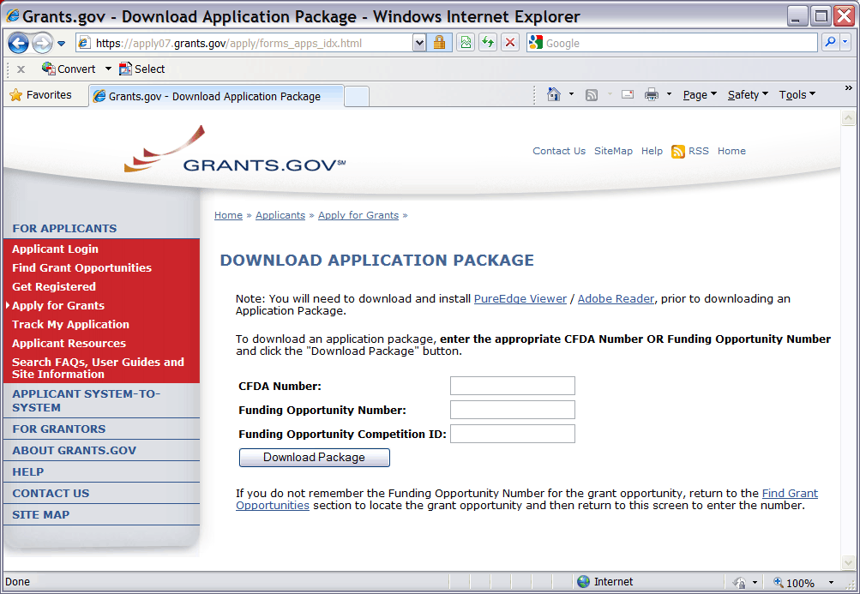
A Funding Opportunity Announcement (FOA) Number is referenced in every announcement. Enter this number in the Funding Opportunity Number field and click Download Package. This takes you to a “Selected Grant Applications for Download” screen.
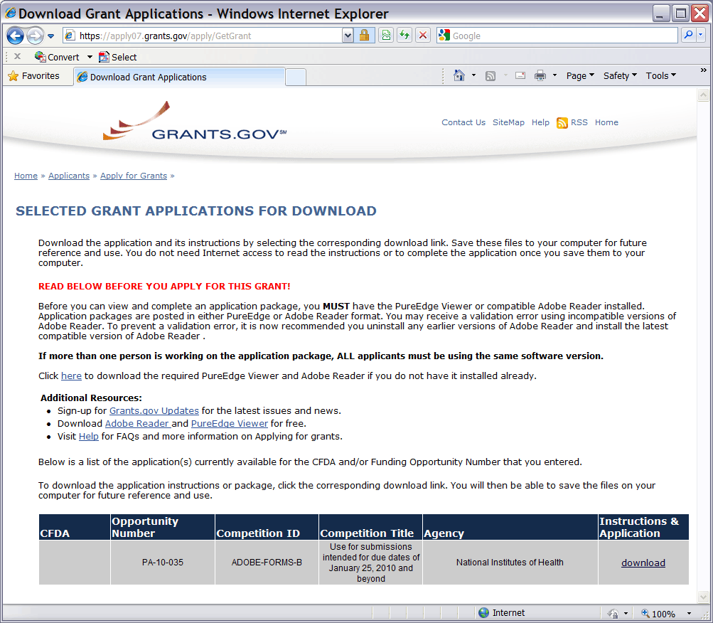
Click the corresponding download link to access the actual application form pages and instruction material. If more than one application package is listed, use the Competition ID and Competition Title to determine the appropriate package to download. The following screen appears:
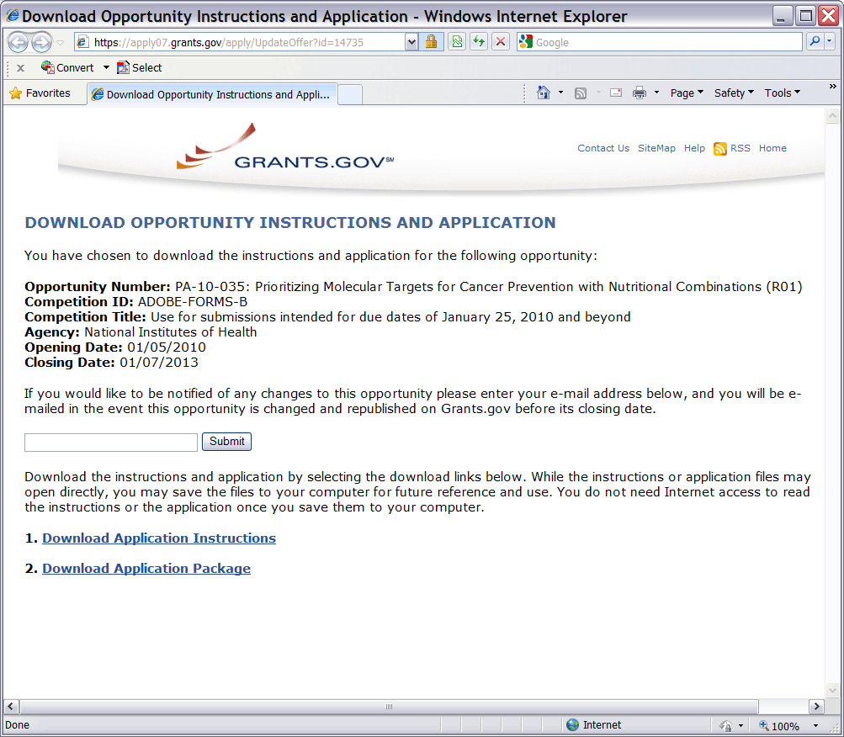
To access the instructions, click Download Application Instructions. For NIH opportunities and other PHS agencies using this Application Guide, this action will download a document containing a link to the NIH Web site where the most current set of application instructions is available (http://grants.nih.gov/grants/funding/424/index.htm). Applicants are encouraged to check this site regularly for the most current version.
To access the form pages, click Download Application Package. Section 2.5 provides specific information regarding the forms of an Application Package. Section 3 provides additional instructions for properly using a package.
On the Download Opportunity Instructions and Applications screen you will be given an opportunity to provide an e-mail address if you would like to be notified of any changes to this particular opportunity. Applicants to NIH and other PHS agencies are strongly encouraged to complete this information. The agency can then use it to provide additional information to prospective applicants.
Note: The forms may or may not show a CFDA number and the CFDA field is not editable. Do not be concerned. The CFDA number is not used for assignment of the application. Be assured the correct CFDA number will be assigned to the record once the appropriate IC assignment has been made.

2.5 Forms for Application to NIH or Other PHS Agencies
The SF424 (R&R) form set comprises a number of forms, each listed in the table below as a separate “document.” In addition to these forms, NIH and other PHS agencies applicants will also complete supplemental forms listed as “PHS 398” forms in the table below.
SBIR/STTR applicants will also complete the “SBIR/STTR Information form.”
Table 2.5-1. Forms of an NIH or Other PHS Agencies Application
document | required | optional | instructions
SF424 (R&R) Cover | x |  | Section 4.2
SF424 (R&R) Project/Performance Site Locations | x |  | Section 4.3
SF424 (R&R) Other Project Information | x |  | Section 4.4
SF424 (R&R) Senior / Key Person Profile(s) | x |  | Section 4.5
SF424 (R&R) Budget | x |  | Section 4.6
SF424 (R&R) Subaward Budget Attachment Form  (Use when required or allowed by the FOA) |  | x | Section 4.7
SBIR/STTR Information | x |  | Section 4.8
PHS 398 Cover Page Supplement | x |  | Section 5.3
PHS 398 Research Plan | x |  | Section 5.4
Planned Enrollment Report |  | x | Section 5.7
PHS 398 Cumulative Inclusion Enrollment Report |  | x | Section 5.7
The application forms package associated with most NIH research grant funding opportunities includes two optional budget forms: (1) SF424 (R&R) Budget and (2) PHS 398 Modular Budget. NIH application submissions must include either the SF424 (R&R) Budget Form or the PHS 398 Modular Budget Form, but never both. (Note AHRQ does not accept modular budgets.) Unless otherwise stated in a funding announcement, an application must always be submitted with a budget form. For those programs where either form is a possibility, the budget forms will be considered “optional” by the Grants.gov package. Nonetheless, it is still required that you select and submit one of these budget forms for an application to be accepted by the NIH.
To determine which budget form to use for NIH applications, consult the modular budget guidelines found in Section 5.4. Additional guidance may also be provided in the specific funding opportunity announcement.
Some funding opportunities will explicitly state the use of only one of the budget forms. In this case, the application package will only include the accepted budget form, which will appear in the list of “mandatory” forms (not in the optional list).
All required and optional forms for electronic submission listed above are available through Grants.gov and should be downloaded from the FOA being applied to. Do not use any forms or format pages from other sources; these may include extraneous headers/footers or other information that could interfere with the electronic application process.

2.6 Format Specifications for Text (PDF) Attachments
Designed to maximize system-conducted validations, multiple separate attachments are required for a complete application. When the application is received by the agency, all submitted forms and all separate attachments are combined into a single document that is used by peer reviewers and agency staff.
When using Adobe Acrobat (and possibly other tools), the signature has to be “off” when you create the originals. Please go to the security options menu selection in Adobe to ensure the signature is off. If you do not have the originals, copy the content of the signed documents and create a new document. Save this document without signing it.
Applicants should not submit protected PDF documents. Protected documents prevent NIH from opening and processing the document. Security settings vary by PDF tool, but please ensure security settings are not marked. The applicant needs to look at the Document Security tab under Document Properties (directly from the tab) and set the security parameters to ensure open access so NIH can process the content. For instance, do not password protect the document and do not mark Content Extraction or Copying, Document Assembly, etc. as “Not Allowed.”
If you are having trouble fixing the PDF settings, simply cut and paste from the PDF document into a Microsoft Word document and then reconvert (in some cases it may be better to use another PDF converter).
NIH and other PHS agencies require all text attachments to the Adobe application forms be submitted as PDFs and that all text attachments conform to the agency-specific formatting requirements noted below. Failure to follow these requirements may lead to rejection of the application during agency validation or delay in the review process. (See Section 2.3.2 for more information on creating PDFs.)
Text attachments should be generated using word processing software and then converted to PDF using PDF generating software. Avoid scanning text attachments to convert to PDF since that causes problems for the agency handling the application. Additional tips for creating PDF files can be found at http://grants.nih.gov/grants/ElectronicReceipt/pdf_guidelines.htm.
When attaching a PDF document to the actual forms, please note you are attaching an actual document, not just pointing to the location of an externally stored document. Therefore, if you revise the document after it has been attached, you must delete the previous attachment and then reattach the revised document to the application form. Use the View Attachment button to determine if the correct version has been attached.
File Name
Save all files with descriptive file names of 50 characters or less and be sure to only use standard characters in file names: A through Z, a through z, 0 through 9, underscore (_), hyphen (-), space ( ), and period (.). Do not use any special characters (example: “&”, “*”, “%”, “/”, and “#”) or spacing in the file name. For word separation use underscore (example: “My_Attached_File.pdf”) in naming the attachments.
Font
Use an Arial, Helvetica, Palatino Linotype, or Georgia typeface, a black font color, and a font size of 11 points or larger. (A Symbol font may be used to insert Greek letters or special characters; the font size requirement still applies.)
Type density, including characters and spaces, must be no more than 15 characters per inch.
Type may be no more than six lines per inch.
Paper Size and Page Margins
Use standard paper size (8 ½” x 11).
Use at least one-half inch margins (top, bottom, left, and right) for all pages. No information should appear in the margins, including the PI’s name and page numbers.
Page Formatting
Since a number of reviewers will be reviewing applications as an electronic document and not a paper version, applicants are strongly encouraged to use only a standard, single-column format for the text. Avoid using a two-column format since it can cause difficulties when reviewing the document electronically.
Do not include any information in a header or footer of the attachments. A header will be system-generated that references the name of the PD/PI. Page numbers for the footer will be system-generated in the complete application, with all pages sequentially numbered.
Figures, Graphs, Diagrams, Charts, Tables, Figure Legends, and Footnotes
You may use a smaller type size but it must be in a black font color, readily legible, and follow the font typeface requirement. Color can be used in figures; however, all text must be in a black font color, clear and legible.
Grantsmanship
Use English and avoid jargon.
If terms are not universally known, spell out the term the first time it is used and note the appropriate abbreviation in parentheses. The abbreviation may be used thereafter.
Page Limits
Although many of the sections of this application are separate text (PDF) attachments, page limits referenced in these instructions and/or funding opportunity announcements must still be followed. Agency validations will include many checks for page limits. Some accommodation will be made for sections that when combined must fit within a specified limitation. Note that while these computer validations will help minimize incomplete and/or non-compliant applications, they may not address all page limit requirements for a specific FOA and do not replace the validations conducted by NIH staff. Applications found not to comply with the requirements may lead to rejection of the application during agency validation or delay in the review process.
All applications for NIH and other PHS agency funding must be self-contained within specified page limits. Unless otherwise specified in an NIH solicitation, Internet Web site addresses (URLs) may not be used to provide information necessary to the review because reviewers are under no obligation to view the Internet sites. Moreover, reviewers are cautioned that they should not directly access an Internet site as it could compromise their anonymity.
Observe the page number limitations given in Table 2.6-1. Only when specifically allowed in a FOA, will the PHS accept applications that exceed the page number limitations. However, specific page number limits may apply to each subproject. For information pertaining to page number limits for such projects, contact the awarding component to which the application may be assigned. (See Table 1.4-1. Agency Contact Table.) The page number limitations may also be different for other specialized grant applications. Applicants are prohibited from using the Appendix to circumvent page limitations in any section of the application for which a page limit applies. For additional information regarding Appendix material and page limits, please refer to the NIH Guide Notice NOT-OD-11-080.
Table 2.6-1. Page Limits
Please visit http://grants.nih.gov/grants/forms_page_limits.htm for a more detailed Table of Page Limits.

section of application  Also refer to the relevant section of the application instructions and the FOA. | page limits *
Introduction to Resubmission and Revision Applications | 1 page
Specific Aims | 1 page
Research Strategy (Item of Research Plan) | Phase I SBIR/STTR: 6 pages  Phase II and Phase IIB SBIR/STTR: 12 pages  Fast-Track SBIR/STTR: 12 pages
Biographical Sketches | 4 pages per person
Commercialization Plans for Phase II, Phase IIB Competing Renewals, and Fast-Track Applications | 12 pages
Appendix | Phase I SBIR/STTR: Not permitted unless specifically requested by NIH.
FOAs (PAs and RFAs) | Follow FOA Instructions
* FOA instructions always supersede these instructions.
Applicants are prohibited from using the Appendix to circumvent page limitations in any section of the application for which a page limit applies. For additional information regarding Appendix material and page limits, please refer to the NIH Guide Notice NOT-OD-11-080, http://grants.nih.gov/grants/guide/notice-files/NOT-OD-11-080.html.

2.7 “Resubmission” Applications
For all original new (i.e. never submitted) and competing renewal applications submitted for the January 25, 2009 due date and beyond, NIH will accept only a single amendment (A1) to the original application (called a resubmission application). A lengthy hiatus after the initial submission may be marked by significant advances in the scientific field and the comments of the reviewers may no longer be relevant. Therefore, a resubmission application must be submitted within 37 months after the date of receipt ("receipt date") of the initial New, Renewal, or revision application (see NOT-OD-10-140). After 37 months, you may submit a New application. Any second resubmission will be administratively withdrawn and not accepted for review.
NIH has established policies for application resubmissions of certain categories. See Resubmission of Unpaid RFA Applications and Resubmission of Applications with a Changed Grant Activity Code in Part III, 1.2.
There are four requirements for a Resubmission application:
- The Summary Statement must be available in the eRA Commons (http://commons.era.nih.gov/commons).
- The PD/PI(s) must make significant changes to the application.
- An Introduction must be included that summarizes the substantial additions, deletions, and changes to the application. The Introduction must also include a response to the issues and criticism raised in the Summary Statement. The Introduction is separate from the Cover Letter. Use Item 2.1 Introduction of the PHS 398 Research Plan Form to provide this information. The page limit for the Introduction may not exceed one page unless indicated otherwise. Please refer to the relevant section of the application instructions and the FOA.
- The substantial scientific changes must be marked in the text of the application by bracketing, indenting, or change of typography. Do not underline or shade the changes. Deleted sections should be described but not marked as deletions. If the changes are so extensive that essentially all of the text would be marked, explain this in the Introduction. The Preliminary Studies/Progress Report section should incorporate work completed since the prior version of the application was submitted.
See NOT-OD-11-057 for special conditions and due dates for new investigator resubmission applications submitted for consecutive review cycles. Note this applies only to new investigator R01s submitted for standard receipt dates and reviewed in recurring study sections in CSR.
Acceptance of a resubmission application will not automatically withdraw the prior version. eRA keeps all versions (e.g., 01, A1) of a grant application active and provides an internal Multiple Active Applications (MAA) flag for each application in an active cluster. The cluster allows applicants to identify quickly all versions of one application. If any version in a cluster is awarded, all other applications within the cluster will be automatically withdrawn without any additional action by applicants or staff.
Investigators who have submitted two versions of an application and have not been successful often ask NIH what constitutes a “new application.” It is recognized that investigators are trained in a particular field of science and are not likely to make drastic changes in their research interests. However, a new application following two reviews is expected to be substantially different in content and scope with more significant differences than are normally encountered in a resubmission application. Simply rewording the title and Specific Aims or incorporating minor changes in response to comments in the previous Summary Statement does not constitute a substantial change in scope or content. Changes to the Research Strategy should produce a significant change in direction and approach for the research project. Thus, a new application would include substantial changes in all portions of the Specific Aims and Research Strategy. Requests for review by a different review committee or funding consideration by a different NIH IC are not sufficient reasons to consider an application as new.
In the referral process, NIH staff look at all aspects of the application, not just the title and Description (abstract). Requesting review by a different review committee does not affect the implementation of this policy. When necessary, previous applications are analyzed for similarities to the present one. Thus, identical applications or those with only minor changes will not be accepted for review. If identified after assignment or review, identical applications will be withdrawn.

2.8 “Revision” Application
A competing supplemental application (now known as a “Revision” application) may be submitted to request support for a significant expansion of a project’s scope or research protocol. Applications for revisions are not appropriate when the sole purpose is to restore awards to the full SRG-recommended level if they were administratively reduced by the funding agency. A revision application should not be submitted until after the original application has been awarded and must not extend beyond the term of the current award period.
Provide a one-page “Introduction” that describes the nature of the supplement and how it will influence the specific aims, research design, and methods of the current grant. Use Item 2.1, Introduction to Application, of the PHS 398 Research Plan form to provide this information. The body of the application should contain sufficient information from the original grant application to allow evaluation of the proposed supplement in relation to the goals of the original application. Note that all revision applications must be submitted by the same PD/PI (or contact PD/PI for multi-PI grants) as listed on the current award. Also, any budgetary changes for the remainder of the project period of the current grant should be discussed in the Budget Justification.
If the revision application relates to a specific line of investigation presented in the original application that was not recommended for approval by the SRG, then the applicant must respond to the criticisms in the prior Summary Statement, and substantial revisions must be clearly evident and summarized in the “Introduction.”
Administrative Supplements
An administrative supplement provides additional funding to meet increased costs that are within the scope of an approved application, but that were unforeseen when the new or competing renewal application was submitted. If considering administrative supplement funding, you must consult in advance with your designated Grants Management Officer and Program Official. It is important to submit a request before the grant expires. To be considered for an administrative supplement, you must submit a request in writing to the IC (not to the Division of Receipt and Referral, Center for Scientific Review). For additional information, see NIH Guide Notice NOT-OD-12-043. The request must be signed by the authorized Business Official and describe the need for additional funding and the categorical costs. In the letter, point out what will NOT be able to be accomplished if such a request is denied. At this time, administrative supplements may not be submitted through Grants.gov.

2.9 Similar, Essentially Identical, or Identical Applications
Submissions of identical applications to one or more components of the PHS are not allowed.
Submissions of identical applications to one or more components of the PHS are not allowed, and the NIH will not accept similar grant applications with essentially the same research focus from the same applicant organization. This includes derivative or multiple applications that propose to develop a single product, process or service that, with non-substantive modifications, can be applied to a variety of purposes. Likewise, identical or essentially identical grant applications submitted by different applicant organizations will not be accepted. Applicant organizations should ascertain and assure that the materials they are submitting on behalf of the principal investigator are the original work of the principal investigator and have not been used elsewhere in the preparation and submission of a similar grant application. Applications to the NIH are grouped by scientific discipline for review by individual Scientific Review Groups and not by disease or disease state. The reviewers can thus easily identify multiple grant applications for essentially the same project. In these cases, application processing may be delayed or the application(s) may not be reviewed.
Essentially identical applications will not be reviewed except for: 1) individuals submitting an application for an Independent Scientist Award (K02) proposing essentially identical research in an application for an individual research project; 2) individuals submitting an individual research project identical to a subproject that is part of a program project or center grant application; 3) Submissions of applications previously submitted to an RFA that were not paid or resubmissions of investigator-initiated applications originally submitted to an RFA (see Grants Policy Statement section 2.3.7.3); and 4) Resubmissions of applications with a changed grant activity code.

2.10 Submitting Your Application Via Grants.gov
The Authorized Organization Representative (AOR) registered in Grants.gov is the only official with the authority to actually submit applications through Grants.gov. Therefore, PD/PIs will need to work closely with their AOR to determine that all the necessary steps have been accomplished prior to submitting an application. This includes any internal review process required by the applicant organization.
Before starting the final submission step, applicants are encouraged to save a copy of the final application locally. Once you have properly completed all required documents and attached any required or optional documentation, click on the Check Package for Errors button to ensure that you have successfully completed all required data fields. If any of the required fields are not completed you will receive an error notice which will indicate where revision is needed within your package. Correct any errors or if none are found, save the application package. The Save & Submit button will now become active and clicking this button will begin the application submission process. Only after the package has been saved with no errors will the Save & Submit button become active. The application package must then be saved once more before the submission process begins. Only an AOR will be able to perform the submit action, and they will be taken to the applicant login page to enter the Grants.gov username and password that was established in the Register with Grants.gov process (if not connected to the internet you will be instructed to do so).
Once logged in, the application package will be automatically uploaded to Grants.gov. A confirmation screen will appear once the upload is complete and a Grants.gov Tracking Number will be provided on this screen. Applicants should record this number so that they may refer to it should they need to contact Grants.gov Customer Support or the eRA Commons Help Desk.
For additional information, see http://www.grants.gov/applicants/apply_for_grants.jsp.
Applicants should be aware that on-time submission means that an application is submitted error free (of both Grants.gov and eRA Commons errors) before 5 p.m. on the receipt date, local time of the applicant organization. Applicants are encouraged to submit their applications to Grants.gov several days early to ensure enough time to correct any errors before the deadline.

2.11 After You Submit Your Application Via Grants.gov
Grants.gov’s Track My Application feature for Applicants provides basic status information for a specified Grants.gov Tracking Number. The Authorized Organization Representative (AOR) can also login to Grants.gov with their username and password to obtain a more detailed status of an application by using the Check My Application Status feature.

Once an application has been submitted via Grants.gov, several e-mails are sent to the email address on file with Grants.gov for the AOR (known at NIH/in eRA Commons as the Signing Official [SO]) who submitted the application. Each email notification will reference a Grants.gov tracking number that is assigned to the submission:

1) Submission Receipt: An e-mail is sent indicating your application has been received by Grants.gov and is currently being validated.
2) Submission Validation Receipt: An e-mail is sent indicating your application has been received and validated by Grants.gov and is being prepared for Grantor agency retrieval.
3) Grantor Agency Retrieval Receipt: An e-mail is sent indicating your application has been retrieved by the Grantor agency.
4) Agency Tracking Number Assignment for Application: An e-mail is sent indicating your application has been assigned an Agency Tracking Number.
If the AOR/SO has not received a confirmation message from Grants.gov within 48 hours of submission, please contact:
Grants.gov Contact Center
Telephone: 1-800-518-4726
E-mail: support@grants.gov
At that point, the application will be scheduled for download into the eRA system for agency validation. It is imperative that the e-mail address provided in blocks 14 for the PD/PI and 19 for the AOR/SO on the SF424 (R&R) Cover form be current and accurate. Once agency validation is completed, an agency notification (not Grants.gov) will be e-mailed to the PD/PI, AOR/SO, and the Applicant Contact e-mail provided in the application.
This e-mail notification will inform the PD/PI, AOR/SO, and the Applicant Contact (if named) that the application has been received and processed by the agency and will indicate whether any errors or warnings resulted during the validation process. The PD/PI, AOR/SO, and the Applicant Contact will be invited to log on the eRA Commons to view the assembled application or review the list of warnings/errors that were encountered during the validation process. SOs for the applicant organization, the PD/PI for the application and any Assistants that have been delegated in eRA Commons to view the PD/PIs status information will have access to the submission results in eRA Commons.
If there were no validation errors, this e-mail notification will also inform the PD/PI, AOR/SO, and the Applicant Contact of an agency accession number, which represents the “agency tracking number.” This number replaces the Grants.gov tracking number that was assigned when the application was first submitted. The Grants.gov system will indicate that the agency tracking number has been assigned, and will reflect both numbers. In subsequent interaction with the eRA Commons, however, it is the agency accession number that will be used to refer to the application, not the Grants.gov tracking number.
The eRA system will make every effort to send an e-mail to the PD/PI, AOR/SO, and the Applicant Contact summarizing download and validation results. However, since e-mail can be unreliable, applicants are responsible for checking on their application status in the Commons. However, since e-mail can be unreliable, applicants are responsible for checking on their application status in the Commons.
Once an application package has been successfully submitted through Grants.gov, any encountered errors have been corrected by the applicant, and an application image has been assembled by the eRA Commons, PD/PIs and AORs/SOs will have two business days (Monday – Friday, excluding Federal holidays) to check the assembled application before it automatically moves forward to NIH staff for further processing and consideration. Once the application has moved forward, no additional changes to the application will be accepted through Grants.gov or eRA Commons. This window is known as the application viewing window.
Within the viewing window, SOs have the authority to reject an application to stop it from completing the submission process. After an application is rejected, a changed/corrected application can be submitted to address warnings or other issues if it is still before the submission deadline. However, changed/corrected applications submitted after the submission deadline will be subject to the NIH Late Policy and may not be accepted.
Remember, warnings do not stop further application processing. If an application submission results in warnings (but not errors), the application will automatically move forward after the application viewing window if no action is taken. Some warnings may need to be addressed later in the process.
It is your responsibility to view the entire assembled application in eRA Commons and notify the eRA Commons Help Desk within this window if the assembled application does not correctly reflect the information submitted to Grants.gov (e.g., submitted information is missing in image, graph/chart appears upside-down). The eRA Commons Help Desk will provide guidance on appropriate corrective actions.
If you encounter a system issue beyond your control that threatens your ability to complete the submission process on-time, you must follow the Guidelines for Applicants Experiencing System Issues.
Only the eRA Help Desk can confirm whether a system issue has taken place and provide instructions on how to resolve the issue. Applications affected by confirmed system issues will not be considered late as long as the applicant works diligently with the eRA Help Desk on a resolution. If the application needs to be Rejected and resubmitted, applicants should follow the instructions for correcting errors in Section 2.12, including the requirement for cover letters on late applications.
PIs should work with their AOR/SO to determine when the “Reject” feature is appropriate.
To view the assembled application the AOR/SO should:
1. Login to the eRA Commons (https://commons.era.nih.gov/commons/) with your Signing Official (SO) account.
2. Click the Status tab on the Commons menu bar.
3. Click Recent/Pending eSubmissions on the left-hand side of the screen.
4. Search for your application by date received, Grants.gov tracking number, or accession number, to view a hit list of available applications.
5. When you find the appropriate application, click the accession number in the Application ID column to view the Status Information screen.
6. Click e-Application from the Other Relevant Documents section to view the assembled application.
Note: The SO can reject the application by clicking on the Reject eApplication hypertext link from the Action column of the search hit list.
To view the assembled application the PD/PI should:
1. Login to the eRA Commons (https://commons.era.nih.gov/commons/) with your Principal Investigator (PI) account.
2. Click the Status tab on the Commons menu bar.
3. Click Recent/Pending eSubmissions near the top of the screen to view a hit list of available applications.
4. When you find the appropriate application, click the accession number in the Application ID column to view the status information screen.
5. Click e-Application from the Other Relevant Documents section to view the assembled application.

2.12 Correcting Errors
Prior to a specified submission date, applicants may make corrections and resubmit an application through Grants.gov. After a specified submission date, if applicants make corrections and resubmit, the application will be considered late. In this case, applicants must include a cover letter explaining the reasons for the delay. See Section 2.14 for additional information on submission dates.
If errors or warnings result from the validation process, the PD/PI, AOR/SO and Applicant Contact will be issued an e-mail instructing them to log on to the eRA Commons to review the list of warnings/errors that were encountered during the validation process. The eRA system will make every effort to send an e-mail to the PD/PI, AOR/SO and Applicant Contact indicating whether errors or warnings were detected. However, since e-mail can be unreliable, applicants are responsible for periodically checking their application status in the eRA Commons, so that any errors or warnings can be resolved in the timeliest manner possible, before the deadline. SOs for the applicant organization, the PD/PI for the application and any Assistants that have been delegated in eRA Commons to view the PD/PIs status information will have access to the submission results in eRA Commons.
Please be aware of the distinction between errors and warnings. The word error is used to characterize any condition which causes the application to be deemed unacceptable for further consideration. Generally, errors will indicate significant inaccuracies, inconsistencies, omissions, or incorrect formatting that have been identified in the body of the application. Conversely, the word warning characterizes any condition that is acceptable, at least for the time being, but worthy of bringing to the applicant’s attention. It is at the applicant’s discretion whether a warning condition requires any action, but some warnings may need to be addressed later in the process.
A Changed/Corrected application may also be submitted if the PDF image, as viewed in the eRA Commons, is incomplete or inaccurate from that submitted.
Submitting a Changed/Corrected application will overwrite the previous submission and the previous application cannot be reinstated.
Errors and warnings may be reviewed in the Commons by performing the following steps:
1. After the application has been downloaded from Grants.gov and validated by the system, login to the eRA Commons (https://commons.era.nih.gov/commons/) using your username and password.
2. Click the Status tab on the Commons menu bar.
3. Click Recent/Pending eSubmissions.
4. Search for your application by date received, Grants.gov tracking number, or accession number, if you are the SO. If you are the PI, clicking Recent/Pending eSubmissions will automatically display a hit list of your applications.
5. A hit list of application numbers is displayed. If the application was validated with warnings only, or without encountering any problems whatsoever, then it is identified in the hit list by its NIH accession number (e.g., “AN:2911064”). This is the same number that Grants.gov displays, and refers to as the “agency tracking number.”
If any errors were identified during validation, then the application still appears in the hit list, but in this case it is identified by its Grants.gov tracking number (e.g., “GRANT87654321”). This is the number that Grants.gov assigned to your application at the time of submission.
6. When you find the appropriate application in the hit list (Application Status will read “eSubmission Error” if errors were received), click its Application ID link to view the list of errors/warnings.
7. The error/warning page appears, and you are then able to review all conditions that were identified during validation. If only warnings were identified, you may elect to take action and resubmit; however you may also disregard the warnings and proceed to view the application, as described earlier.
To correct errors and resubmit the application:
- Make whatever corrections are necessary, wherever appropriate, to your local copy of the application. Most often this means that you have to edit the data within the application forms to correct whatever problem or inconsistency that was noted. Be as careful as possible when correcting your application; NIH’s post-submission materials policy does not allow for applicants to correct oversights in their application after the due date.
- Check the “Changed/Corrected Application” box in Item 1 of the SF424 (R&R) Cover form.
- If you are submitting this Changed/Corrected application after the due date, be sure to document the reason for the late submission in the form of a cover letter. NIH makes no guarantees that applications submitted after the due date will be accepted. See the NIH late policy for more information.
- When you check the Changed/Corrected Application box, Item 4a. Federal Identifier becomes a required field.
- When you have made all of your corrections, save the Changed/Corrected application to your computer.
- The AOR will have to submit the Changed/Corrected application package to Grants.gov. The applicant will have to follow the Changed/Corrected application through Grants.gov to the eRA Commons to view the application image or the list of errors/warnings received during the validation process. It is the applicant’s responsibility to track the application through to the eRA Commons. If you cannot view your application image in the Commons, NIH can’t review your application! Successful submission may take several rounds of Changed/Corrected applications, since correcting one error may reveal or create an additional error.
The same e-mail notifications will be issued once the agency has downloaded and validated the re-submitted application and the PD/PI, AOR/SO, and Applicant Contact will once again be required to log on to the Commons either to view the application, or to review the errors that were encountered during validation.
The application will only be assigned for scientific review once errors are resolved.
In addition to the validations performed by the eRA system, further administrative review will be conducted by agency staff. The PD/PI and/or the applicant organization may be contacted for further corrections/clarifications.

2.13 Post-Submission Application Materials
Grant application materials will only be accepted after submission of the application but before the initial peer review if they result from unforeseen administrative issues. Exceptions to this policy are indicated below. See NOT-OD-10-091 for additional information.
The materials should be sent as a PDF attachment to an e-mail. E-mail communication is preferred. If e-mail is not feasible, please send in a hard copy.
The original application is kept intact; any application material sent post-submission is sent separately to reviewers. Updated or supplemental grant application materials used in the peer review process will be retained as part of the official grant file and remain part of the permanent record for that application.
Acceptable post-submission materials include:
- Revised budget page(s) (e.g., change in budget request due to new funding or institutional acquisition)
- Biographical sketches (e.g., change in senior/key personnel due to the loss of an investigator)
- Letters of support or collaboration resulting from a change in senior/key personnel due to the loss of an investigator
- Adjustments resulting from natural disasters (e.g., loss of an animal colony)
- Adjustments resulting from change of institution (e.g., PI moved to another university)
- News of an article accepted for publication
Unacceptable post-submission materials [for all applications but those under Exceptions below] include:
- Updated Specific Aims or Research Strategy pages
- Late-breaking research findings
- Supplemental pages - information not contained in the existing application
- New letters of support or collaboration that do not result from a change in senior/key personnel due to the loss of an investigator
Exceptions to this policy include:
- Applications submitted in response to Requests for Applications (RFAs) that have only one due date. Post-submission materials for these applications will be accepted as outlined in NOT-OD-10-070
- Applications for training grants (see NOT-OD-10-104)
- Certain NIH Funding Opportunity Announcements (FOAs) may allow certain other types of post-submission materials to facilitate the goals of the program. Such stipulations must be explained in the FOA in the NIH Guide for Grants and Contracts
Page limits for post-submission materials under the new policy:
- All post-submission materials must conform to NIH policy on font size, margins, and paper size as referenced in Part I.2.6 of the applicable application instructions
- NIH additional form pages such as budget, biographical sketches, and other required forms must follow NIH standards for required NIH form pages.
- If post-submission material is not required on a form page, each explanation or letter is limited to one page (see Acceptable post-submission materials above)
- If the application has subprojects or cores, each subproject or core is allowed explanations or letters (see Acceptable post-submission materials above), but each explanation or letter is limited to one page
The additional materials must be submitted to the NIH SRO with the concurrence of the applicant organization’s designated AOR/SO. Although the content of post-submission materials may originate from the PD/PI, Contact PD/PI for multiple PD/PI applications, or organizational officials, the AOR must send the materials directly to the SRO, or must send his/her concurrence to the PD/PI who will forward the materials and concurrence to the SRO. A communication from the PD/PI only or with a “cc” to the AOR will not be accepted.
The deadline for receipt of additional materials is one month (30 calendar days) prior to the peer review meeting. FOAs may provide stricter or more lenient guidance.
After the initial peer review phase is completed, the NIH Chief Grants Management Officer is the NIH official responsible for accepting additional materials. Most of the materials submitted after the initial peer review can be submitted as part of the Just-In-Time process (see Supplemental Instructions Part III.1.7).

2.14 Application Submission Dates
For submission of applications to NIH, each FOA includes an Opportunity Open Date and an Opportunity Close Date. Many announcements, including those using the “Standard Submission Dates” noted in Table 2.15-1 below, include multiple submission/receipt dates and are active for several years. These announcements are posted in Grants.gov and the NIH Guide to Grants and Contracts showing an Open/Close period that spans the entire active period of the announcement. Applicants should read the Funding Opportunity Announcement carefully for specific submission/receipt dates. If specific dates are not referenced in the announcement, applicants should refer to the Standard Submission Dates for Competing Applications noted in Table 2.15-1.
Applications submitted for the Standard Submission Dates listed in Table 2.15-1 are considered on time if they are submitted to Grants.gov on or before 5 p.m. local time on the appropriate date listed. Applications submitted to FOAs with a single submission date are considered on time if they are submitted to Grants.gov on or before 5 p.m. local time on the appropriate date listed. Applications submitted for Special Receipt Dates are considered on time if they are submitted to Grants.gov on or before 5 p.m. local time on the specified Application Due Date(s). Requests for Applications (RFAs) and Program Announcements with Special Referral Considerations (PARs) with special receipt dates always must be received by Grants.gov on the dates designated in the announcement.
Weekend/Federal Holiday Submission Dates. When a postmark/submission date falls on a weekend or Federal holiday, the application deadline is automatically extended to the next business day. If the submission deadline shifts beyond the expiration date of the FOA, applicants submitting electronically may receive a warning message from Grants.gov. This warning will not keep your application from processing through Grants.gov. As always, applicants must check the eRA Commons to view their application and to ensure they have addressed any errors (instances of non-compliance with NIH business rules) identified by NIH systems.
Modified Application Submission and Review Policy. A continuous submission process is available to appointed members of chartered standing NIH Study Sections, Boards of Scientific Counselors, Advisory Boards or Councils, Program Advisory Committees, and peer reviewers who have served as regular or temporary members of peer review committees six times in 18 months. This alternative submission and review process is limited to R01, R21, and R34 application that would normally be received on standard submission dates. See the Peer Review Policies & Practices, Continuous Submission web page for additional information on the continuous submission process and eligibility requirements.
Late Applications. Permission for a late submission is not granted in advance. In rare cases, late applications will be accepted but only when accompanied by a cover letter that details the compelling reasons for the delay. While the reasons are sometimes personal in nature, an objective evaluation of their merit requires that some details be provided. Late applications have been accepted for reasons such as: death of an immediate family member of the PD/PI, sudden acute severe illness of the PD/PI or immediate family member, or large scale natural disaster.
NIH will consider accepting late applications based on the acceptability of the explanation and the processing time required for two different kinds of submission/receipt dates.
- Regular Standard Submission/Receipt Dates: To be considered applications must be received at the NIH within two weeks of the standard submission date.
- Expedited Standard Submission/Receipt Dates: To be considered applications must be received at the NIH within one week of the standard submission date. SBIR and STTR applications submitted in response to standard receipt dates fall in this category.
- NIH will not consider late applications for the Special Receipt Dates for RFAs and PARs. This includes the special receipt dates (March 20, July 20, and November 20) for resubmission applications that are part of the New Investigator Initiative (http:grants.nih.gov/grants/guide/notice-files/NOT-OD-07-083.html).
- NIH does not expect to accept any applications received beyond the window of consideration.
The windows of time for consideration of late applications have been carefully chosen so that the late applications can be processed with the cohort of on-time applications. In all cases, when the regular standard submission date or expedited submission date falls on a weekend or federal holiday and is extended to the next business day, the window of consideration for late applications will be calculated from that business day. Note that the late window always ends in a receipt (not submission) date.
If an application is submitted late, attach a Cover Letter to the SF424 (R&R) cover form using the Cover Letter Attachment field to provide specific information on the timing and nature of the cause of the delay. No other documentation is expected. Late applications are evaluated on an individual basis considering the reasons provided. Contacting the Division of Receipt and Referral, Center for Scientific Review (CSR), NIH in advance will not influence the acceptance of a late application.
Related Guide Notices include:
- NOT-OD-12-001 Update of NIH Late Application Policy to Reflect Change in Due Dates for New Investigator R01 Resubmission Applications at http://grants.nih.gov/grants/guide/notice-files/NOT-OD-12-001.html;
- NOT-OD-11-035 NIH Policy on Late Submission of Grant Applications at http://grants.nih.gov/grants/guide/notice-files/NOT-OD-11-035.html; and
- NOT-OD-11-093 Change in the NIH Continuous Submission Policy for Reviewers with Recent Substantial Service at http://grants.nih.gov/grants/guide/notice-files/NOT-OD-11-093.html.

2.15 Submission, Review and Award Cycles
The PHS submission, review, and award schedule is provided in Table 2.15-1. For specialized grant applications, consult with the appropriate PHS agency prior to the preparation of an application.
Table 2.15-1. Submission Dates, Review, and Award Cycles
 | receipt cycle i | receipt cycle ii |  | receipt cycle iii
Small Business Innovation Research (SBIR),  Small Business Technology Transfer (STTR) Grants – R41, R42, R43, R44, U43, and U44  new, renewal, resubmission, revision | April 5 | August 5 | December 5
AIDS and AIDS-Related Grants  All (including SBIR/STTR)  new, renewal, resubmission, revision | May 7 | September 7 | January 7
NOTE: RFAs and some PARs have special receipt dates indicated in the specific NIH Guide Announcement.

review and award cycles: | cycle i | cycle ii | cycle iii
Scientific Merit Review | June - July | October - November | February - March
Advisory Council Review | September - October | January - February | May - June
Earliest Project Start Date | December | April | July
Note: Awarding components may not always be able to honor the requested start date of an application; therefore, applicants should make no commitments or obligations until confirmation of the start date by the awarding component.
Application Assignment Information
Competing grant applications that have been successfully submitted through Grants.gov (including correcting all errors and the grant application assembled by the eRA Commons system) will be processed through the Division of Receipt and Referral, CSR, NIH unless otherwise stated. The application will be assigned to an appropriate Scientific Review Group and awarding component(s). Assignment is based on the scientific content of the application using established referral guidelines. Business rule validations are conducted by the system as well as NIH staff.
Assignment to Review Group. The Center for Scientific Review (CSR) will assign appropriately completed applications to the Scientific Review Groups (commonly referred to as “SRGs” or “study sections”) that will perform the scientific/technical merit review. The CSR lists the recurring review panels (http://public.csr.nih.gov/StudySections/IntegratedReviewGroups/Pages/default.aspx), and you may suggest a specific group in the PHS Cover Letter form. See Part I, Section 5.2 of this Guide for a suggested format for requesting a specific SRG in the Cover Letter.
NIH has implemented Special Council Review procedures for the additional review of grant and cooperative agreement applications from Program Director(s)/Principal Investigator(s) [PD(s)/PI(s)] who already receive in excess of $1 million per year in total costs to determine if additional funds should be provided to already well-supported investigators. It is important to note that the Special Council Review does not represent a cap on total NIH funding for any one investigator. For additional information, please see NOT-OD-12-110 and NOT-OD-12-140.
Assignment to Relevant Potential Awarding Component(s) (ICs). In addition, CSR will assign each application to the agency awarding component that is the potential funding component. When the scientific areas and the research proposed in a grant application are sufficiently relevant to the program responsibilities of two or more awarding components, CSR may assign your application to all such components. The component that has the most relevant program responsibility is designated as the primary assignee. The other components that have an interest in your application are designated as secondary assignees. If your application is eligible for funding and the primary assignee does not intend to make an award, the secondary assignees will be given the opportunity to do so. Although these suggestions will be taken into consideration, the final determination will be made by the agencies participating in this solicitation.
After the submission date, usually within two (2) weeks, the PD/PI and the applicant organization will be able to access in the eRA Commons and view the following information regarding the grant application:
- Application assignment number;
- Name, address, and telephone number of the Scientific Review Officer (if the review takes place in CSR) of the Scientific Review Group to which the application has been assigned for peer review; and
- Assigned Institute/Center information.
Review outcome and other important information are also available in the Commons.
If assignment information is not available in the eRA Commons within two weeks of the submission date, contact the Division of Receipt and Referral, Center for Scientific Review (CSR), National Institutes of Health, Bethesda, MD 20892-7720, (301) 435-0715; TTY (301) 451-5936. If there is a change in assignment, you will receive a notification and the change will be reflected in the eRA Commons.
Applicant investigators must not communicate directly with any review group member about an application either before or after the review. Failure to strictly observe this policy will create serious breaches of confidentiality and conflicts of interest in the peer review process. From the time of assignment to the time the review of your application is complete, applicant investigators must direct all questions to the Scientific Review Officer. This individual is in charge of the review group and is identified in the eRA Commons.

2.16 Resources for Finding Help

2.16.1 Finding Help for Grants.gov Registration or Submissions
If help is needed with the Grants.gov registration process or with the technical aspects of submitting an application through the Grants.gov system, check first the resources available at Grants.gov (http://grants.gov/).
Grants.gov customer support is also provided by the following office:
Grants.gov Program Management Office
200 Independence Avenue, SW
HHH Building, Room 739F
Washington, DC 20201
Grants.gov Help Desk: support@grants.gov
Grants.gov Self-Service Web Portal: https://grants-portal.psc.gov/Welcome.aspx?pt=Grants
Grants.gov Contact Center Phone Number: 1-800-518-4726 (Toll Free); 606-545-5035 (Local or International)
The Contact Center is available 24 hours a day, 7 days a week (except Federal holidays).

2.16.2 Finding Help for the eRA Commons Registration or
eRA Commons Validation Processes
If help is needed with the eRA Commons registration process for the applicant organization and PD/PIs or with the application validation process in the Commons after submission through Grants.gov, check first the resources available at Electronic Submission of Grant Applications (http://grants.nih.gov/grants/ElectronicReceipt/).
eRA Commons customer support is also provided by the eRA Commons Help Desk:
eRA Web site: http://era.nih.gov
eRA Commons Web site: https://commons.era.nih.gov/commons/index.jsp
eRA Commons on-line resources and Web ticketing: http://era.nih.gov/help/
eRA Commons Help Desk E-mail: commons@od.nih.gov
eRA Commons Phone: 301-402-7469
866-504-9552 (Toll Free)
301-451-5939 (TTY)
The eRA Commons Help Desk hours of operation are Monday-Friday from 7:00 a.m. to 8:00 p.m. Eastern Time (except Federal holidays).
NOTE: To help expedite your Help Desk request, we recommend that you have the following information readily available (NOTE: Additional details may be required depending upon the type of issue/request):
- Full Name of Affected User
- Full Name of Institution/Organization
- Grants.gov Tracking Number
- Submission Date
- Funding Opportunity Announcement (FOA)
- Principal Investigator’s (PI) Username
- Signing Official’s (SO) Username

2.16.3 Finding Help for Application Preparation
If after reviewing this application instruction guide, help is still needed in preparing the application, contact GrantsInfo:
GrantsInfo Phone: 301-435-0714
301-451-5936 (TTY)
GrantsInfo E-mail: GrantsInfo@nih.gov

2.16.4 Finding Help for SBIR/STTR Specific Inquiries
Questions of a general nature about the NIH SBIR/STTR program should be directed to:
NIH SBIR/STTR Program Office
Phone: 301-435-2688
Fax: 301-480-0146
E-mail: sbir@od.nih.gov

2.16.5 Finding Help for the SBA Company Registry
For questions and for technical assistance concerning the SBA Company Registry, please contact the SBA at http://sbir.gov/feedback?type=reg.

3. Using the Grant Application Package
This section describes the steps an applicant takes once the appropriate FOA (see Section 2.4) has been located and the corresponding grant application package has been successfully downloaded.

3.1 Verify Grant Information
When you select a funding opportunity in Grants.gov Apply, verify that the information shown in the Grant Application Package screen corresponds to the funding opportunity for which you wish to apply. Grants.gov auto-populates the following information:
- Opportunity Title
- Offering Agency
- CFDA Number
- CFDA Description
- Opportunity Number
- Competition ID
- Opportunity Open Date
- Opportunity Close Date
- Agency Contact
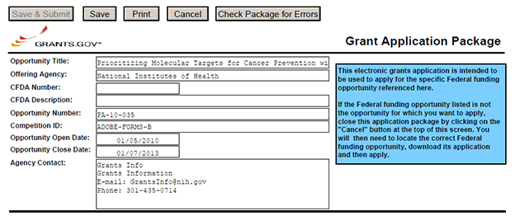
CFDA Number Field: Many FOAs include multiple CFDA (Catalog for Domestic Assistance) numbers. When this is the case, the CFDA Number and CFDA Description fields will appear blank in the Grants.gov Grant Application Package screen shown above. The appropriate CFDA number will be automatically assigned once the application is assigned to the appropriate agency awarding component.
Opportunity Open Date & Close Date Fields: Many FOAs posted by NIH and other PHS agencies include multiple submission/receipt dates and are active for several years. These announcements are posted in Grants.gov showing an Open/Close period that spans the entire active period of the announcement. Applicants should read the funding opportunity announcement carefully for specific submission/receipt dates. If specific dates are not referenced in the announcement, applicants should refer to the Standard Postmark/Submission Dates for Competing Applications found in Table 2.15-1. Submission Dates, Review, and Award Cycles. Applications submitted after a posted submission date will normally not be held over into the next review cycle. Instead, the PD/PI will be notified and will have to submit the application again. See Section 2.14 of this Guide for more information on the late application policy.

3.2 Enter the Name for the Application
Enter a name for the application in the Application Filing Name field (this is a required field). This name is for use solely by the applicant for tracking the application through the Grants.gov submission process. It is not used by the receiving agency.

3.3 Open and Complete Mandatory Documents
Open and complete all of the documents listed in the Mandatory Documents box. Complete the form titled SF424 (R&R) first. Data entered in this form populates other mandatory and optional forms where applicable.
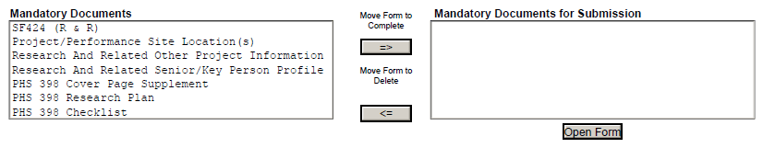
To open an item:
1. Click the form name in the Mandatory Documents box.
2. Click Move Form to Complete.
3. Click the form name in the Mandatory Documents for Submission box and click Open Form.
4. To remove a form from the Mandatory Documents for Submission box, click the form name to select it and then click the Move Form to Delete box. This returns the form to the Mandatory Documents box.

3.4 Open and Complete Optional Documents
These documents can be used to provide additional information for the application or may be required for specific types of grant activities. Information on each of these documents is found later in these instructions.

3.5 Submitting the Application via Grants.gov
Once you have properly completed all required documents and attached any required or optional documentation, click on the Check Package for Errors button to ensure that you have successfully completed all required data fields. If any of the required fields are not completed you will receive an error notice which will indicate where revision is needed within your package. Correct any errors or if none are found, save the application package. The Save & Submit button will now become active and clicking this button will begin the application submission process. Only after the package has been saved with no errors will the Save & Submit button become active. The application package must then be saved once more before the submission process begins. Only an AOR will be able to perform the submit action, and they will be taken to the applicant login page to enter the Grants.gov username and password that was established in the Register with Grants.gov process (if not connected to the internet you will be instructed to do so).

4. Completing the SF424 Research and Related (R&R) Forms

4.1 Overview
This section contains all of the instructions you will need to complete the SF424 (R&R) forms.
Any agency-specific instructions are denoted by the DHHS logo displayed to the left of the paragraph, as illustrated here.
Conformance to all instructions is required and strictly enforced. Agencies may withdraw any applications from the review process that are not consistent with these instructions.
As you navigate through the forms, required fields are highlighted in yellow, outlined in red, and noted with an asterisk (*). Optional fields and completed fields are displayed in white. Data entered into a specific field is not accepted until you have navigated to the next field. If you enter invalid or incomplete information in a field, you will receive an error message.
Note the highlighted fields required for submissions, and the Check Package for Errors button, only refer to requirements and errors in the actual Adobe Reader forms. They do not refer to requirements or data errors against PHS business processes. Those validations will be performed by the eRA Commons system after the application has been submitted.
For those forms that are more than one page, click the Next button at the top of the form or scroll down (using the scroll bar on the right hand side of the screen) to navigate to a subsequent page. Once all data have been entered, scroll up using the scroll bar to return to the Grant Application Package Screen.

4.2 Cover Form
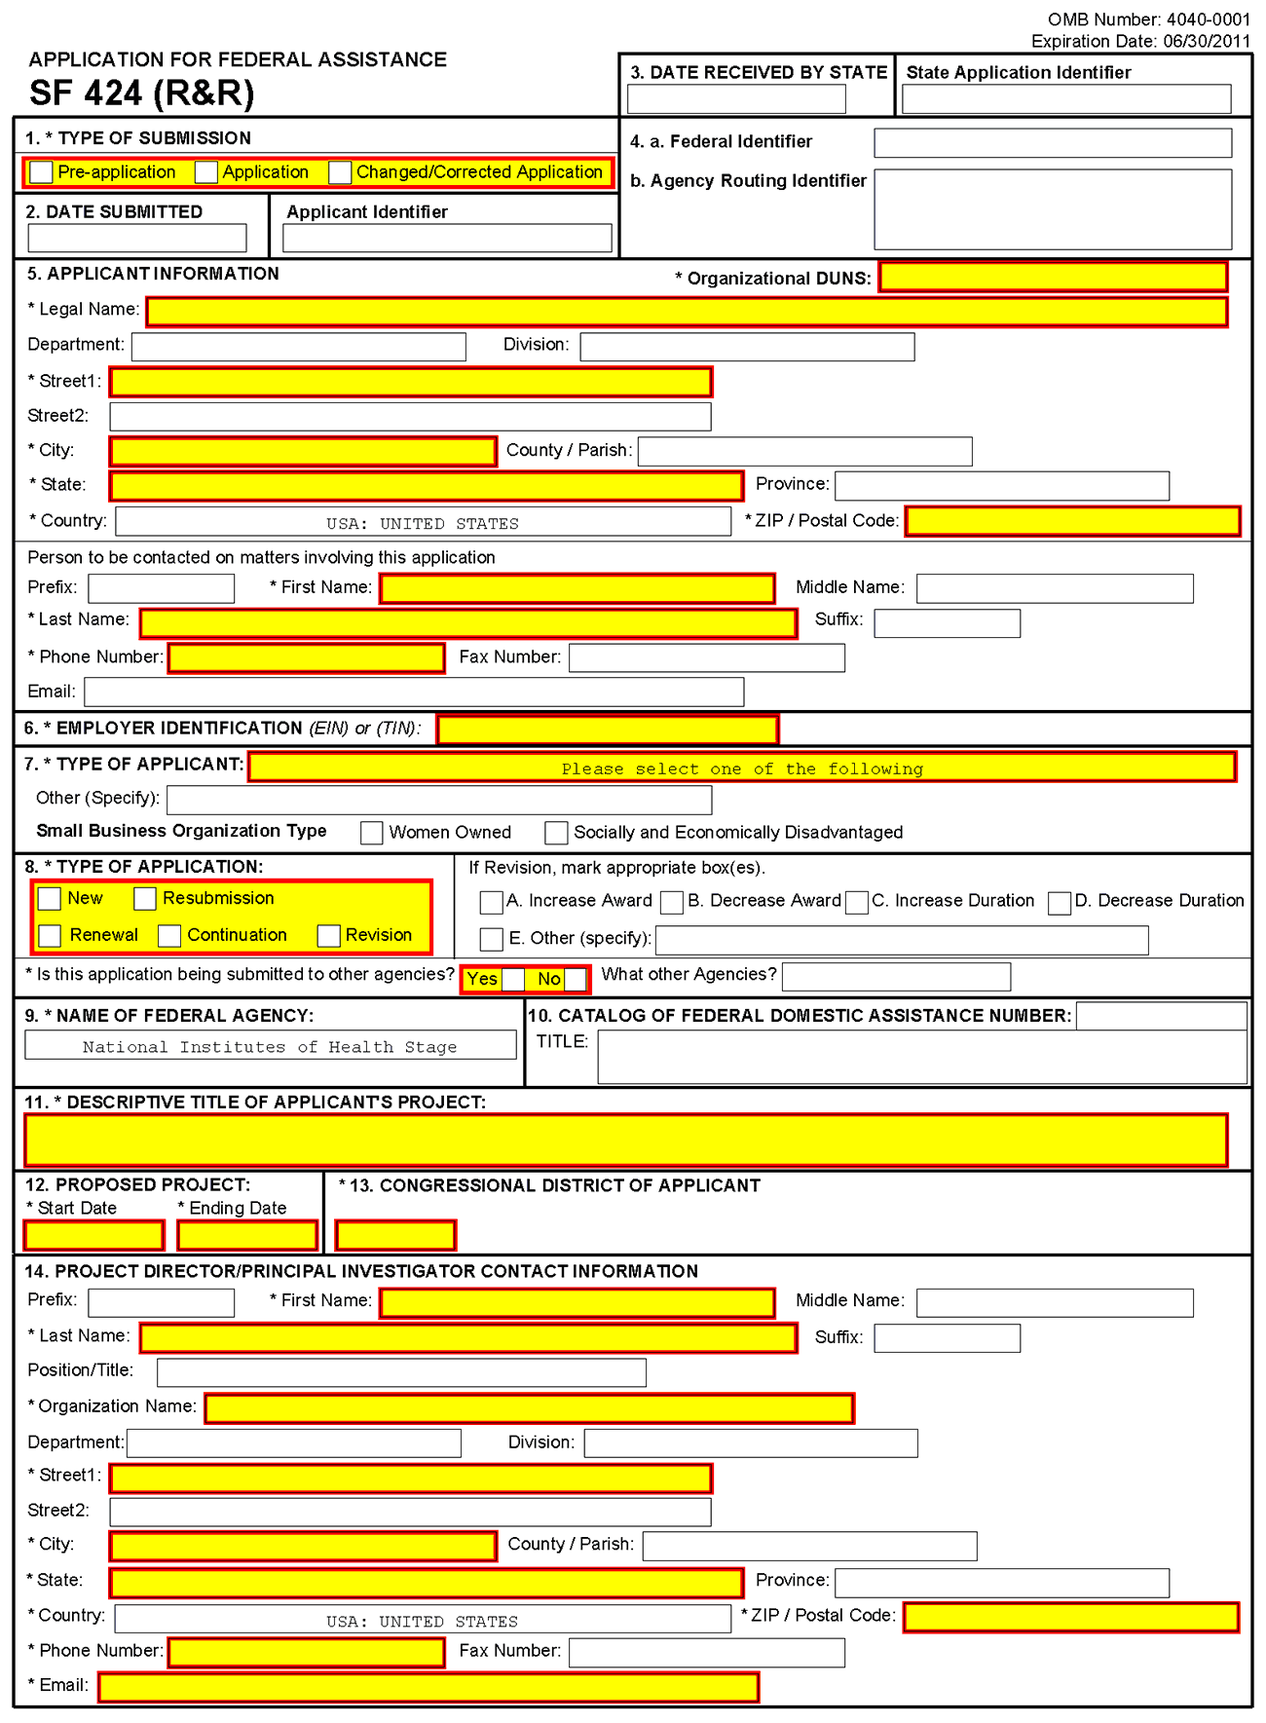
1. Type of Submission
Check one of the Type of Submission boxes. If this submission is to change or correct a previously submitted “New” application, click the Changed/Corrected Application box and enter the Grants.gov tracking number in the Federal Identifier field. If this submission is to change or correct a “resubmission,” “renewal,” “continuation,” or “revision” application, leave the Federal Identifier field as previously filled with the existing identifier (e.g., Award number). Do NOT insert the Grants.gov tracking number in these cases.
Unless requested by the agency, applicants may not use this to submit changes after the closing date. This field is required.
Pre-Application: Unless specifically noted in a program announcement, the Pre-application option is not used by NIH and other PHS agencies.
Changed/Corrected Application: This box must be used if you need to submit the same application again because of corrections for system validation errors or if a portion of the application was lost or distorted during the submission process. This option is for correcting system validation errors only and may not be used to include last minute changes to any of the PDF attachments. When submitting a Changed/Corrected Application:
  - If submitting after the submission date, include an explanation in the Cover Letter Form. Note that if you are submitting additional grant application materials after the submission date some special guidelines may apply. See NIH Guide Notice NOT-OD-08-082 (http://grants.nih.gov/grants/guide/notice-files/not-od-08-082.html) for the NIH Policy on Submission of Additional Grant Application Materials.
  - When you check the Changed/Correct Application box, Item 4a. Federal Identifier becomes a required field.
  - When submitting a Changed/Corrected Application for a “New” Type of Application (Item 8 = New), in the Federal Identifier field (Item 4a)) enter the Grants.gov tracking number for the previous application that you are correcting. If you are unable to recall the Grants.gov tracking number, enter “N/A.”
  - When submitting a Changed/Corrected Application for a “Resubmission”, “Renewal”, or “Revision” Type of Application (Item 8 = Resubmission, Renewal, or Revision), in the Federal Identifier field (Item 4a) enter the IC and serial number of the previously assigned application/award number (e.g., CA987654).
  - Do not use the Changed/Corrected Application box to denote a submission of a resubmission or amended application. That will be indicated in item 8. Type of Application.
SBIR/STTR Phase II applications may be submitted either before or after expiration of the Phase I budget period. However, Phase II grant applications should be submitted no later than the first six submission dates following expiration of the Phase I budget period.
Applicant small business concerns are reminded that Phase II funding is based on the results of Phase I, demonstration of feasibility, scientific, and technical merit, and commercial potential of the Phase II application. Applicants are cautioned that applications demonstrating insufficient results in Phase I may not receive a score in the peer review process.
2. Date Submitted and Applicant Identifier
Enter the date the application is submitted to Federal agency (or state, if applicable). In the Applicant Identifier field, enter the applicant’s control number (if applicable).
Note the Applicant Identifier field is a control number created by the applicant organization, not the Federal agency.
3. Date Received by State and State Application Identifier
Enter the date received by state (if applicable). In the State Application Identifier field, enter the state application identifier, if applicable.
For submissions to NIH and other PHS agencies, leave these fields blank.

4.a. Federal Identifier
New project applications should leave this field blank unless you are submitting a Changed/Corrected application or a New application following a Pre-Application. When submitting a Changed/Corrected “New” application, enter the Grants.gov tracking number. When a New Application is being submitted following a Pre-Application, enter the agency-assigned pre-application number, if applicable. If this is a resubmission, continuation, revision, or renewal application, enter the assigned Federal Identifier number (for example, award number)--even if submitting a Changed/Corrected application.
For submissions to NIH and other PHS agencies, include only the IC and serial number of the previously assigned application/award number (e.g., CA987654).
Existing definitions for NIH and other PHS agencies applications are somewhat different:
- New is the same; i.e., an application that is submitted for the first time. See also the policy Resubmission of Unpaid RFA Applications and Resubmission of Applications with a Changed Grant Activity Code.
- Resubmission is equivalent to NIH and other PHS agencies Revision; i.e., a revised or amended application. See also the NIH Policy on Resubmission Applications.
- Renewal is equivalent to NIH and other PHS agencies Competing Continuation.
- Continuation is equivalent to NIH and other PHS agencies Progress Report. For the purposes of NIH and other PHS agencies, the box for Continuation will not be used.
- Revision is somewhat equivalent to NIH and other PHS agencies Competing Supplement. Applicants should contact the awarding agency for advice on submitting any revision/supplement application.
Applicants to NIH and other PHS agencies should complete this field when submitting a resubmission, renewal or revision application. When submitting a “New” application, this field should remain blank unless you are submitting a Changed/Corrected Application. In this case, where Item 1 = Changed/Corrected Application and Item 8 = New, the Federal Identifier field becomes a required field. Therefore you must enter the Grants.gov tracking number assigned to the application that you are correcting. If you are unable to recall the tracking number, enter “N/A.” See instructions for “8. Type of Application.”
4.b. Agency Routing Identifier
Enter the agency-assigned routing identifier per the agency-specific instructions. Unless specifically noted in a program announcement, the Agency Routing Identifier is not used by NIH or other PHS agencies.
5. Applicant Information
This information is for the Applicant Organization, not a specific individual.
The small business concern is ALWAYS the applicant organization for an SBIR or STTR award (e.g., ABC Incorporated).
Field Name | Instructions
Organizational DUNS | Enter the DUNS or DUNS+4 number of the applicant organization. This field is required.  For submission to NIH and other PHS agencies, this DUNS must match the number entered in the eRA Commons Institutional Profile for the applicant organization. The applicant AOR is encouraged to confirm that a DUNS has been entered in the eRA Commons Institutional Profile prior to submitting an application. If your organization does not already have a DUNS number, you will need to go to the Dun & Bradstreet Web site at http://fedgov.dnb.com/webform to obtain the number.
Legal Name | Enter the legal name of the applicant which will undertake the assistance activity, enter the complete address of the applicant (including county/parish and country), and name, telephone number, e-mail, and fax of the person to contact on matters related to this application.
Department | Enter the name of the primary organizational department, service, laboratory, or equivalent level within the organization that will undertake the assistance activity.
Division | Enter the name of the primary organizational division, office, or major subdivision which will undertake the assistance activity.
Street1 | Enter the first line of the street address for the applicant in “Street1” field. This field is required.
Street2 | Enter the second line of the street address for the applicant in “Street2” field. This field is optional.
City | Enter the city for address of applicant. This field is required.
County/Parish | Enter the county or parish for address of applicant.
State | Enter the state where the applicant is located. This field is required if the applicant is located in the United States.
Province | Enter the province.  If “Country” is not Canada, please leave blank.
Country | Select the country for the applicant address.  For SBIR/STTR applications, the small business concern must be located in the United States.
ZIP Code | Enter the nine-digit postal code (e.g., ZIP code) of applicant. This field is required if the applicant is located in the United States. This field is required if a State is selected; optional for Province.

Person to be contacted on matters involving this application:
This information is for the Administrative or Business Official, not the PD/PI. This person is the individual to be notified if additional information is needed and/or if an award is made. To avoid potential errors and delays in processing, please ensure that the information provided in this section is identical to the AO profile information contained in the eRA Commons.
Field Name | Instructions
Prefix | Enter the prefix (e.g., Mr., Mrs., Rev.) for the person to contact on matters related to this application.  See also the PHS 398 Cover Page Supplement for additional required contact information.
First Name | Enter the first (given) name of the person to contact on matters related to this application. This field is required.
Middle Name | Enter the middle name of the person to contact on matters related to this application.
Last Name | Enter the last (family) name of the person to contact on matters related to this application. This field is required.
Suffix | Enter the suffix (e.g., Jr., Sr., Ph.D.) for the person to contact on matters related to this application.
Phone Number | Enter the daytime phone number for the person to contact on matters related to this application. This field is required.
Fax Number | Enter the fax number for the person to contact on matters related to this application.
E-mail | Enter the e-mail address for the person to contact on matters related to this application.  Provide only one e-mail address. This is a required field for applications submitted to NIH and other PHS agencies.
6. Employer Identification
Enter either TIN or EIN as assigned by the Internal Revenue Service. If your organization is not in the U.S., enter 44-4444444. This field is required.
If you have a 12-digit EIN established for grant awards from NIH or other PHS agencies, enter all 12digits (e.g., 1123456789A1). For SBIR/STTR applications, the small business concern must be located in the United States.
7. Type of Applicant
This information is for the Applicant Organization, not a specific individual AOR or PD/PI.

Field Name | Instructions
Type of Applicant | Select from the menu or enter the appropriate letter in the space provided. If Small Business is selected as Type of Applicant, then note if the organization is “Woman-owned” and/or “Socially and Economically Disadvantaged.”  For SBIR/STTR applicant organizations, select R. Small Business.  The applicant organization must certify that it will qualify as a small business concern at the time of award.
Other (Specify) | Complete only if “Other” is selected as the Type of Applicant.
Woman Owned | Check if you are a woman-owned small business: a small business that is at least 51% owned by a woman or women, who also control and operate it.
Socially and Economically Disadvantaged | Check if you are a socially and economically disadvantaged small business, as determined by the U.S. Small Business Administration pursuant to Section 8(a) of the Small Business Act U.S.C. 637(a).
8. Type of Application
Field Name | Instructions
Type of Application | Select the type from the following list. Check only one. This field is required.  - New: An application that is being submitted to an agency for the first time.  - Resubmission: An application that has been previously submitted, but was not funded, and is being resubmitted for new consideration.  - Renewal: An application requesting additional funding for a period subsequent to that provided by a current award. A renewal application competes with all other applications and must be developed as fully as though the applicant is applying for the first time.  - Continuation: A non-competing application for an additional funding/budget period within a previously approved project period.  - Revision: An application that proposes a change in  1) the Federal Government’s financial obligations or contingent liability from an existing obligation, or  2) any other change in the terms and conditions of the existing award.  Existing definitions for NIH and other PHS agencies Type of Application are somewhat different:  New is the same. Check this option when submitting an application for the first time. See also the policy Resubmission of Unpaid RFA Applications and Resubmission of Applications with a Changed Grant Activity Code.  Resubmission is equivalent to NIH and other PHS agencies Revision. Check this option when submitting a revised (altered or corrected) or amended application. See also the NIH Policy on Resubmission Applications. Institutions submitting revision or renewal applications that are also resubmissions (A1 or A2 if allowed, see NIH Grant Notice NOT-OD-09-003, http://grants.nih.gov/grants/guide/notice-files/not-od-09-003.html) are instructed to select “Resubmission.” For additional information, see NIH Guide Notice NOT-OD-10-052, http://grants.nih.gov/grants/guide/notice-files/not-od-10-052.html).  Renewal is equivalent to NIH and other PHS agencies Competing Continuation.  Continuation is equivalent to NIH and other PHS agencies Progress Report. For the purposes of NIH and other PHS agencies, the box for Continuation will not be used and should not be checked.  Revision is somewhat equivalent to NIH and other PHS agencies Supplement, but would also include other changes as noted in the definition above. In general, changes to the “terms and conditions of the existing award” (as noted in example 2 above) would not require the submission of another application through Grants.gov. Applicants should contact the awarding agency for advice on submitting any revision/supplement application.  This field also affects how you complete Item 4a. Federal Identifier. If “Type of Application” is “New”, you can leave the Federal Identifier field blank on the first submission attempt. However, the Federal Identifier field becomes a required field when submitting a Changed/Corrected application to address errors/warnings. When submitting a Changed/Corrected “New” application, enter the Grants.gov tracking number of the previous submission attempt (e.g. GRANT87654321). If you are unable to find the tracking number, enter “N/A”.  If “Type of Application” is “Renewal,” “Revision,” or “Resubmission,” enter the IC and serial number of the previously assigned application/award number (e.g. CA987654). For these types of applications, do not change the Federal Identifier field when submitting Changed/Corrected applications.
If Revision, mark appropriate box(es) | If Revision, mark appropriate box(es). May select more than one:  A. Increase Award  B. Decrease Award  C. Increase Duration  D. Decrease Duration  E. Other  If “Other” is selected, please specify in the text box provided.  For the purposes of NIH and other PHS agencies, the boxes for options B, C, D, and E will generally not be used and should not be selected unless specifically addressed in a particular FOA.
Other | If “Other” is selected for Revision, add text to explain.
Is this application being submitted to other agencies? | Check applicable box. This field is required.  In the field “Is this application being submitted to other agencies?,” please check the box “yes” if one or more of the specific aims submitted in your application are also contained in a similar, identical, or essentially identical application submitted to another Federal agency. Indicate the agency or agencies to which the application has been submitted. For additional information, please see NIH Guide Notice NOT-OD-09-100, Reminder and Clarification of NIH Policies on Similar, Identical, or Essentially Identical Applications, Submission of Applications Following RFA Review, and Submission of Applications with a Changed Activity Code, http://grants.nih.gov/grants/guide/notice-files/NOT-OD-09-100.html.
What Other Agencies? | Enter Agency name.
9. Name of Federal Agency
Name the Federal agency from which assistance is being requested with this application. This information is pre-populated by Grants.gov.
10. Catalog of Federal Domestic Assistance (CFDA) Number and Title (CFDA)
Use the Catalog of Federal Domestic Assistance number and title of the program under which assistance is requested. This information is pre-populated by Grants.gov.
This field may be blank if you are applying to an opportunity that references multiple CFDA numbers. When this field is blank, leave it blank; the field will not allow any data entry. The appropriate CFDA number will be automatically assigned by the agency once the application is assigned to the appropriate awarding component.
11. Descriptive Title of Applicant’s Project
Enter a brief descriptive title of the project. This field is required.
A “new” application must have a different title from any other PHS project with the same PD/PI. A “resubmission” or “renewal” application should normally have the same title as the previous grant or application. If the specific aims of the project have significantly changed, choose a new title.
A “revision” application must have the same title as the currently funded grant.
NIH and other PHS agencies limit title character length to 81 characters, including the spaces between words and punctuation. Titles in excess of 81 characters will be truncated. Be sure to only use standard characters in the descriptive title: A through Z, a through z, 0 through 9, and underscore (_).
An SBIR/STTR Phase II application should have the same title as the previously awarded Phase I grant.
12. Proposed Project
Start Date: Enter the proposed start date of the project. This field is required.
Ending Date: Enter the proposed ending date of the project. This field is required.
Phase I: Routinely, SBIR Phase I awards do not exceed six (6) months and STTR Phase I awards do not exceed one year.
Phase II: Routinely, SBIR and STTR Phase II awards do not exceed two years.
Under special circumstances, applicants to NIH may propose longer periods of time for completion of the research project (e.g., feasibility demonstration). Such requests that deviate from the guidelines must be thoroughly justified. Project duration deviations apply to NIH ONLY, as CDC, FDA, and ACF do not make awards for periods longer than the stated guidelines.
13. Congressional District of Applicant
Enter the Congressional District in the format: 2 character State Abbreviation – 3 character District Number. Examples: CA-005 for California’s 5th district, CA-012 for California’s 12th district.
If outside the U.S., enter 00-000.
To locate your congressional district, visit the Grants.gov Web site.
For States and U.S. territories with only a single congressional district enter “001” for the district code. For jurisdictions with no representative, enter “099”. For jurisdictions with a nonvoting delegate, enter “098” for the district number. Example: DC-098, PR-098.
14. Program Director/Principal Investigator (PD/PI) Contact Information
If submitting an application reflecting Multiple PD/PIs, the individual designated as the Contact PI must be affiliated in the Commons with the applicant organization should be entered here. See Section 4.5 Senior/Key Person Profile Forms for additional instructions for Multiple PD/PIs. To avoid potential errors and delays in processing, please ensure that the information provided in this section is identical to the PD/PI profile information contained in the eRA Commons.
Name the one person responsible to the applicant small business concern for the scientific and technical direction of the project if a single PD/PI application, or the contact PD/PI for a multiple PD/PI application. PHS staff conduct official business only with the named PD/PIs and organizational/institutional officials. A revision/supplemental application must have the same PD/PI as the currently funded grant.

Field Name | Instructions
Prefix | The Project Director/Principal Investigator (PD/PI) is the individual responsible for the overall scientific and technical direction of the project. Enter the prefix of the PD/PI.  See also the PHS 398 Cover Page Supplement for additional PD/PI required data.
First Name | Enter the first name of the PD/PI. This field is required.
Middle Name | Enter the middle name of the PD/PI.
Last Name | Enter the last name of the PD/PI. This field is required.
Suffix | Enter the suffix of the PD/PI.  Do not use this field to record degrees. Degrees for the PD/PI are requested separately in the PHS 398 Cover Page Supplement.
Position/Title | Enter the Position/title of the PD/PI.
Organization Name | Enter the organization name of the PD/PI.
Department | Enter the department of the PD/PI.
Division | Enter the division of the PD/PI.
Street1 | Enter first line of the street address for the PD/PI in the “Street1” field. This field is required.
Street2 | Enter the second line of the street address for the PD/PI in the “Street2” field. This field is optional.
City | Enter the city for address of the PD/PI . This field is required.
County/Parish | Enter the county or parish for address of the PD/PI.
State | Enter the state where the PD/PI is located. This field is required if the PD/PI is located in the United States.
Province | Enter the Province for PD/PI.  If “Country” is not Canada, please leave blank.
Country | Select the country for the PD/PI address.
ZIP/Postal Code | Enter the nine-digit Postal Code (e.g., ZIP Code) of the PD/PI. This field is required if the PD/PI is located in the United States.
Phone Number | Enter the daytime phone number for the PD/PI. This field is required.
Fax Number | Enter the fax number for the PD/PI.
E-mail | Enter the e-mail address for the PD/PI. This field is required.

Program Director/Principal Investigator Criteria

SBIR
Under the SBIR program, for both Phase I and Phase II, the primary employment of the PD/PI must be with the small business concern at the time of award and during the conduct of the proposed project. Primary employment means that more than one half (51% or greater) of the PD/PI’s time is spent in the employ of the small business concern. Primary employment with a small business concern precludes full-time employment at another organization. Occasionally, deviations from this requirement may occur. Such deviations must be approved in writing by the grants management officer after consultation with the NIH SBIR/STTR Program Coordinator.
For Multiple PD/PI applications: The first PI listed must be affiliated with the applicant small business concern organization submitting the application and will serve as the contact PD/PI. For both SBIR Phase I and SBIR Phase II, the primary employment of the “Contact PD/PI” must be with the small business concern at the time of award and during the conduct of the proposed project. As noted above, occasionally, deviations from this requirement may occur. Such deviations must be approved in writing by the grants management officer after consultation with the NIH SBIR/STTR Program Coordinator.
As defined in 42 CFR 52, the PD/PI(s) is or are the “…individual(s) judged by the applicant organization to have the appropriate level of authority and responsibility to direct the project or program supported by the grant and who is or are responsible for the scientific and technical direction of the project.” When the proposed PD/PI clearly does not have sufficient qualifications to assume this role, the application is not likely to receive a favorable evaluation.
If the application has the likelihood for funding, the awarding component will require documentation to verify the eligibility of the PD/PI, if at the time of submission of the application, the PD/PI is a less-than-full-time employee of the small business concern, is concurrently employed by another organization, or gives the appearance of being concurrently employed by another organization, whether for a paid or unpaid position.
If the PD/PI is employed or appears to be employed by an organization other than the applicant organization in a capacity such as Research Fellow, Consultant, Adjunct Professor, Clinical Professor, Clinical Research Professor, or Associate, a letter must be provided by each employing organization confirming that, if an SBIR grant is awarded to the applicant small business concern, the PD/PI is or will become a less-than-half-time employee of such organization and will remain so for the duration of the SBIR project. If the PD/PI is employed by a university, such a letter must be provided by the Dean's office or equivalent; for other organizations, the letter must be signed by a corporate official.
This requirement applies also to those individuals engaged currently as the PD/PI on an active SBIR project. All current employment and all other appointments of the PD/PI must be identified in his or her “Biographical Sketch” required as part of the application. Be certain that correct beginning and ending dates are indicated for each employment record listed.

STTR
The PD/PI must commit a minimum of 10% (1.2 calendar months) effort to the project and the PD/PI must have a formal appointment with or commitment to the applicant small business concern, which is characterized by an official relationship between the small business concern and that individual. Such a relationship does not necessarily involve a salary or other form of remuneration. In all cases, however, the PD/PI’s official relationship with the grantee must entail sufficient opportunity for the PD/PI to carry out his or her responsibilities for the overall scientific and technical direction of the project. Documentation (e.g., consortium and contractual arrangements) describing the official relationship of the PD/PI with the applicant small business concern should NOT be submitted with the grant application, but a copy must be furnished upon the request of the NIH awarding component.
For Multiple PD/PI applications: The first PD/PI listed must be affiliated with the applicant small business concern and will serve as the Contact PD/PI. For STTR, the Contact PD/PI may be from either the SBC or the single partnering research institution. Note: the Contact PD/PI must have a formal appointment with or commitment to the SBC, which must be in the form of an official relationship between the parties, but need not include a salary or other form of remuneration.
Following is guidance for such documentation, which is required prior to award: The letter should be prepared on the letterhead of the independent PD/PI and addressed to the Small Business Concern (SBC). One page is recommended. At a minimum, each letter should (1) verify the PD/PI’s commitment to the project; (2) refer to the specific project by name; and (3) specify what assets or services the PI will contribute (e.g. expertise, number of hours/ percent of effort) as well as the PD/PI’s remuneration. The letter should also indicate that the PD/PI and the SBC have reached an agreement on proprietary interests for the project to continue to move forward (e.g., intellectual property).
Signatures of the Authorized Organization Representative (a.k.a. Signing Official) for the applicant organization on the SF424 (R&R) Cover form (Item 17) and the signature of the duly authorized representative of the research institution certifies, among other things, that the PD/PI has a formal relationship with/commitment to the small business concern when the PD/PI is an employee of the Research Institute (RI).
The following are examples of situations describing the official relationship of the PD/PI with the applicant small business organization:
- PD/PI with a full-time, university appointment may also have appointments with other organizations (with or without salary) and still appropriately consider his or her commitment to the university to be “full-time,” consistent with the personnel policies and procedures of the university applied on a routine basis. The PD/PI’s commitment to the university and other organizations (including the applicant small business concern) cannot exceed 100% of his or her total professional effort.
- PD/PI with a full-time, 12-month appointment with a small business concern would be considered to have a commitment to the applicant organization of 100% of his or her total professional effort.
- PD/PI who has a part-time appointment with a small business concern and has concurrent commitments or appointments with organizations in addition to the small business concern would deem each commitment as a portion of 100% of his or her total professional effort.
As responsible stewards of funds, the NIH is concerned that the PD/PI has the time available to carry out the proposed STTR research activities. Therefore, it should be clear in the application that the time proposed for the PD/PI on a particular project is reasonable and it should be clear that the PD/PI has sufficient time (minimum 10% effort, which is 1.2 calendar months) from among his or her total professional commitments to devote to this project.
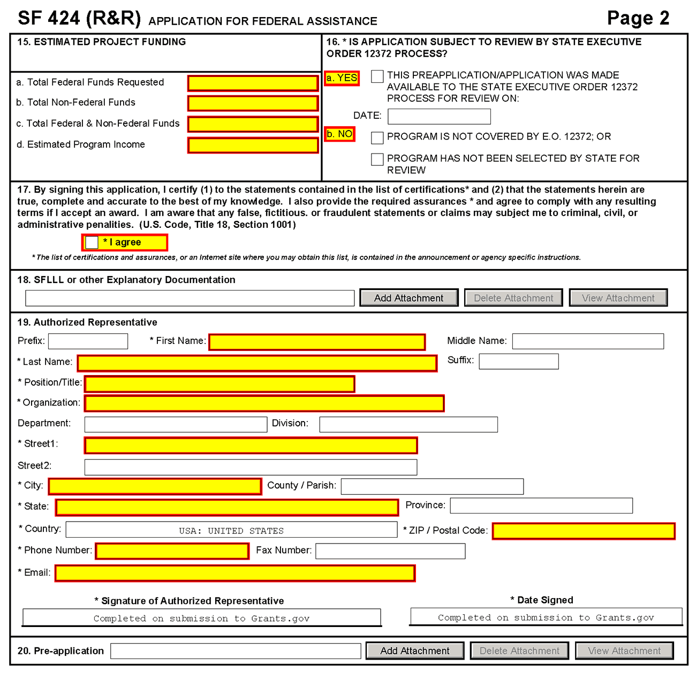
15. Estimated Project Funding
Field Name | Instructions
a. Total Federal Funds Requested | Enter the total Federal funds, including Direct Costs, F&A Costs (Indirect Costs), and Fee, requested for the entire project period.  According to statutory guidelines, total funding support (direct costs, indirect costs, fee) normally may not exceed $150,000 for Phase I awards and $1,000,000 for Phase II awards. With appropriate justification from the applicant, Congress will allow awards to exceed these amounts by up to 50% ($225,000 for Phase I and $1,500,000 for Phase II, a hard cap). As written in the statute and under appropriate circumstances, NIH can apply for a waiver from SBA to issue an award exceeding $225,000 for Phase I or $1,500,000 for Phase II, if this hard cap will interfere with NIH‘s ability to meet its mission. Award waivers from the SBA are not guaranteed and may delay the release of funds. Applicants are strongly encouraged to contact NIH program officials prior to submitting any award in excess of the guidelines. In all cases, applicants should propose a budget that is reasonable and appropriate for completion of the research project. NOTE: CDC, FDA, and ACF do not make awards above these statutory guidelines.
b. Total Non-Federal Funds | Enter total non-Federal funds proposed for the entire project period.  For applications to NIH and other PHS agencies, enter “0” in this field unless cost sharing is a requirement for the specific announcement.
c. Total Federal & Non-Federal Funds | Enter total estimated funds for the entire project period, including both Federal and non-Federal funds. This is required information.  For NIH and other PHS agencies applicants, this field will be the same as item 15a unless the specific announcement indicates that cost sharing is a requirement.
d. Estimated Program Income | Identify any Program Income estimated for this project period, if applicable. This field is required.
16. Is Application Subject to Review by State Executive Order 12372 Process?
If yes, check box. If the announcement indicates that the program is covered under Executive Order 12372, applicants should contact the State Single Point of Contact (SPOC) for Federal Executive Order 12372. If no, check appropriate box.
If block 16a is checked, insert date application was submitted to State.
For NIH and other PHS agencies submissions using the SF424 (R&R), applicants should check “No, Program is not covered by E.O. 12372.”
17. Certification
Check “I agree” to provide the required certifications and assurances. This field is required.
The list of NIH and other PHS agencies Assurances, Certifications, and other Policies is found in Supplemental Instructions Part III, Policies, Assurances, Definitions, and Other Information.
The applicant organization is responsible for verifying its eligibility and the accuracy, validity, and conformity with the most current institutional guidelines of all the administrative, fiscal, and scientific information in the application, including the Facilities and Administrative rate. Deliberate withholding, falsification, or misrepresentation of information could result in administrative actions, such as withdrawal of an application, suspension and/or termination of an award, debarment of individuals, as well as possible criminal penalties. The signer further certifies that the applicant organization will be accountable both for the appropriate use of any funds awarded and for the performance of the grant-supported project or activities resulting from this application. The grantee institution may be liable for the reimbursement of funds associated with any inappropriate or fraudulent conduct of the project activity.
18. SFLLL or Other Explanatory Documentation
If applicable, attach the SFLLL or other explanatory document per agency instructions.
If unable to certify compliance in Item 17 (above), attach an explanation. Additionally, as applicable, attach the SFLLL (Standard Form LLL, Disclosure of Lobbying Activities) or other documents in this item. A fillable version of the SFLLL form is available at http://www.whitehouse.gov/omb/assets/omb/grants/sflllin.pdf.
19. Authorized Representative
This is equivalent to the individual with the organizational authority to sign for an application; otherwise known as the Authorized Organization Representative or the Signing Official.
Field Name | Instructions
Prefix | Enter the prefix (Mr., Mrs., Rev.) for the name of the Authorized Representative.
First Name | Enter the first (given) name of the Authorized Representative. This field is required.
Middle Name | Enter the middle name of the Authorized Representative.
Last Name | Enter the last (family) name of the Authorized Representative. This field is required.
Suffix | Enter the suffix (e.g., Jr., Sr., Ph.D.) for the name of the Authorized Representative.
Position/Title | Enter the title of the Authorized Representative. This field is required.
Organization | Enter the name of the organization for the Authorized Representative. This field is required.
Department | Enter the name of the primary organizational department, service, laboratory, or equivalent level within the organization of the Authorized Representative.
Division | Enter the name of the primary organizational division, office, or major subdivision of the Authorized Representative.
Street1 | Enter the first line of the street address for the Authorized Representative in the “Street1” field. This field is required.
Street2 | Enter the second line of the street address for the Authorized Representative in the “Street2” field. This field is optional.
City | City for address of the Authorized Representative. This field is required.
County/Parish | Enter the county or parish for address of the Authorized Representative.
State | Enter the State where the Authorized Representative is located. This field is required if the Authorized Representative is located in the United States.
Province | Enter the Province for the Authorized Representative.  If “Country” is not Canada, please leave blank.
Country | Select the country for the Authorized Representative address.
ZIP/Postal Code | Enter the nine-digit Postal Code (e.g., ZIP Code) of the Authorized Representative. This field is required if the Authorized Representative is located in the United States.
Phone Number | Enter the daytime phone number for the Authorized Representative. This field is required.
Fax Number | Enter the fax number for the Authorized Representative.
E-mail | Enter the e-mail address for the Authorized Representative. This field is required.
Signature of Authorized Representative | It is the organization’s responsibility to assure that only properly authorized individuals sign in this capacity and/or submit the application to Grants.gov. If this application is submitted through Grants.gov, leave blank. If a hard copy is submitted, the AOR must sign this block.
Date Signed | If this application is submitted through Grants.gov, the system will generate this date. If submitting a hard copy, enter the date the AOR signed the application.
20. Pre-Application
If you are submitting a pre-application, provide a summary description of the project in accordance with the announcement and/or agency specific instructions, and save the file in a location you remember. Click Add Attachment, browse to where you saved the file, select the file, and then click Open.
Unless specifically noted in a program announcement, NIH and other PHS agencies do not use Pre-applications.

Once all data have been entered, use the scroll bar to scroll up. You will be returned to the Grant Application Package screen. To remove a document from the Submission box, click the document name to select it and then click the Move Form to Delete button. This will return the document to the Mandatory Documents Submission List or Optional Documents Submission List.

4.3 Project/Performance Site Locations Form
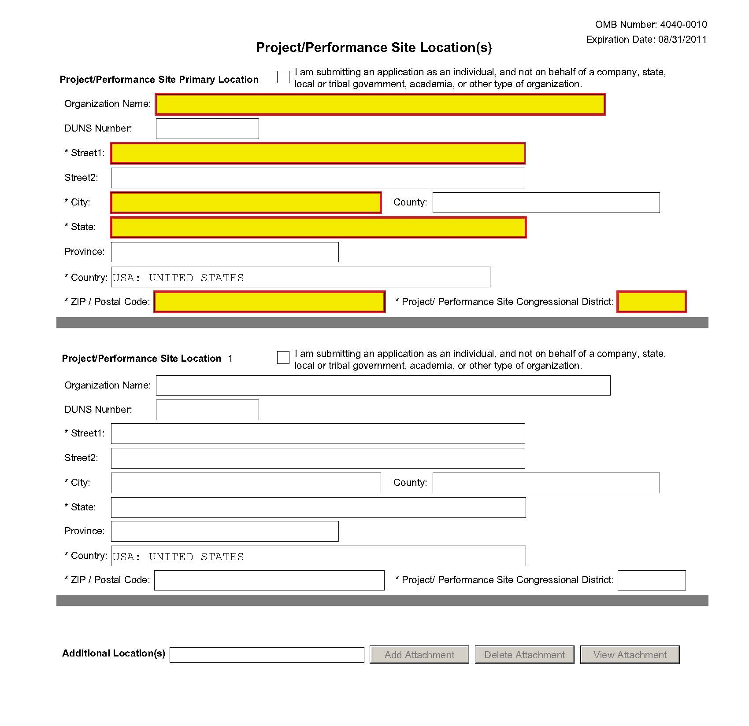
Indicate the primary site where the work will be performed. If a portion of the project will be performed at any other site(s), identify the site location(s) in the blocks provided.
Project/Performance Site Primary Location
Generally, the Primary Location should be that of the applicant organization or identified as off-site in accordance with the conditions of the applicant organization’s negotiated Facilities and Administrative (F&A) agreement. This information must agree with the F&A information on the Checklist Form Page of the application If there is more than one performance site, including any Department of Veterans Affairs (VA) facilities and foreign sites, list them in the fields provided for Location 1 - # below. Applicants should also provide an explanation of resources available from each Project/Performance Site in Item 10, Facilities and Resources of the Other Project Information form, and describe any consortium/contractual arrangements in Item 13 of the PHS 398 Research Plan.
Do not check the “I am submitting an application as an individual, and not on behalf of a company, state, local or tribal government, academia, or other type of organization” box.
If a Project/Performance Site is engaged in research involving human subjects, the applicant organization is responsible for ensuring that the Project/Performance Site operates under an appropriate Federal Wide Assurance for the protection of human subjects and complies with 45 CFR part 46 and other NIH human subject related policies described in Supplemental Instructions Part II of this Application Guide and in the NIH Grants Policy Statement.
For research involving live vertebrate animals, the applicant organization must ensure that all Project/Performance Sites hold an OLAW-approved Animal Welfare Assurance. If the applicant organization has neither an animal care and use program, facilities to house animals and conduct research on site, nor an IACUC, and the animal work will be conducted at an institution with an Animal Welfare Assurance, the applicant must obtain an Inter-institutional Assurance from OLAW prior to an award.
For SBIR/STTR applications, one of the performance sites indicated must be that of the applicant small business concern.
For both Phase I and Phase II, the research or R&D project activity must be performed in the United States. However, based on a rare and unique circumstance, for example, if a supply or material or the study design (e.g., patient population) is not available in the United States, NIH may allow that particular portion of the research or R&D work to be performed or obtained in a foreign country. Investigators must thoroughly justify the use of these sites in the application. These rare and unique situations will be considered on a case-by-case basis, and they should be discussed with NIH staff prior to submission of the application. Approval by the funding officer for such specific condition(s) must be in writing prior to issuance of an award. Whenever possible, non-SBIR/STTR funds should be used for other work outside of the United States that is necessary to the overall completion of the project.
The research and analytical work performed by the grantee organization is to be conducted in research space occupied by, available to, and under the control of the SBIR/STTR grantee for the conduct of its portion of the proposed project. However, when required by the project activity, access to special facilities or equipment in another organization is permitted, as in cases where the SBIR/STTR awardee has entered into a subcontractual agreement with another institution for a specific, limited portion of the research project.
Whenever a proposed SBIR/STTR project is to be conducted in facilities other than those of the applicant organization, the awarding component will request that the small business concern provide a letter from the organization stating that leasing/rental arrangements have been negotiated for appropriate research space. This letter must be signed by an authorized official of the organization whose facilities are to be used for the SBIR/STTR project and must certify that the small business concern (grantee organization) will have access to and control over the research space. In addition, the letter must include a description of the facilities and, if appropriate, equipment that will be leased/rented to the grantee organization. (If the letter is included with the application, it is excluded from the page limitations.) Attach this letter to the PHS 398 Research Plan Form, Item 13, Consortium/Contractual Arrangements.

Field Name | Instructions
Organization Name | Indicate the organization name of the primary site where the work will be performed.
DUNS Number | Enter the DUNS number associated with the organization where the project will be performed.  The DUNS Number is a required field for the Primary Performance Site.
Street1 | Enter first line of the street address of the primary performance site location. This field is required.
Street2 | Enter second line of the street address of the primary performance site location, if applicable.
City | Enter the city for address of the primary performance site location. This field is required.
County/Parish | Enter the county or parish of the primary performance site location.
State | Select the state of the primary performance site location. This field is not active until USA has been selected for the country. This field is required if the performance site location is in the United States.
Province | Enter the province of the primary performance site location.  If “Country” is not Canada, please leave blank.
Country | Select the country of the primary performance site location. This field is required.
ZIP Code | Enter the nine-digit postal code (e.g., ZIP code) of the performance site location. This field is required if the performance site location is in the United States.
Project/Performance Site Congressional District | Enter the Congressional District in the format: 2 character State Abbreviation – 3 character District Number. Examples: CA-005 for California’s 5th district, CA-012 for California’s 12th district.  If all districts in a state are affected, enter “all” for the district number. Example MD-all for all congressional districts in Maryland.  If nationwide (all districts in all states), enter US-all.  If the program/project is outside the U.S., enter 00-000.  To locate your congressional district, visit the Grants.gov Web site. Note it is likely this field will be identical to the “Congressional District of Applicant” field provided elsewhere in the application.  For States and U.S. territories with only a single congressional district enter “001” for the district code. For jurisdictions with no representative, enter “099”. For jurisdictions with a nonvoting delegate, enter “098” for the district number. Example: DC-098, PR-098.
Project/Performance Site Location 1
Field Name | Instructions
Organization Name | Enter the name of organization of the performance site location.
DUNS Number | Enter the DUNS number associated with the organization where the project will be performed.
Street1 | Enter first line of the street address of the performance site location. This field is required.
Street2 | Enter second line of the street address of the performance site location, if applicable.
City | Enter the city of the performance site location. This field is required.
County/Parish | Enter the county or parish of the performance site location.
State | Select the state where the performance site is located. This field is not active until USA has been selected for the country. This field is required if the performance site location is in the United States.
Province | Enter the province of the performance site location.  If “Country” is not Canada, please leave blank.
Country | Select the country for the performance site location. This field is required.
ZIP Code | Enter the nine-digit postal code (e.g., ZIP code) of the performance site location. This field is required if the performance site location is in the United States.
Project/Performance Site Congressional District | Enter the Congressional District in the format: 2 character State Abbreviation – 3 character District Number. Examples: CA-005 for California’s 5th district, CA-012 for California’s 12th district.  If all districts in a state are affected, enter “all” for the district number. Example MD-all for all congressional districts in Maryland.  If nationwide (all districts in all states), enter US-all.  If the program/project is outside the U.S., enter 00-000.  To locate your congressional district, visit the Grants.gov Web site. Note it is likely this field will be identical to the “Congressional District of Applicant” field provided elsewhere in the application.  For States and U.S. territories with only a single congressional district enter “001” for the district code. For jurisdictions with no representative, enter “099”. For jurisdictions with a nonvoting delegate, enter “098” for the district number. Example: DC-098, PR-098.
For additional performance site locations, click Next Site to display the fields for Project/Performance Site Locations 3 through 30.
If you need to add more than thirty locations, enter the information in a separate file. In the Additional Locations section at the bottom of the form, click Add Attachment, select the file, and then click Open. A sample Additional Performance Sites format page for greater than eight locations is found under “Additional Format Pages” at: http://grants.nih.gov/grants/funding/424/index.htm.

Once all data have been entered, use the scroll bar to scroll up. You will be returned to the Grant Application Package screen. To remove a document from the Submission box, click the document name to select it and then click the Move Form to Delete button. This will return the document to the Mandatory Documents Submission List or Optional Documents Submission List.

4.4 Other Project Information Form
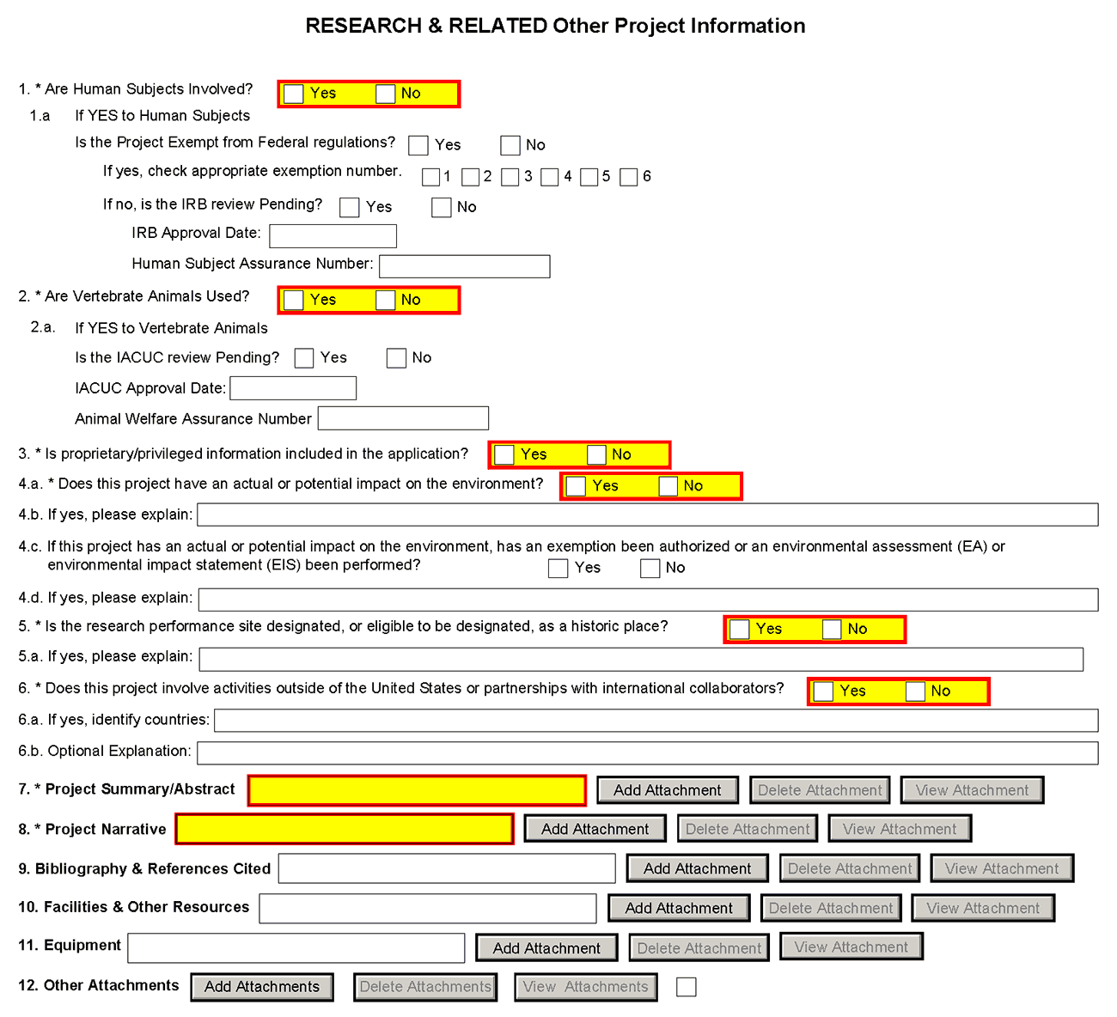
1. Are Human Subjects Involved?
If activities involving human subjects are planned at any time during the proposed project at any performance site, check yes. Check Yes even if the proposed project is exempt from Regulations for the Protection of Human Subjects. If activities involving human subjects are not planned at any time during the proposed project at any performance site, select no and skip the rest of block 1. This field is required.
Applications proposing human subjects research may be required to submit additional information, forms, or attachments with the application, in accordance with NIH and PHS policies covering human subjects research. Refer to Part II, Supplemental Instructions for Preparing the Human Subjects Section of the Research Plan.
1.a. If YES to Human Subjects
Exemption Number
Is the Project Exempt from Federal Regulations? Yes/No
Yes: If the project is exempt from Federal regulations, check Yes. If yes, check the appropriate exemption number.
No: If the project is not exempt from Federal regulations, check No.
If yes, check appropriate exemption number 1, 2, 3, 4, 5, 6
Select the appropriate exemption number from 1, 2, 3, 4, 5, 6.
If human subject activities are exempt from Federal regulations, provide the exemption numbers corresponding to one or more of the exemption categories. The six categories of research that qualify for exemption from coverage by the regulations are defined in the Common Rule for the Protection of Human Subjects. These regulations can be found at http://www.hhs.gov/ohrp/humansubjects/guidance/45cfr46.html.
OHRP guidance states that appropriate use of Exemptions described in 45 CFR 46 should be determined by an authority independent from the investigators (http://answers.hhs.gov/ohrp/categories/1564). Institutions often designate their IRB to make this determination. Because NIH does not require IRB approval at the time of application, the exemptions designated often represent the opinion of the PD/PI, and the justification provided for the exemption by the PD/PI is evaluated during peer review.
Proposed research may include more than one research project; thus the application may include individual projects that meet the requirements for non-exempt or exempt human subjects research, or are not defined as human subjects research. Human subjects research should be designated as exempt if all of the proposed research meets the criteria for one or more of the six exemptions.
If no, is the IRB review Pending? Yes/No
If IRB review is pending, check Yes. If IRB review is not pending, check No.
IRB Approval Date
Enter the latest Institutional Review Board (IRB) approval date (if available). Leave blank if Pending.
Applicants should check “Yes” to the question “Is the IRB review Pending?” even if the IRB review/approval process has not yet begun at the time of submission. Also note that an IRB Approval Date is not required at the time of submission. This may be requested later in the pre-award cycle as a Just-In-Time requirement.
Human Subject Assurance Number
Enter the approved Federal Wide Assurance (FWA) that the applicant has on file with the Office for Human Research Protections, if available. If the applicant has a FWA number, enter the 8-digit number. Do not enter the FWA before the number.
Insert “None” if the applicant organization does not have an approved assurance on file with OHRP. In this case, the applicant organization, by the signature in item 19 on the SF424 (R&R) Cover form, is declaring that it will comply with 45 CFR part 46 and proceed to obtain a human subjects assurances (see http://www.hhs.gov/ohrp). Do not insert the human subjects assurance number of any collaborating institution in the space provided.
2. Are Vertebrate Animals Used?
If activities involving vertebrate animals are planned at any time during the proposed project at any performance site, check yes. If no, skip the rest of block 2.
Note that the generation of custom antibodies constitutes an activity involving vertebrate animals. If animal involvement is anticipated within the period of award but plans are indefinite, check "Yes" and in the Research Plan, item 10, Vertebrate Animals, provide an explanation and indicate when it is anticipated that animals will be used. If an award is made, prior to the involvement of animals the grantee must provide all of the information required by 5.5, Research Plan, item 10, Vertebrate Animals, and verification of IACUC approval to the awarding component.
2.a. If YES to Vertebrate Animals
Is the IACUC review Pending?
Indicate if an Institutional Animal Care and Use Committee (IACUC) review is pending.
Yes: Indicate if an Institutional Animal Care and Use Committee (IACUC) review is pending. No: Indicate if an Institutional Animal Care and User Committee (IACUC) review is pending. Click No, if no review is pending.
Check “Yes” even if the IACUC review and approval process has not yet begun.

IACUC Approval Date
Enter the latest IACUC approval date (if available). Leave blank if Pending.
IACUC approval must have been granted within three years to be valid. Note that an IACUC Approval Date is not required at the time of submission. NIH does not require verification of review and approval of the proposed research by the IACUC before peer review of the application. However, this information is required under Just-In-Time Policy.
Animal Welfare Assurance Number
Enter the Federally approved assurance number, if available.
Enter “None” if the applicant organization does not have an OLAW-approved Animal Welfare Assurance. To determine if the applicant organization holds an Animal Welfare Assurance, see the lists of Domestic and Foreign Assured institutions. Do not enter the Animal Welfare Assurance number for a Project/Performance Site of a collaborating institution. When an applicant organization does not have an Animal Welfare Assurance, the Authorized Organization Representative’s signature on the application constitutes declaration that the applicant organization will submit an Animal Welfare Assurance when requested by OLAW.
3. Is proprietary/privileged information included in the application?
Patentable ideas, trade secrets, privileged or confidential commercial or financial information, disclosure of which may harm the applicant, should be included in applications only when such information is necessary to convey an understanding of the proposed project. If the application includes such information, check yes and clearly mark each line or paragraph on the pages containing the proprietary/privileged information with a legend similar to: “The following contains proprietary/privileged information that (name of applicant) requests not be released to persons outside the Government, except for purposes of review and evaluation.” This field is required.
If a grant is awarded as a result of or in connection with the submission of this application, the Government shall have the right to use or disclose the information to the extent authorized by law. Although the grantee institution and the PD/PI will be consulted about any such disclosure, the PHS will make the final determination. Any indication by the applicant that the application contains proprietary or privileged information does not automatically shield the information from release in response to a Freedom of Information Act (FOIA) request should the application result in an award (see 45 CFR Part 5). If an applicant fails to identify proprietary information at the time of submission as instructed in the application guide, a significant substantive justification will be required to withhold the information if requested under FOIA.
4. Environmental Questions
Most NIH research grants are not expected to individually or cumulatively have a significant effect on the environment, and NIH has established several categorical exclusions allowing most applicants to answer ‘No’ to this question unless a specific FOA indicates that the National Environmental Policy Act (NEPA) applies. However, if an applicant expects that the proposed project will have an actual or potential impact on the environment, or if any part of the proposed research and/or project includes one or more of the following categorical exclusions listed below, the box marked “Yes” should be checked and an explanation provided in field 4.b.
1. The potential environmental impacts of the proposed research may be of greater scope or size than other actions included within a category.
2. The proposed research threatens to violate a Federal, State, or local law established for the protection of the environment or for public health and safety.
3. Potential effects of the proposed research are unique or highly uncertain.
4. Use of especially hazardous substances or processes is proposed for which adequate and accepted controls and safeguards are unknown or not available.
5. The proposed research may overload existing waste treatment plants due to new loads (volume, chemicals, toxicity, additional hazardous wasted, etc.)
6. The proposed research may have a possible impact on endangered or threatened species.
7. The proposed research may introduce new sources of hazardous/toxic wastes or require storage of wastes pending new technology for safe disposal.
8. The proposed research may introduce new sources of radiation or radioactive materials.
9. Substantial and reasonable controversy exists about the environmental effects of the proposed research.
4.a. Does this project have an actual or potential impact on the environment?
Indicate if this project has an actual or potential impact on the environment? Click No here if this is not the case. This field is required.
4.b. If yes, please explain
Explanation of the actual or potential impact on the environment.
4.c. If this project has an actual or potential impact on the environment, has an exemption been authorized or an Environmental Assessment (EA) or an Environmental Impact Statement (EIS) been performed?
If this project has an actual or potential impact on the environment, has an exemption been authorized or an environmental assessment (EA) or environmental impact statement (EIS) been performed? - Check yes or no.
4.d. If yes, please explain
Enter additional details about the EA or EIS. If desired, you can provide the information in a separate file, and attach by clicking Add Attachments located to the right of Step 11 - Other Attachments.
5. Is the research performance site designated, or eligible to be designated, as a historic place? Yes/No
If any research performance site is designated, or eligible to be designated, as a historic place, if Yes, check the Yes box and then provide an explanation in the box provided in 5.a. Otherwise, check the No box. This field is required.
5.a. If yes, please explain:
If you checked the Yes box indicating any performance site is designated, or eligible to be designated, as a historic place, provide the explanation here.
6. Does this project involve activities outside of the United States or partnerships with International Collaborators?
Indicate whether this project involves activities outside of the United States or partnerships with international collaborators. Check yes or no. This field is required.
Applicants to NIH and other PHS agencies must check “Yes” if the applicant organization is a foreign institution or if the project includes a foreign component. For a definition of a foreign component, see “Definitions” section of Supplemental Instructions Part III: Policies, Assurances, Definitions, and Other Information.
6.a. If yes, identify countries
Enter the countries with which international cooperative activities are involved.
6.b. Optional Explanation
Enter an explanation for involvement with outside entities (optional). If desired, you can provide the information in a separate file, and attach by clicking Add Attachments located to the right of Item 11, Other Attachments.
If you have checked “Yes” to 6, applicants to the NIH and other PHS agencies must describe special resources or characteristics of the research project (e.g., human subjects, animals, disease, equipment, and techniques), whether similar research is being done in the United States and whether there is a need for additional research in this area. Provide this information in a separate file, attaching it as Item 12, Other Attachments. In the body of the text, begin the section with a heading indicating “Foreign Justification.” When saving this file, please name it “Foreign Justification” as well.
7. Project Summary/Abstract
The Project Summary must contain a summary of the proposed activity suitable for dissemination to the public. It should be a self-contained description of the project and should contain a statement of objectives and methods to be employed. It should be informative to other persons working in the same or related fields and insofar as possible understandable to a scientifically or technically literate lay reader. This Summary must not include any proprietary/confidential information. Please click the Add Attachment button to the right of this field to complete this entry.
The Project Summary is meant to serve as a succinct and accurate description of the proposed work when separated from the application. State the application's broad, long-term objectives and specific aims, making reference to the health relatedness of the project (i.e., relevance to the mission of the agency). Describe concisely the research design and methods for achieving the stated goals. This section should be informative to other persons working in the same or related fields and insofar as possible understandable to a scientifically or technically literate reader. Avoid describing past accomplishments and the use of the first person. Finally, please make every effort to be succinct. This section must be no longer than 30 lines of text, and follow the required font and margin specifications. An abstract which exceeds this allowable length may be flagged as an error by the agency upon submission. This would require a corrective action before the application will be accepted.
As noted above, do not include proprietary, confidential information or trade secrets in the description section. If the application is funded, the Project Description will be entered into an NIH database and made available on the NIH Research Portfolio Online Reporting Tool (RePORT, available at http://report.nih.gov) and will become public information.
The attachment must be in PDF format. (See Section 2.6 for additional information on preparing attachments.)
8. Project Narrative
Provide Project Narrative in accordance with the announcement and/or agency-specific instructions. Please click the Add Attachment button to the right of this field to complete this entry.
For NIH and other PHS agencies applications, this attachment will reflect the Relevance of the proposed project. Using no more than two or three sentences, describe the relevance of this research to public health. In this section, be succinct and use plain language that can be understood by a general, lay audience.
A separate Research Plan form is required for NIH and other PHS agencies applications. Refer to Section 5.4, Research Plan Form, for separate file uploads and instructions.
9. Bibliography & References Cited
Provide a bibliography of any references cited in the Project Narrative. Each reference must include the names of all authors (in the same sequence in which they appear in the publication), the article and journal title, book title, volume number, page numbers, and year of publication. Include only bibliographic citations. Applicants should be especially careful to follow scholarly practices in providing citations for source materials relied upon when preparing any section of the application. To attach a document for Bibliography and References Cited, click Add Attachment.
Unless otherwise noted in an FOA, this section is required for submissions to NIH and other PHS agencies. This section (formerly “Literature Cited”) should include any references cited in the PHS 398 Research Plan form (see Section 5.4 for details on completing that form). When citing articles that fall under the Public Access Policy, were authored or co-authored by the applicant and arose from NIH support, provide the NIH Manuscript Submission reference number (e.g., NIHMS97531) or the PubMed Central (PMC) reference number (e.g., PMCID234567) for each article. If the PMCID is not yet available because the Journal submits articles directly to PMC on behalf of their authors, indicate “PMC Journal – In Process.” A list of these journals is posted at: http://publicaccess.nih.gov/submit_process_journals.htm.
Citations that are not covered by the Public Access Policy, but are publicly available in a free, online format may include URLs or PubMed ID (PMID) numbers along with the full reference (note that copies of publicly available publications are not accepted as appendix material). The references should be limited to relevant and current literature. While there is not a page limitation, it is important to be concise and to select only those literature references pertinent to the proposed research.
10. Facilities & Other Resources
This information is used to assess the capability of the organizational resources available to perform the effort proposed. Identify the facilities to be used (Laboratory, Animal, Computer, Office, Clinical and Other). If appropriate, indicate their capacities, pertinent capabilities, relative proximity and extent of availability to the project. Describe only those resources that are directly applicable to the proposed work. Provide any information describing the Other Resources available to the project (e.g., machine shop, electronic shop) and the extent to which they would be available to the project. Please click the Add Attachment button to the right of this field to complete this entry.
The research to be performed by the applicant small business concern and its collaborators must be in United States facilities (i.e., foreign sites must be approved by the funding officer) that are available to and under the control of each party for the conduct of each party’s portion of the proposed project.
No special form is required but this section must be completed and attached for submissions to NIH and other PHS agencies unless otherwise noted in an FOA. Describe how the scientific environment in which the research will be done contributes to the probability of success (e.g., institutional support, physical resources, and intellectual rapport). In describing the scientific environment in which the work will be done, discuss ways in which the proposed studies will benefit from unique features of the scientific environment or subject populations or will employ useful collaborative arrangements.
For Early Stage Investigators, describe institutional investment in the success of the investigator, e.g., resources for classes, travel, training; collegial support such as career enrichment programs, assistance and guidance in the supervision of trainees involved with the ESI’s project, and availability of organized peer groups; logistical support such as administrative management and oversight and best practices training; and financial support such as protected time for research with salary support.
If there are multiple performance sites, describe the resources available at each site.
Describe any special facilities used for working with biohazards or other potentially dangerous substances. Note: Information about select agents must be described in the Research Plan, Section 11 (Select Agent Research).
11. Equipment
List major items of equipment already available for this project and, if appropriate identify location and pertinent capabilities. Please click the Add Attachment button to the right of this field to complete this entry.
12. Other Attachments
Attach a file only to provide any other project information not provided above or in accordance with the announcement and/or agency-specific instruction.
1. SBA Company registry (for both SBIR and STTR)
All applicants to the SBIR and STTR programs are required to register at the SBA Company Registry prior to application submission and attach proof of registration. Completed registrations will receive a unique SBC Control ID and .pdf file. If applicants have previously registered, you are still required to attach proof of registration. The SBA Company Registry recommends verification with SAM, but a SAM account is not required to complete the registration. In order to be verified with SAM, your email address must match one of the contacts in SAM. If you are unsure what is listed in SAM for your company, you may verify the information on the SAM site. Confirmation of your company's DUNS is necessary to verify your email address in SAM. Follow these steps listed below to register and attach proof of registration to your application.
a. Navigate to the SBA Company Registry.
b. If you are a previous SBIR/STTR awardee from any agency, search for your small business by Company Name, EIN/Tax ID, DUNS, or Existing SBIR/STTR Contract/Grant Number in the search fields provided. Identify your company and click “Proceed to Registration”.
c. If you are a first time applicant, click the New to the SBIR Program? link on lower right of registry screen.
d. Fill out the required information on the “Basic Information” and “Eligibility Statement” screens.
e. Press “Complete Registration” on the lower right of the “Eligibility Statement” screen and follow all instructions.
f. Download and save your SBA registry PDF locally. The name will be in the format of SBC_123456789.pdf, where SBC_123456789 (9 digit number) is your firm’s SBC Control ID. DO NOT CHANGE OR ALTER THE FILE NAME. Changing the file name may cause delays in the processing of your application.
g. When you are completing the application package, attach this SBA registry PDF as a separate file by clicking Add Attachments located to the right of Other Attachments on the “Research and Related Other Project Information” form.
For questions and for technical assistance concerning the SBA Company Registry, please contact the SBA at http://sbir.gov/feedback?type=reg.
2. NIH SBIR Only - SBIR Application Certification for small business concerns majority-owned by multiple venture capital operating companies, hedge funds, or private equity firms
Applicant small business concerns that are majority-owned by multiple venture capital operating companies, hedge funds, or private equity firms (e.g. majority VCOC-owned) are required to submit a Certification at time of their application submission per the SBIR Policy Directive. Follow the instructions below.
Applicants small business concerns who are more than 50% directly owned and controlled by one or more individuals (who are citizens or permanent resident aliens of the United States), other business concerns (each of which is more than 50% directly owned and controlled by individuals who are citizens or permanent resident aliens of the United States), or any combination of these (i.e. NOT majority VCOC-owned) should NOT fill out this certification and should NOT attach it their application package.
- Download the “SBIR Application VCOC Certification.pdf” at the NIH SBIR Forms webpage.
b. Answer the 3 questions and check the certification boxes.
c. The authorized business official must sign the certification.
d. Save the certification using the original file name. The file must be named “SBIR Application VCOC Certification.pdf”. DO NOT CHANGE OR ALTER THE FILE NAME. Changing the file name may cause delays in the processing of your application.
e. When you are completing the application package, attach this certification as a separate file by clicking Add Attachments located to the right of Other Attachments on the “Research and Related Other Project Information” form.

Once all data have been entered, use the scroll bar to scroll up. You will be returned to the Grant Application Package screen. To remove a document from the Submission box, click the document name to select it and then click the Move Form to Delete button. This will return the document to the Mandatory Documents Submission List or Optional Documents Submission List.

4.5 Senior/Key Person Profile (Expanded) Form
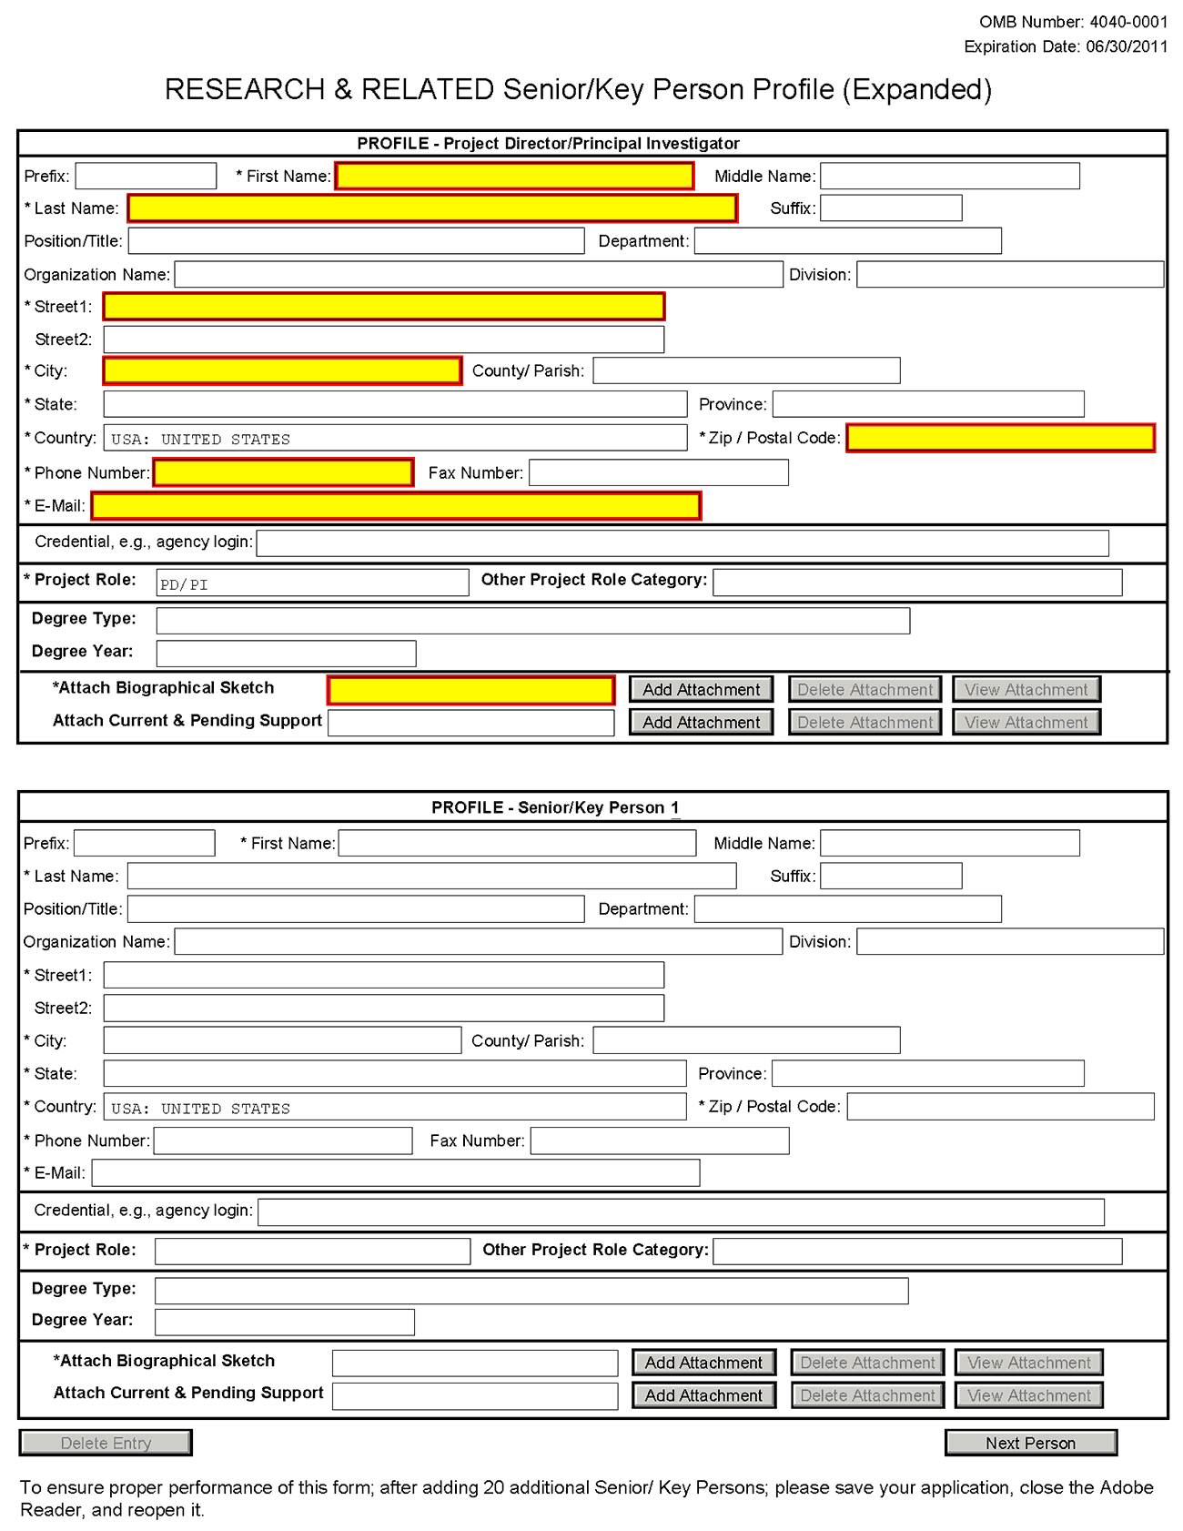
This form provides the ability to collect structured data for up to 40 senior/key persons. Data must be entered for the first 40 individuals (PD/PI + 39 others) before the Additional Senior/Key Person Form Attachments section becomes available. The information for the PD/PI continues to be pre-populated from the SF424 (R&R) Cover form. See instructions in Section 4.2 Cover Form if these fields are empty. Unless otherwise specified in an agency announcement, senior/key personnel are defined as all individuals who contribute in a substantive, meaningful way to the scientific development or execution of the project, whether or not salaries are requested. Consultants should be included if they meet this definition.
Multiple PD/PIs
NIH is now accepting applications reflecting Multiple PD/PIs for all grant activity codes using the SF424 (R&R) application. When submitting an application involving Multiple PD/PIs, the Contact PI must be affiliated in the Commons with the applicant organization and should be listed as the PD/PI in the SF424 R&R Cover Form (see Section 4.2.14). That information automatically prepopulates the first senior/key person profile record in this form. For the additional PD/PIs, complete all the requested information. Each PD/PI must be assigned the PD/PI role, even those at subaward/consortium sites when applicable. (Do not use the “Co-PI” role.) For more information, please see Section 4.7 Special Instructions for Preparing Applications with a Subaward/Consortium.
Each PD/PI must also be registered in the eRA Commons and must be assigned the PI Role in that system (note other roles such as SO or IAR will not give PD/PIs the appropriate access to the application records). Each PD/PI must include their respective eRA Commons ID in the Credential field. For more information on NIH Implementation of Multiple PD/PIs, see: http://grants.nih.gov/grants/multi_pi/index.htm.
When completing the detailed budget form for either the prime organization or a subaward/consortium organization, the project roles listed in the budget form should be consistent with those used in the senior/key person form.
Special Note for STTR applicants: The STTR applicant organization must officially affiliate the PD/PI with the small business concern in the Commons if the PD/PI is not an employee of the small business concern. See Section 2.2.2.2 for steps to affiliate a PD/PI to the applicant organization/institution.
Profile – Program Director/Principal Investigator (PD/PI)
Field Name | Instructions
Prefix | This field is automatically populated from the SF424 (R&R). It is the prefix (e.g., Mr., Mrs., Rev.) for the name of the PD/PI.
First Name | This field is automatically populated from the SF424 (R&R). It is the first (given) name of the PD/PI. This field is required.
Middle Name | This field is automatically populated from the SF424 (R&R). It is the middle name of the PD/PI.
Last Name | This field is automatically populated from the SF424 (R&R). It is the last (family) name of the PD/PI. This field is required.
Suffix | This field is automatically populated from the SF424 (R&R). It is the suffix (e.g., Jr., Sr., PhD) for the name of the PD/PI.
Position/Title | This field is automatically populated from the SF424 (R&R). It is the title of the PD/PI.
Department | This field is automatically populated from the SF424 (R&R). It is the name of primary organizational department, service, laboratory, or equivalent level within the organization of the PD/PI.
Organization Name | This field is automatically populated from the SF424 (R&R). It is the name of the organization of the PD/PI.
Division | This field is automatically populated from the SF424 (R&R). It is the name of primary organizational division, office, or major subdivision of the PD/PI.
Street1 | This field is automatically populated from the SF424 (R&R). It is the first line of the street address of the PD/PI. This field is required.
Street2 | This field is automatically populated from the SF424 (R&R). It is the second line of the street address of the PD/PI, if applicable. This field is optional.
City | This field is automatically populated from the SF424 (R&R). It is the city for the address of the PD/PI.
County/Parish | This field is automatically populated from the SF424 (R&R). It is the county or parish for the address of the PD/PI.
State | This field is automatically populated from the SF424 (R&R). It is the state where the PD/PI is located. This field is required if the PD/PI is located in the United States.
Province | This field is automatically populated from the SF424 (R&R). It is the province where the PD/PI is located.  If “Country” is not Canada, this will be blank.
Country | This field is automatically populated from the SF424 (R&R). It is the country for the PD/PI address.
ZIP Code | This field is automatically populated from the SF424 (R&R). The nine-digit Postal Code (e.g., ZIP Code) of the PD/PI. This field is required if the PD/PI is located in the United States.
Phone Number | This field is automatically populated from the SF424 (R&R). It is the daytime phone number for the PD/PI. This field is required.
Fax Number | This field is automatically populated from the SF424 (R&R). It is the fax number for the PD/PI.
E-mail | This field is automatically populated from the SF424 (R&R). It is the e-mail address for the PD/PI. This field is required for the PD/PI.
Credential, e.g., agency login | If you are submitting to an agency (e.g., NIH) where you have an established personal profile, enter the agency ID. If not, leave blank.  For NIH and other PHS agencies, registration in the eRA Commons for all PD/PIs is required. The assigned Commons UserName (the unique name used to log into the system) for anyone assigned the PD/PI role must be entered here. This is a required field for applications submitted to NIH and other PHS agencies. Applications will not pass agency validation requirements without this field.
Project Role | Select one. Use "Other" if a category is not listed in the pick list.  Select Program Director/Principal Investigator for this person.
Other Project Role Category | Complete if you selected “Other Professional” or “Other” as a project role; e.g., Engineer, Chemist.
Degree Type | Enter the highest academic or professional degree or other credentials (e.g., RN). This is optional information.
Degree Year | Enter the year the highest degree or other credential was obtained. This is optional information.
Attach Biographical Sketch | Provide a biographical sketch for the PD/PI. Recommended information includes: Education and Training, Research and Professional Experience, Collaborators and Affiliations (for conflicts of interest), Publications and Synergistic Activities. Save the information in a single file and attach. This is required information.  Biographical sketches should follow the format described below.
Attach Current & Pending Support | Unless otherwise required in a specific FOA, do not use this attachment upload for NIH and other PHS agency submissions. This information is no longer required at the time of application submission. This information may be requested later in the pre-award cycle. When this occurs, you will be instructed to refer to Other Support in Supplemental Instructions Part III, Policies, Assurances, Definitions and Other Information.

Profile – Senior/Key Person [n]
The remaining senior/key person profiles should be listed in alphabetical order. While alphabetical order is preferred, it is not required. However, be aware that these profiles will appear in the application in the order provided by the applicant. Therefore, peer reviewers will see them in the order presented. Those with a postdoctoral role should be included if they meet the definition of senior/key personnel. Also use this section to list any Other Significant Contributors (OSCs). OSCs should be listed after all senior/key persons. OSCs are individuals who have committed to contribute to the scientific development or execution of the project, but are not committing any specified measurable effort (in person months) to the project. These individuals are typically presented at “effort of zero person months” or “as needed” (individuals with measurable effort cannot be listed as Other Significant Contributors). Consultants should be included if they meet this definition.
A biosketch, including Research Support information, will be required for these individuals as this highlights their accomplishments as scientists. Reviewers use these pages to address the “investigator” review criterion. However, if an award is to be made, Other Support information will not be required or accepted since considerations of overlap do not apply to these individuals.
Should the level of involvement change for an individual listed as an OSC, the individual should be redesignated as “senior/key personnel.” This change should be made before any compensation is charged to the project.
After providing data for each individual senior/key person, click the Next Person button at the bottom of the form to enter data for the next senior/key person. Continue in this manner until data has been provided for up to 40 senior/key persons. To ensure proper performance of this form, after adding 20 additional senior/key persons please save your application, close the Adobe reader, and reopen it. For applications involving more than 40 senior/key persons, the “Additional Senior/Key Person Profiles” fields will become available once data for the first 40 senior/key persons has been provided.

Field Name | Instructions
Prefix | Enter the prefix (e.g., Mr., Mrs., Rev.) for the name of the senior/key person.
First Name | Enter the first (given) name of the senior/key person. This field is required.
Middle Name | Enter the middle name of the senior/key person, if applicable.
Last Name | Enter the last (family) name of the senior/key person. This field is required.
Suffix | Enter the suffix (e.g., Jr., Sr., Ph.D.) for the name of the senior/key person.
Position/Title | Enter the title of the senior/key person.
Department | Enter the name of primary organizational department, service, laboratory, or equivalent level within the organization of the senior/key person.
Organization Name | Enter the name of organization of the senior/key person.  This is a required field for applications submitted to NIH and other PHS agencies.
Division | Enter the name of primary organizational division, office, or major subdivision of the senior/key person.
Street1 | Enter first line of the street address for the senior/key person. This field is required.
Street2 | Enter second line of the street address for the senior/key person, if applicable. This field is optional.
City | Enter the city for the address of the senior/key person. This field is required.
County/Parish | Enter the county or parish for the address of the senior/key person.
State | Enter the State where the senior/key person is located. This field is required if the senior/key person is located in the United States.
Province | Enter the Province where the senior/key person is located.  If “Country” is not Canada, please leave blank.
Country | Select the country for the senior/key person address. This field is required.
ZIP Code | Enter the nine-digit Postal Code (e.g., ZIP Code) of the senior/key person address. This field is required if the senior/key person is located in the United States.
Phone Number | Enter the daytime telephone number for the senior/key person. This field is required.
Fax Number | Enter the fax number for the senior/key person.
E-mail | Enter the e-mail address for the senior/key person. This field is required for the senior/key person.
Credential, e.g., agency login | If you are submitting to an agency (e.g., NIH) where you have an established personal profile, enter the agency ID. If not, leave blank.  For NIH and other PHS agencies, registration in the eRA Commons for all PD/PIs is required. The assigned Commons UserName (the unique name used to log into the system) for anyone assigned the PD/PI role must be entered here. This is a required field for applications submitted to NIH and other PHS agencies. Applications will not pass agency validation requirements without this field.  Note for applications reflecting Multiple PD/PIs, the Commons UserName must be provided for all individuals assigned the PD/PI Role.
Project Role | Select one. Use "Other" if a category is not listed in the pick list.  If you are submitting an application reflecting Multiple PD/PIs, all such individuals must be assigned the PD/PI role, even those at organizations other than the applicant organization. The role of “Co-PD/PI” is not currently used by NIH and other PHS agencies. Assigning an individual(s) the role of "Co-PD/PI" will not identify the application as a Multiple PD/PI application. If applicants wish to use a different role, select “Other” for the Project Role field and then insert the appropriate role descriptor in the Other Project Role Category field.  If including individuals classified as “Other Significant Contributors (OSCs),” use the “Other” category and indicate “Other Significant Contributor” as the role in the “Other Project Role Category.” OSCs should be listed last after all other senior/key persons have been listed.
Other Project Role Category | Complete if you selected “Other Professional” or “Other” as a project role; e.g., Engineer, Chemist.
Degree Type | Enter the highest academic or professional degree or other credentials (e.g., RN). This is optional information.
Degree Year | Enter the year the highest degree or other credential was obtained. This is optional information.
Attach Biographical Sketch | Provide a biographical sketch for the senior/key person. Recommended information includes: Education and Training, Research and Professional Experience, Collaborators and Affiliations (for conflicts of interest), Publications and Synergistic Activities. Save the information in a single file and attach here. This field is required.  Biographical sketches should follow the format described below.
Attach Current & Pending Support | Unless otherwise required in a specific FOA, do not use this attachment upload for NIH and other PHS agency submissions. This information is no longer required at the time of application submission. This information may be requested later in the pre-award cycle. When this occurs, refer to Other Support in Supplemental Instructions Part III, Policies, Assurances, Definitions, and Other Information.

Additional Senior/Key Person Profile(s)
If more than forty senior/key person profiles are proposed, enter the information in a separate file and attach it here.
A sample Additional Senior/Key Person Profiles format page for greater than 40 profiles is found under “Additional Format Pages” at: http://grants.nih.gov/grants/funding/424/index.htm.
Additional Biographical Sketch(es) (Senior/Key Person)
Provide a biographical sketch for each senior/key person. Recommended information includes: Education and Training, Research and Professional Experience, Collaborators and Affiliations (for conflicts of interest), Publications and Synergistic Activities. Save the information in a single file and attach here.
Biographical sketches should follow the format described below

Additional Current and Pending Support(s)
Provide a list of all current and pending support for the PD/PI and each senior/key person (even if they receive no salary support from the project(s) for ongoing projects and pending proposals). Show the total award amount for the entire award period (including indirect costs) as well as the number of person months per year to be devoted to the project by the senior/key person, regardless of source of support. Concurrent submission of a proposal to other organizations will not prejudice its review.
Unless otherwise required in a specific FOA, do not use this attachment upload for NIH and other PHS agency submissions. This information is no longer required at the time of application submission. This information may be requested later in the pre-award cycle. When this occurs, refer to Other Support in Supplemental Instructions Part III, Policies, Assurances, Definitions, and Other Information.
Additional NIH and Other PHS Agencies Instructions for a Biographical Sketch
Use the sample format on the Biographical Sketch Format Page to prepare this section for all (modular and other) grant applications. Include biographical sketches of all senior/key personnel and Other Significant Contributors. The Biographical Sketch may not exceed four pages per person. This 4-page limit includes the table at the top of the first page. See the sample of a completed Biographical Sketch.
If the individual is registered in the eRA Commons, include the Commons User Name. This data item is required for the PD/PI but is currently optional for all other senior/key persons. In other federal forms this information is referred to as “Credential, e.g., agency login.” For information on the eRA Commons, see https://commons.era.nih.gov/commons/index.jsp.
Complete the educational block at the top of the format page beginning with baccalaureate or other initial professional education, such as nursing, and include postdoctoral training, separately referencing residency training when applicable. For each entry provide the name and location of the institution; the degree received (if applicable); the month and year the degree was received, and the field of study. For residency entries, the field of study section should reflect the area of residency.
Following the educational block, complete sections A, B, C, and D as described below.
A. Personal Statement. Briefly describe why your experience and qualifications make you particularly well-suited for your role (e.g., PD/PI, mentor, participating faculty) in the project that is the subject of the application. Within this section you may, if you choose, briefly describe factors such as family care responsibilities, illness, disability, and active duty military service that may have affected your scientific advancement or productivity.
B. Positions and Honors. List in chronological order previous positions, concluding with your present position. List any honors. Include present membership on any Federal Government public advisory committee.
C. Selected Peer-reviewed Publication and Patent Citations. NIH encourages applicants to limit the list of selected peer-reviewed publications, manuscripts in press, and patent citations to no more than 15. Do not include manuscripts submitted or in preparation. The individual may choose to include selected publications based on recency, importance to the field, and/or relevance to the proposed research. When citing articles that fall under the Public Access Policy, were authored or co-authored by the applicant and arose from NIH support, provide the NIH Manuscript Submission reference number (e.g., NIHMS97531) or the PubMed Central (PMC) reference number (e.g., PMCID234567) for each article. If the PMCID is not yet available because the Journal submits articles directly to PMC on behalf of their authors, indicate “PMC Journal – In Process.” A list of these journals is posted at: http://publicaccess.nih.gov/submit_process_journals.htm. Citations that are not covered by the Public Access Policy, but are publicly available in a free, online format may include URLs or PubMed ID (PMID) numbers along with the full reference (note that copies of publicly available publications are not acceptable as appendix material).
D. Research Support. List both selected ongoing and completed (during the last three years) research projects (Federal or non-Federal support). Begin with the projects that are most relevant to the research proposed in this application. Briefly indicate the overall goals of the projects and responsibilities of the senior/key person identified on the Biographical Sketch. Do not include number of person months or direct costs.
Don't confuse “Research Support” with “Other Support.” Though they sound similar, these parts of the application are very different. As part of the biosketch section of the application, “Research Support” highlights your accomplishments, and those of your colleagues, as scientists. This information will be used by the reviewers in the assessment of each individual's qualifications for a specific role in the proposed project, as well as to evaluate the overall qualifications of the research team. In contrast, “Other Support” information is required for all applications that are selected to receive grant awards. NIH staff will request complete and up-to-date “other support” information from you after peer review. This information will be used to check that the proposed research has not already been Federally-funded.

Once all data have been entered, use the scroll bar to scroll up. You will be returned to the Grant Application Package screen. To remove a document from the Submission box, click the document name to select it and then click the Move Form to Delete button. This will return the document to the Mandatory Documents Submission List or Optional Documents Submission List.

4.6 R&R Budget Form
The R&R Budget form includes three separate data entry screens: (1) Sections A and B; (2) Sections C through E; and (3) Sections F through K. To navigate between the various screens, use the Previous and Next buttons at the top of the form or use the scroll bar on the side of the screen. Complete the R&R Budget form following the instructions provided. You must complete a separate detailed budget for each year of support requested. The form will generate a cumulative budget for the total project period. You must complete all the required information (i.e., those fields that are highlighted in yellow, outlined in red and noted with an “*”) before the Next Period button is activated. If no funds are requested for a required field, enter “0.”
While the dollar fields allow cents to be entered, all dollar fields should be presented in whole numbers. Please round to the nearest whole number.
NIH and other PHS agencies use the concept of person months as a metric for determining percent of effort. To assist applicants unfamiliar with this concept, resources are available on the web at: http://grants.nih.gov/grants/policy/person_months_faqs.htm. Frequently asked questions and a conversion calculator are available.
If funds are being requested for more than one budget period, click the Next Period button at the top of the third budget screen (Sections F through K) to navigate to screens for the next budget period.
Revision (Supplemental) Application. For a “Revision” (Supplemental) application, show only those items for which additional funds are requested. If the initial budget period of the supplementation application is less than 12 months, prorate the personnel costs and other appropriate items of the detailed budget.

4.6.1 Section A and B
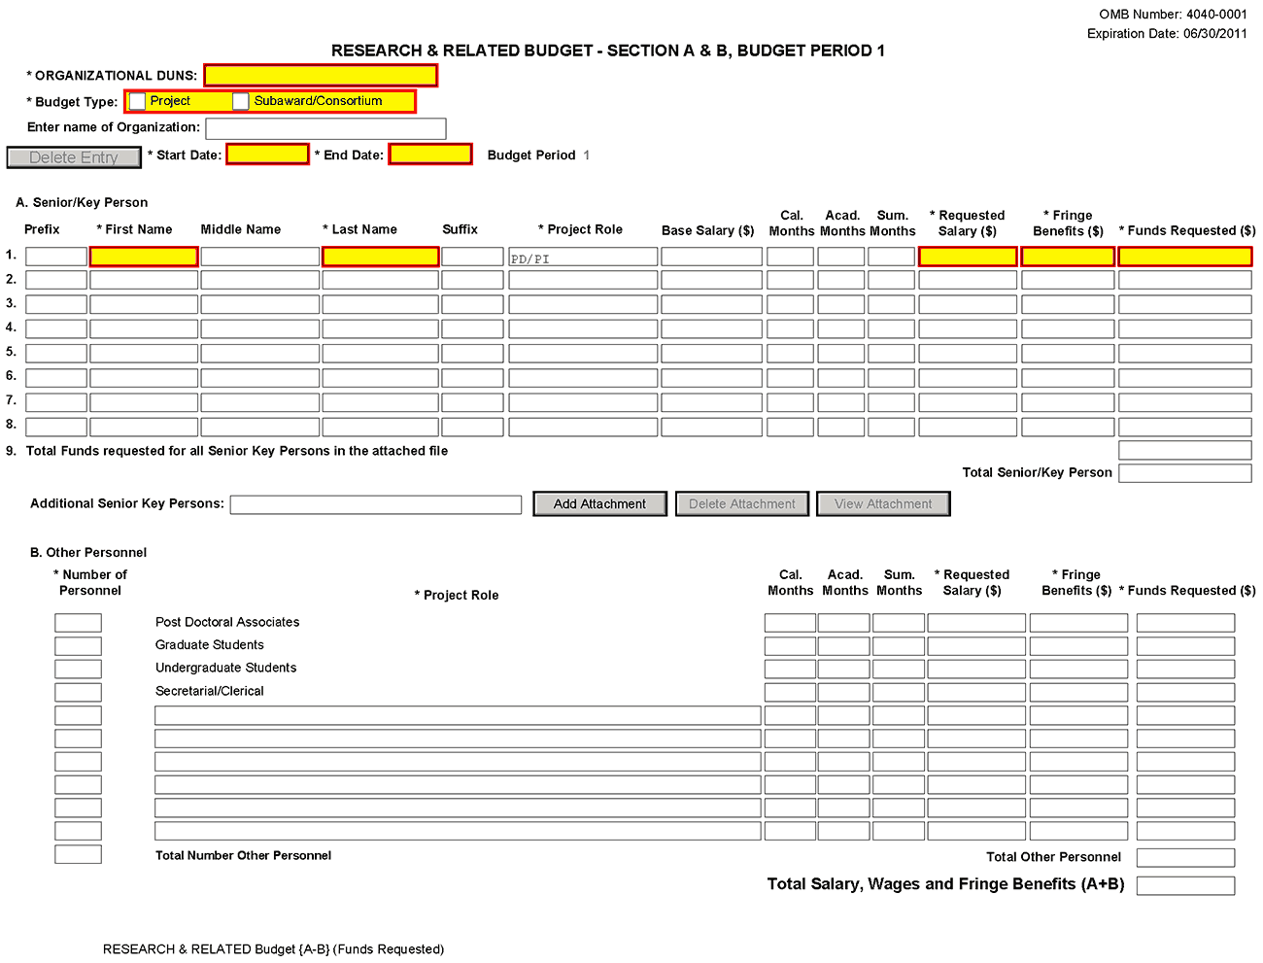
Organizational DUNS
Enter the DUNS or DUNS+4 number of the applicant organization. For project applicant, this field is pre-populated from the R&R SF424 Cover Page. For subaward applicants, this field is a required enterable field.
Budget Type
Project, Subaward/Consortium: Check the appropriate block.
Project: The budget requested for the primary applicant organization.
Subaward/Consortium: The budget requested for subawardee/consortium organization(s). Note, separate budgets are required only for subawardee/consortium organizations that perform a substantive portion of the project.
If creating Subaward Budget, use the R&R Subaward Budget Attachment and attach as a separate file on the R&R Budget Attachment(s) form.
If you are preparing an application that includes a subaward/consortium, see Section 4.7 Special Instructions for Preparing Applications with a Subaward/Consortium.
Enter name of Organization
Pre-populated from the R&R SF424. Enter the name of the organization.
Delete Entry
Reset entries on page.
Start Date
Pre-populated from the R&R SF424. Enter the requested/proposed start date of each budget period. This field is required.
End Date
Enter the requested/proposed end date of each budget period. This field is required.
Budget Period
Identify the specific budget period (for example, 1, 2, 3, 4, 5). If submitting through Grants.gov, the system will automatically generate a cumulative budget for the total project period. This is a required field.
(If the Reset Entries button is pressed, please navigate to previous year to enable the submission of the form.)
A. Senior/Key Person
This section should include the names of all senior/key persons at the applicant organization who are involved on the project in a particular budget year. Include all collaborating investigators, and other individuals meeting the senior/key person definition if they are from the applicant organization. Details of collaborators at other institutions will be provided in the Subaward budget for each subaward/consortium organization. Personnel listed as Other Significant Contributors who are not committing any specific measurable effort to the project should not be included in the Personnel section of the budget since no associated salary and/or fringe benefits should be requested for their contribution. Consultants designated as senior/key persons in the Senior/Key Person Profile Form can be included in Budget Section A only if they are also employees of the applicant organization. Otherwise, consultant costs should be included in F.3 Consultant Services.
Field Name | Instructions
Prefix | Pre-populated from the R&R SF424. Enter the prefix (e.g., Mr., Mrs., Rev.) for the name of each senior/key person.
First Name | Pre-populated from the R&R SF424. Enter the first (given) name of each senior/key person. This field is required.
Middle Name | Pre-populated from the R&R SF424. Enter the middle name of each senior/key person, if applicable.
Last Name | Pre-populated from the R&R SF424. Enter the last (family) name of each senior/key person. This field is required.
Suffix | Pre-populated from the R&R SF424. Enter the suffix (e.g., Jr., Sr., PhD) of each senior/key person.
Project Role | Identify the project role of each senior/key person in this section. This section could also include such roles as Co-PD/PI, Postdoctoral Associates, and Other Professionals.  The role of the PD/PI is auto-populated in the 01 year budget only. Do not change or edit this field for the PD/PI. For future year budgets, use consistent terminology.  Roles should correspond to the roles included on the Senior/Key Person Profile (Expanded) Form.
Base Salary ($) | Enter the annual compensation paid by the employer for each senior/key person. This includes all activities such as research, teaching, patient care, or other. You may choose to leave this column blank.  An applicant organization may choose to leave this blank; however, PHS staff will request this information prior to award.  STTR: If the PD/PI is an employee of the Research Institution (RI), the PD/PI salary should be entered on the RI subaward budget page.
Cal. Months | Identify the number of months devoted to the project for each senior/key person (i.e., calendar, academic, summer).  If effort does not change throughout the year, it is OK to use only the calendar months column. However, you may use both academic and summer months columns if your institutional business process requires noting each separately even if effort remains constant. If effort varies between academic and summer months, leave the calendar months column blank and use only the academic and summer months columns. Please use either calendar months OR a combination of academic and summer months.  STTR: If the PD/PI is an employee of the Research Institution (RI), the PD/PI months devoted should be entered on the RI subaward budget page.
Acad. Months | Identify the number of months devoted to the project for each senior/key person (for example, calendar, academic, summer).  If your institution does not use a 9-month academic year, indicate your institution’s definition of academic year in the budget justification.  STTR: If the PD/PI is an employee of the Research Institution (RI), the PD/PI months devoted should be entered on the RI subaward budget page.
Sum. Months | Identify the number of months devoted to the project for each senior/key person (for example, calendar, academic, summer).  If your institution does not use a 3-month summer period, indicate your institution’s definition of summer in the budget justification.  STTR: If the PD/PI is an employee of the Research Institution (RI), the PD/PI months devoted should be entered on the RI subaward budget page.
Requested Salary ($) | Regardless of the number of months being devoted to the project, indicate only the amount of salary being requested for this budget period for each senior/key person. This field is required.  Some PHS grant programs are currently subject to a legislatively imposed salary limitation. Any adjustment for salary limits will be made at the time of award; therefore requested salary should be based on institutional base salary at the time the application is submitted and not adjusted for any limitation. For guidance on current salary limitations, see the Salary Cap Summary on the NIH grants Web site or contact your office of sponsored programs.  NIH grants also limit the compensation for graduate students. Compensation includes salary or wages, fringe benefits and tuition remission. While actual institutional-based compensation should be requested and justified, this may be adjusted at the time of the award. For more guidance on this policy, see: http://grants.nih.gov/grants/guide/notice-files/NOT-OD-02-017.html.  STTR: The PD/PI may be paid by either the research institution (RI) or the small business, but not both. If the PD/PI is an employee of the small business, enter the PD/PI’s salary on the small business budget. If the PD/PI is an employee of the RI, enter the PD/PI’s salary on the RI’s subaward budget.
Fringe Benefits ($) | Enter applicable fringe benefits, if any, for each senior/key person.  SBIR and STTR: Leave this section blank as commercial (for-profit) organizations usually treat 'fringe benefits' as indirect costs. In certain cases, fringe benefits may be requested as a direct cost to the extent that they are treated consistently by the organization as a direct cost to all sponsors.
Funds Requested ($) | Enter the requested salary and fringe benefits for each senior/key person. This field is required.
Total Funds requested for all senior/key persons in the attached file | Enter the total funds requested for all senior/key persons. This is required information.
Total Senior/Key Persons | The total funds requested for all senior/key persons.
Additional Senior/Key Persons | If funds are requested for more than eight senior/key persons, include all pertinent budget information as identified in this section and attach as a file here. Enter the total funds requested for all additional senior/key persons in line 9 of Section A. This attachment is required if funds are entered in line 9 of Section A.  Use the same format as the budget form and include all required information.

Special Instructions: Joint University and Department of Veterans Affairs (V.A.) Appointments
Individuals with joint university and V.A. appointments may request the university’s share of their salary in proportion to the effort devoted to the research project. The individual’s salary with the university determines the base for computing that request. Signature by the institutional official on the application certifies that: (1) the individual is applying as part of a joint appointment specified by a formal Memorandum of Understanding between the university and the V.A.; and (2) there is no possibility of dual compensation for the same work, or of an actual or apparent conflict of interest regarding such work. Additional information may be requested by the awarding components.
B. Other Personnel
Field Name | Instructions
Number of Personnel | For each project role category identify the number of personnel proposed.  List any additional project role(s) in the blank(s) provided, e.g., Engineer, IT Professionals, etc.  For all Postdoctoral Associates and Graduate Students not already named in Section A. Senior/Key Person, individually list names, roles (e.g., PostDoc or Graduate Student), associated months, and salary & fringe benefits requested in the Budget Justification.
Project Role | If Project Role is other than Post Doctoral Associates, Graduate Students, Undergraduate Students, or Secretarial/Clerical, enter the appropriate project role (for example, Engineer, IT Professional, etc.) in the blanks.  Do not include consultants in this section. Consultants are included below in Section F. Other Direct Costs.
Cal. Months | Identify the number of months devoted to the project in the applicable box for each project role category (i.e., calendar, academic, summer).
Acad. Months | Identify the number of months devoted to the project in the applicable box for each project role category (i.e., calendar, academic, summer).  If your institution does not use a 9-month academic year, indicate your institution’s definition of academic year in the budget justification.
Sum. Months | Identify the number of months devoted to the project in the applicable box for each project role category (i.e., calendar, academic, summer).  If your institution does not use a 3-month summer period, indicate your institution’s definition of summer in the budget justification.
Requested Salary ($) | Regardless of the number of months being devoted to the project, indicate only the amount of salary/wages being requested for each project role.  Some PHS grant programs are currently subject to a legislatively imposed salary limitation. Any adjustment for salary limits will be made at the time of award. For guidance on current salary limitations, see the Salary Cap Summary on the NIH grants Web site or contact your office of sponsored programs.  NIH grants also limit the compensation for graduate students. Compensation includes salary or wages, fringe benefits and tuition remission. While actual institutional-based compensation should be requested and justified, this may be adjusted at the time of the award. For more guidance on this policy, see: http://grants.nih.gov/grants/guide/notice-files/NOT-OD-02-017.html.
Fringe Benefits ($) | Enter applicable fringe benefits, if any, for this project role category.  SBIR and STTR: Leave this section blank as commercial (for-profit) organizations usually treat 'fringe benefits' as indirect costs. In certain cases, fringe benefits may be requested as a direct cost to the extent that they are treated consistently by the organization as a direct cost to all sponsors.
Funds Requested | Enter requested salary/wages & fringe benefits for each project role.
Total Number of Other Personnel | This total will auto-calculate. Total Salary, Wages and Fringe Benefits (A+B).
Total Other Personnel | Total funds requested for all other Personnel.
Total Salary, Wages and Fringe Benefits (A+B) | Total Funds requested for all senior/key persons and all Other Personnel. This total will auto-calculate.
To navigate to the next page (Sections C through E), click the Next button at the top of the form or use the scroll bar on the left-hand side of the screen.

4.6.2 Sections C through E
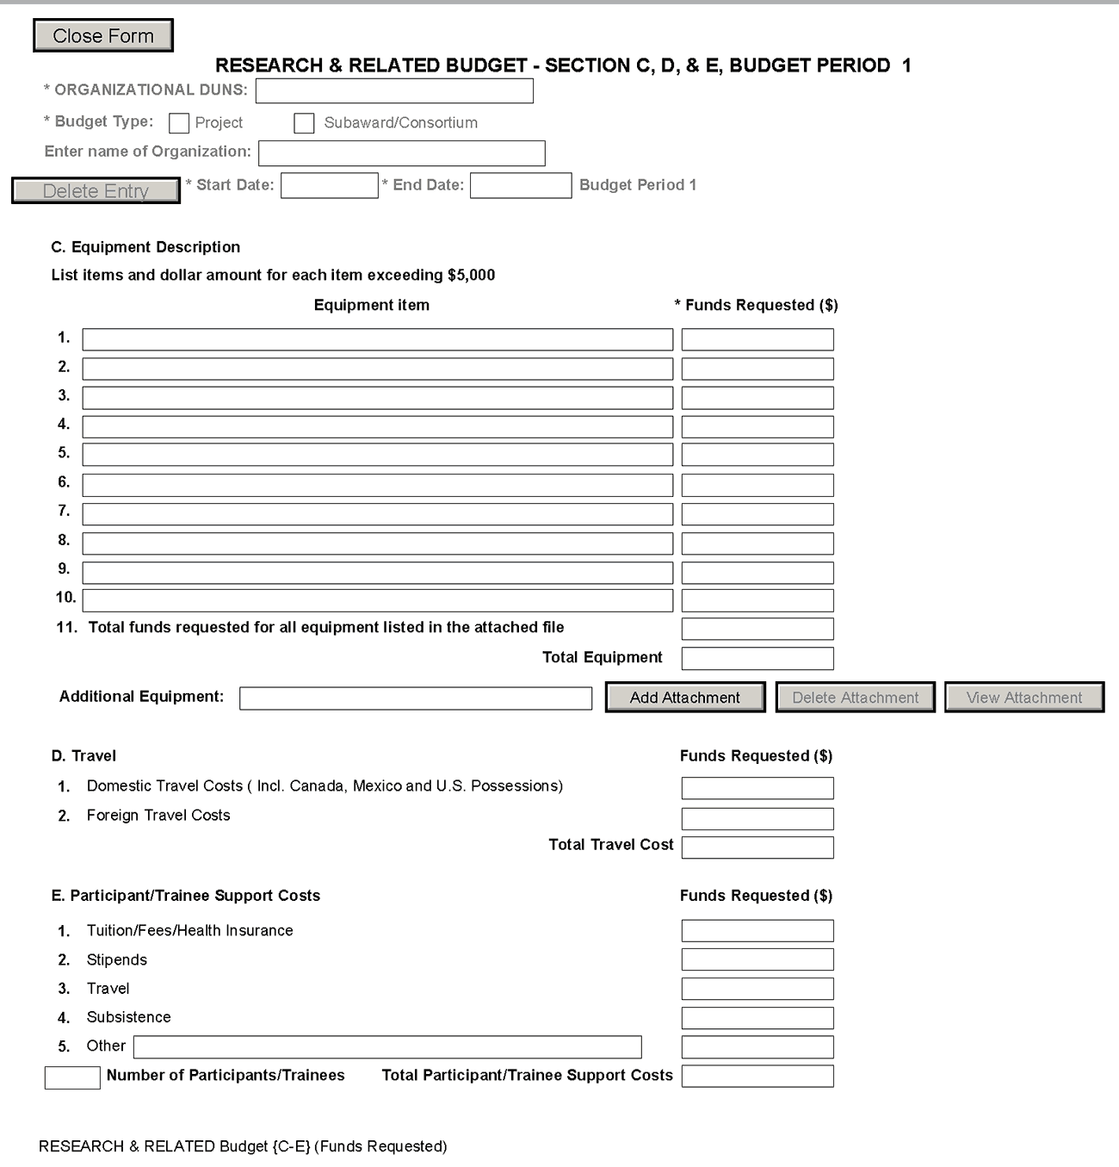
The information for Organizational DUNS, Budget Type, Name of Organization, and Start and End Dates is automatically filled in based on the information entered on the first budget screen. To edit this information, return to the initial budget screen (Sections A and B) by clicking the Previous button.
C. Equipment Description
List of items and dollar amount for each item exceeding $5,000.
Field Name | Instructions
Equipment item | Equipment is defined as an item of property that has an acquisition cost of $5,000 or more (unless the organization has established lower levels) and an expected service life of more than one year. List each item of equipment separately and justify each in the budget justification section. Allowable items ordinarily will be limited to research equipment and apparatus not already available for the conduct of the work. General-purpose equipment, such as a personal computer, is not eligible for support unless primarily or exclusively used in the actual conduct of scientific research.
Funds Requested | List the estimated cost of each item of equipment including shipping and any maintenance costs and agreements. This is required information.
Total funds requested for all equipment listed in the attached file | Total funds requested for all equipment listed in the attached file. Dollar amount for each item should exceed $5000.
Total Equipment | Total Funds requested for all equipment.
Additional Equipment | If the space provided cannot accommodate all the equipment proposed, attach a file in the block provided. List each additional item and the funds requested. For all additional items in the attached file, list the total funds requested on line 11 of this section.
D. Travel
Field Name | Instructions
Domestic Travel Costs (Incl. Canada, Mexico, and U.S. Possessions) | Identify the total funds requested for domestic travel. Domestic travel includes Canada, Mexico, and U.S. possessions. In the budget justification section, include the purpose, destination, dates of travel (if known), and number of individuals for each trip. If the dates of travel are not known, specify estimated length of trip (e.g., 3 days).
Foreign Travel Costs | Enter the total funds requested for foreign travel. Foreign travel includes any travel outside of North America and/or U.S. possessions. In the budget justification section, include the purpose, destination, dates of travel (if known) and number of individuals for each trip. If the dates of travel are not known, specify estimated length of trip (e.g., 3 days).
Total Travel Cost | Total funds requested for all travel.
E. Participant/Trainee Support Costs
Unless specifically stated otherwise in an announcement, NIH and other PHS agencies applicants should leave blank Section E. Note: Tuition remission for graduate students should continue to be included in Section F. Other Direct Costs when applicable.
Field Name | Instructions
Tuition/Fees/Health Insurance | List total funds requested for Participant/Trainee tuition / fees / health insurance.
Stipends | List total funds requested for Participant/Trainee stipends.
Travel | List total funds requested for Participant/Trainee travel.
Subsistence | List total funds requested for Participant/Trainee subsistence.
Other | Describe any other participant trainee funds requested. List total funds requested for any other Participant/Trainee costs described.
Number of Participants/Trainees | List total number of proposed Participants/Trainees.
Total Participant/Trainee Support Costs | Total funds requested for all trainee costs.

4.6.3 Sections F through K
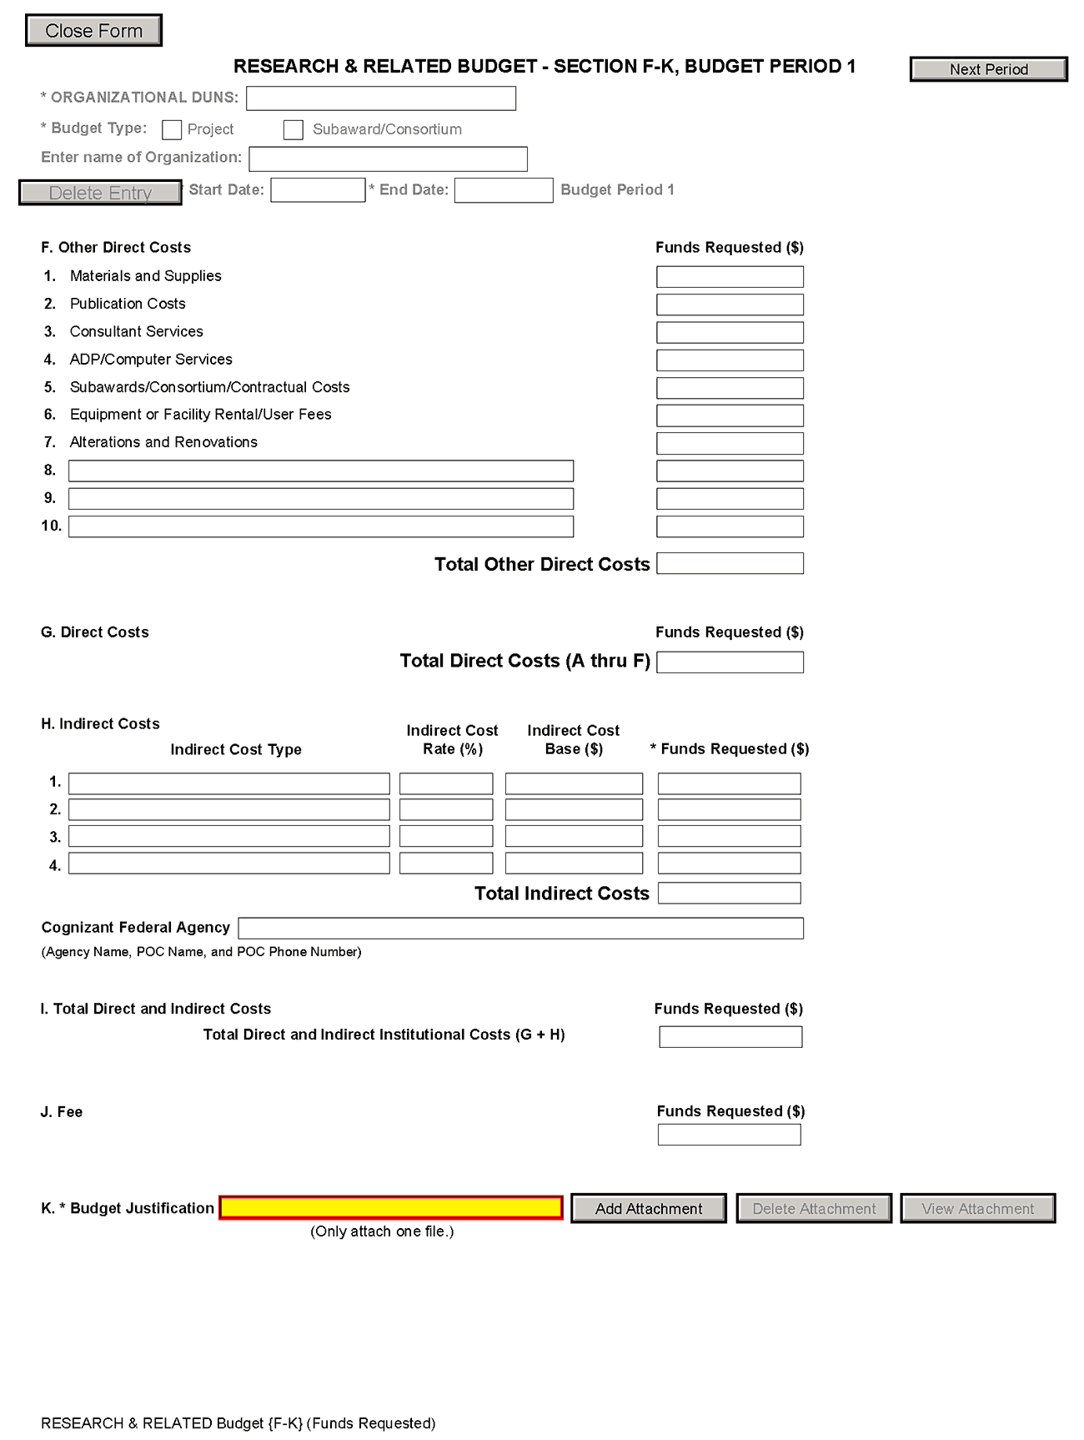
The information for Organizational DUNS, Budget Type, Name of Organization, and Start and End Dates is automatically filled in based on the information entered on the first budget screen. To edit this information, return to the initial budget screen (Sections A and B) by clicking the Previous button.
F. Other Direct Costs
Field Name | Instructions
1. Materials and Supplies | List total funds requested for materials and supplies. In the budget justification, indicate general categories such as glassware, chemicals, animal costs, including an amount for each category. Categories less than $1,000 are not required to be itemized.
2. Publication Costs | List the total publication funds requested. The proposal budget may request funds for the costs of documenting, preparing, publishing, or otherwise making available to others the findings and products of the work conducted under the award. In the budget justification include supporting information.
3. Consultant Services | List the total costs for all consultant services. In the budget justification, identify each consultant, the services he/she will perform, total number of days, travel costs, and the total estimated costs.  In the budget justification also provide the names and organizational affiliations of all consultants, other than those involved in consortium/contractual arrangements. Include consultant physicians in connection with patient care and persons who are confirmed to serve on external monitoring boards or advisory committees to the project. Describe the services to be performed.
4. ADP/Computer Services | List total funds requested for ADP/computer services. The cost of computer services, including computer-based retrieval of scientific, technical and education information may be requested. In the budget justification, include the established computer service rates at the proposing organization if applicable.
5. Subawards/Consortium/ Contractual Costs | List total funds requested for 1) all subaward/consortium organization(s) proposed for the project and 2) any other contractual costs proposed for the project.  This line item should include both direct and indirect costs for all subaward/consortium organizations. Contractual costs for support services, such as the laboratory testing of biological materials, clinical services, or data processing, are occasionally sufficiently high to warrant a categorical breakdown of costs. When this is the case, provide detailed information as part of the budget justification.
6. Equipment or Facility Rental/User Fees | List total funds requested for equipment or facility rental/user fees. In the budget justification, identify each rental user fee and justify.
7. Alterations and Renovations | List total funds requested for alterations and renovations. In the budget justification, itemize by category and justify the costs of alterations and renovations including repairs, painting, removal or installation of partitions, shielding, or air conditioning. Where applicable, provide the square footage and costs.  Under certain circumstances the public policy requirements that apply to construction activities may also apply to A&R activities. Please refer to the NIH Grants Policy Statement section on “Construction Grants – Public Policy Requirements and Objectives” for more information.  Note, costs for any Alterations and Renovations (A&R) were previously unallowable on applications from domestic applications with foreign subawards. However, an HHS policy change now allows for minor A&R (≤$500,000) on these applications.  When requesting minor A&R costs under this policy, please provide detailed information on the planned A&R in the budget justification.
8-10 Other | Add text to describe any “other” direct costs not requested above. Use the budget justification to further itemize and justify.  List total funds requested for items 8-10 “Other.”  Use lines 8-10 for such costs as SBIR/STTR technical assistance, patient care and tuition remission. If requesting patient care costs, request inpatient and outpatient costs separately using lines 8 and 9.
Total Other Direct Costs | Total funds requested for all other direct costs.

Special Instructions for Technical Assistance Costs
NIH offers distinct technical assistance programs to SBIR and STTR Phase I and Phase II awardees. These programs offer specialized, strategic business training and provide access to a vast network of industry experts possible through the efficiencies of scale that under a contract deliver the best value to the government and the intended small businesses seeking such assistance. If you wish to utilize your own technical assistance provider, you are required to include this as a consultant in your budget and to provide a detailed budget justification. You may request up to $5,000 for assistance. Reimbursement is limited to services received that comply with 15 U.S.C. § 638(q):
To provide small business concerns engaged in SBIR or STTR projects with technical assistance services, such as access to a network of scientists and engineers engaged in a wide range of technologies, or access to technical and business literature available through on-line data bases, for the purpose of assisting such concerns in:
- Making better technical decisions concerning such projects;
- Solving technical problems which arise during the conduct of such projects;
- Minimizing technical risks associated with such projects; and
- Developing and commercializing new commercial products and processes resulting from such projects.
To request technical assistance from your own provider:
- Label the requested cost of up to $5,000 “Technical Assistance” on lines 8-10.
- Include a detailed description of the services your vendor will provide in Budget Justification.
G. Total Direct Costs (A through F)
Total funds requested for all direct costs.
H. Indirect Costs
Indirect costs are defined as costs that are incurred by a grantee for common or joint objectives and that, therefore, cannot be identified specifically with a particular project or program. If the applicant small business concern has a currently effective negotiated indirect cost rate with a Federal agency, that rate should be used when calculating proposed indirect costs. (However, these rates must be adjusted for independent [self-sponsored] research and development expenses, which are not allowable by the Department of Health and Human Services [DHHS].)
If applicable, indicate your organization’s most recent indirect cost rate established with the Division of financial Advisory Services (DFAS), NIH, or with another Federal agency. If your applicant organization is in the process of negotiating or renegotiating a rate, use that rate in the application.
If the applicant organization does not have a current negotiated rate, it should develop a provisional rate for application purposes. If the applicant organization has a current negotiated rate with another Federal agency, the negotiated rate must be adjusted to treat any independent research and development (IR&D) costs in accordance with DHHS policy.
In accordance with the Small Business Innovation Development Act of 1982 and the Small Business Technology Transfer Act of 1992, irrespective of the time period in which the costs are incurred, no SBIR/STTR funds can be used to “support” any commercialization (Phase III activities). “Support” in this case includes both direct and indirect costs.
The Small Business Administration’s SBIR and STTR Program Policy Directives defined terms:
SBIR agencies must establish an SBIR Program by reserving, in each fiscal year, not less than 2.7 percent (FY 2013) of its extramural budget for awards to SBCs for R/R&D. “R&D activities” include any activities directed toward reducing the technical risk of the technology.
- Commercialization. The process of developing marketable products or services and producing and delivering products or services for sale (whether by the originating party or by others) to government or commercial markets.
- Phase III is the period during which Phase II innovation moves from the laboratory into the marketplace. No SBIR funds support this phase. The small business must find funding in the private sector or other non-SBIR Federal agency funding.
Based on this position, when NIH is negotiating indirect costs with SBIR/STTR grantees/contractors, we are disallowing all indirect costs applicable to commercialization activities related to SBIR/STTR awards.
Note: Below is a list of cost categories NIH considers to be commercialization. In addition, these items include labor costs for the Marketing Director and Director of Business Development, as well as sales and marketing staff who are grantee/contractor employees or contractors hired for those purposes.
Commercialization cost categories: market and sales; market research; business development/product development/market plans; legal fees, travel and other costs relating to license agreements and partnerships.
You are encouraged to visit the following Division of Financial Advisory Services (DFAS) Web sites or call the DFAS staff at 301-496-2444 for guidance:
Main DFAS Web site, http://oamp.od.nih.gov/dfas/dfas.asp
FAQS, http://oamp.od.nih.gov/dfas/faqIndirectCosts.asp
Listing of unallowable and unallocable costs and the related Federal Acquisition Regulation (FAR) citation for each, http://oamp.od.nih.gov/dfas/unallowables.asp

Field Name | Instructions
Indirect Cost Type | Indicate the type of cost (e.g., Salary & Wages, Modified Total Direct Costs, or Other [explain]). Also indicate if Off-site. If more than one rate/base is involved, use separate lines for each. If you do not have a current indirect rate(s) approved by a Federal agency, indicate, “None--will negotiate” and include information for a proposed rate. Use the budget justification if additional space is needed.
Indirect Cost Rate (%) | Indicate the most recent indirect cost rate(s) (also known as Facilities & Administrative Costs [F&A]) established with the cognizant Federal office, or in the case of for-profit organizations, the rate(s) established with the appropriate agency. If you have a cognizant/oversight agency and are selected for an award, you must submit your indirect rate proposal to that office for approval. If you do not have a cognizant/oversight agency, contact the awarding agency.  If this field does not allow a figure greater than 100% to be entered, use two lines to show the entire calculation. This field should be entered using a rate such as “55.5.”  SBIR and STTR Phase I Applicants: If your organization does not have a currently effective negotiated F&A cost rate with a Federal agency, then propose estimated F&A costs at a rate not to exceed 40% of the total direct costs. If awarded at a rate of 40% or less of total direct costs the rate used to charge actual F&A costs to projects cannot exceed the awarded rate. NIH will not negotiate F&A rates for Phase I awards.  SBIR and STTR Phase II Applicants: SBIR and STTR applicants who propose in the application an F&A rate of 40 percent of total direct costs or less will not be required to provide further justification at the time of award, and F&A costs will be awarded at the requested rate. However, DFAS will retain the authority to require well-documented proposals for F&A rates on an ad hoc basis. If the applicant SBC has a currently effective negotiated indirect cost rate(s) with a Federal agency, such rate(s) should be used when calculating proposed F&A costs for an NIH application. (However, the rates(s) must be adjusted for IR&D expenses, which are not allowable under HHS awards.) SBCs are reminded that only actual F&A costs may be charged to projects. If awarded at a rate of 40 percent or less of total direct costs, the rate used to charge actual F&A costs to projects cannot exceed the awarded rate unless the SBC negotiates an indirect cost rate(s) with DFAS. DFAS will negotiate F&A/IDC rates for SBCs receiving Phase II awards if the requested rate is greater than 40 percent of total direct costs. For more detailed information, see NIH Guide Notice: http://grants.nih.gov/grants/guide/notice-files/NOT-OD-09-038.html.
Indirect Cost Base ($) | Enter the amount of the base for each indirect cost type.
Funds Requested | Enter funds requested for each indirect cost type.
Total Indirect Costs | Total funds requested for indirect costs.
Cognizant Federal Agency | Enter the name of the cognizant Federal Agency, name and phone number of the individual responsible for negotiating your rate. If no cognizant agency is known, enter “None.”
I. Total Direct and Indirect Institutional Costs (G + H)
Total funds requested for direct and indirect costs.
Ensure that the direct costs and the indirect costs (G+H) on Section F-K EQUAL the Total Direct and Indirect Costs (G+H) on the Cumulative Budget page.
According to statutory guidelines, total funding support (direct costs, indirect costs, fee) normally may not exceed $150,000 for Phase I awards and $1,000,000 for Phase II awards. With appropriate justification from the applicant, Congress will allow awards to exceed these amounts by up to 50% ($225,000 for Phase I and $1,500,000 for Phase II, a hard cap). As written in the statute and under appropriate circumstances, NIH can apply for a waiver from SBA to issue an award exceeding $225,000 for Phase I or $1,500,000 for Phase II, if this hard cap will interfere with NIH‘s ability to meet its mission. Award waivers from the SBA are not guaranteed and may delay the release of funds. Applicants are strongly encouraged to contact NIH program officials prior to submitting any award in excess of the guidelines. In all cases, applicants should propose a budget that is reasonable and appropriate for completion of the research project.
The ability to deviate from the statutory guidelines applies to NIH ONLY –
SBIR Phase I applications to CDC, FDA, and ACF are limited to a total cost of $150,000.
SBIR Phase II applications to CDC, FDA, and ACF are limited to a total cost of $1,000,000.
J. Fee
A reasonable fee, not to exceed 7% of total costs (direct and indirect) for each Phase (I and II) of the project, is available to small business concerns receiving awards under the SBIR/STTR program. The fee is intended to be a reasonable profit factor available to for-profit organizations, consistent with normal profit margins provided to profit-making firms for research and development work.
Explain the basis and the amount requested for the fee in the budget justification. The amount requested for the fee should be based on the following guidelines: (1) it must be consistent with that paid under contracts by the PHS for similar research conducted under similar conditions of risk; (2) it must take into account the complexity and innovativeness of the research to be conducted under the SBIR/STTR project; and (3) it must recognize the extent of the expenditures for the grant project for equipment and for performance by other than the grantee organization through consultant and subaward agreements.
The fee is not a direct or indirect "cost" item and may be used by the small business concern for any purpose, including additional effort under the SBIR/STTR award. The fee applies solely to the small business concern receiving the award and not to any other participant in the project. However, the grantee may pay a profit/fee to a contractor providing routine goods or services in accordance with normal commercial practice.
Note: The electronic system automatically rounds up. If you get an error “The fee must be less than 7%,” try using 6.99% as the rate.
K. Budget Justification
Use the budget justification to provide the additional information requested in each budget category identified above and any other information the applicant wishes to submit to support the budget request. The following budget categories must be justified, where applicable: equipment, travel, participant/trainee support and other direct cost categories. Only one file may be attached.
Use this section to list the names, role (e.g., PostDoc or Graduate Student), associated months, salary and fringe benefits for all Postdoctoral Associates and Graduate Students included in Budget Section B. Other Personnel.
Include a justification for any significant increases or decreases from the initial year budget. Justify budgets with more than a standard escalation from the initial to the future year(s) of support. Also use this section to explain any exclusions applied to the F&A base calculation.
If the application includes a subaward/consortium budget, a separate budget justification is submitted for that budget. See Section 4.7 Special Instructions for Preparing Applications with a Subaward/Consortium.
Completing Budget Periods 2-5
If funds are being requested for more than one budget period, you must complete a separate detailed budget for each year of support requested. To navigate to screens for the next budget period, click the Next Period button at the top of the 3rd budget screen (Sections F through K). You must complete all the required information (i.e., those fields that are highlighted in yellow, outlined in red and noted with an “*”) before the Next Period button is activated. If no funds are requested for a required field, enter “0.” Note the Budget Justification is also a required item and must be attached before the Next Period button is activated.
Supplemental/Revision Application
For a supplemental/revision application, show only those items for which additional funds are requested. If the initial budget period of the supplemental/revision application is less than 12 months, prorate the personnel costs and other appropriate items of the detailed budget.
Submitting Budgets With More Than 5 Budget Periods
When authorized or requested by the appropriate NIH IC, applicants may submit applications with more than 5 budget periods. In these situations complete the detailed budget for periods 1-5 as usual. However, include the same level of detail for Period 6 in the Budget Justification along with an explanation of the situation. Also, be sure to include a cover letter that addresses these extra budget periods, and include the IC Program Official’s preapproval as part of the Cover Letter PDF.

4.6.4 Cumulative Budget
All values on this form are calculated automatically. They present the summations of the amounts that you have entered previously, under Sections A through K, for each of the individual budget periods. Therefore, no data entry is allowed or required, in order to complete this “Cumulative Budget” section.
If any of the amounts displayed on this form appears to be incorrect, you may correct it by adjusting one or more of the values that contribute to that total. To make any such adjustments, you will need to revisit the appropriate budget period form(s), to enter corrected values.
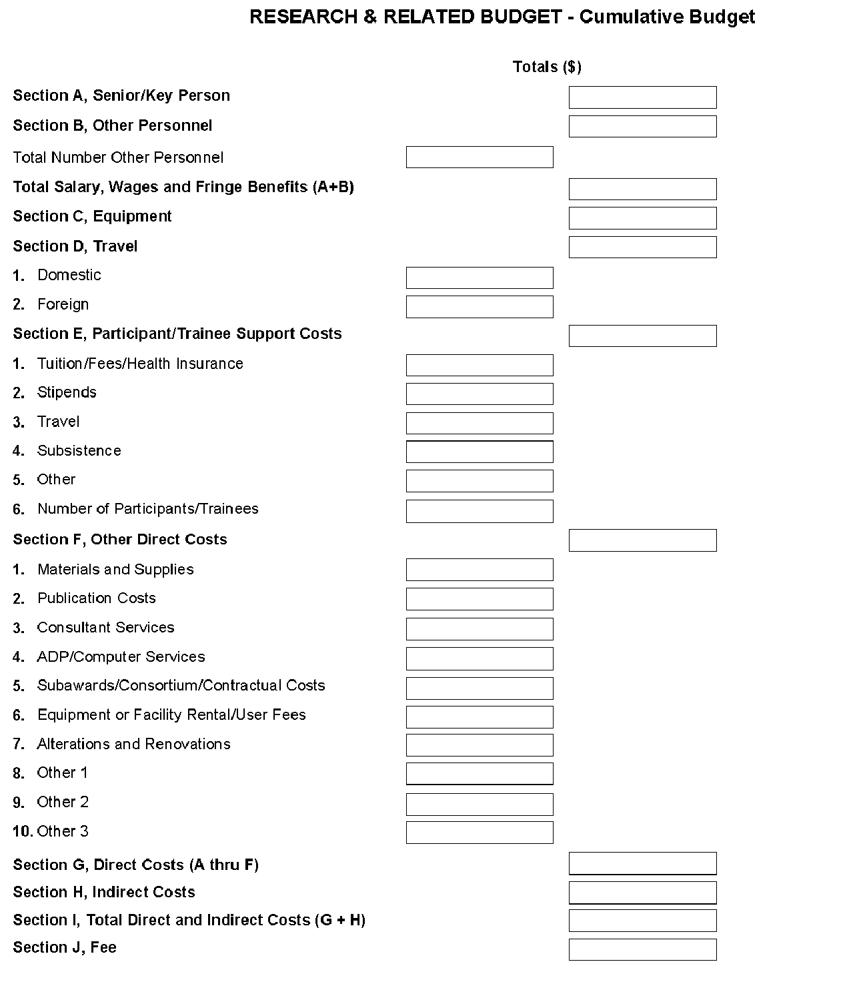

Once all data have been entered, use the scroll bar to scroll up. You will be returned to the Grant Application Package screen. To remove a document from the Submission box, click the document name to select it and then click the Move Form to Delete button. This will return the document to the Mandatory Documents Submission List or Optional Documents Submission List.

4.7 Special Instructions for Preparing Applications with a Subaward/Consortium

SBIR
In Phase I, normally, a minimum of two-thirds or 67% of the research or analytical effort must be carried out by the small business concern. The total amount of all consultant and contractual arrangements to third parties for portions of the scientific and technical effort generally may not exceed 33% of the total amount requested (direct, F&A/indirect, and fee).
If the application is selected for an award, the Authorized Organization Representative (AOR) will need to certify that the applicant and all proposed consortium participants understand and agree to the following statement: The appropriate programmatic and administrative personnel of each organization involved in this grant application are aware of the NIH consortium agreement policy and are prepared to establish the necessary inter-organizational agreement(s) consistent with that policy.
In Phase II, normally, a minimum of one-half or 50% of the research or analytical effort must be carried out by the small business concern. The total amount of consultant and contractual arrangements to third parties for portions of the scientific and technical effort generally may not exceed 50% of the total Phase II amount requested (direct and F&A/indirect).
The basis for determining the percentage of work to be performed by each of the cooperative parties will be the total of the requested costs (direct and F&A/indirect) attributable to each party, unless otherwise described and justified in Item 13, Consortium/Contractual Arrangements, of the PHS 398 Research Plan form.

STTR
In Phase I and Phase II, at least 40% of the work must be performed by the small business concern and at least 30% of the work must be performed by the single partnering research institution. The basis for determining the percentage of work to be performed by each of the cooperative parties will be the total of the requested costs (direct and F&A/indirect) attributable to each party, unless otherwise described and justified in Item 13, Consortium/Contractual Arrangements, of the PHS 398 Research Plan form.
The single “partnering” research institution must provide a letter to the applicant small business concern certifying that at least 30% of the work of the STTR project will be performed by the research institution. The small business concern will include this letter as an attachment upload in Item 13, Consortium/Contractual Arrangements, of the PHS 398 Research Plan form.
In addition, a small business concern must negotiate a written agreement between the small business and the research institution allocating intellectual property rights to carry out follow-on research, development or commercialization. See Model Agreement for the Allocation of Rights. This agreement is required to receive support under the STTR program but is NOT submitted with the application. A copy of the Agreement must be furnished upon request of the NIH awarding component.
A small business concern may subcontract a portion of its SBIR or STTR award to a Federal laboratory within the limits above. A Federal laboratory, as defined in 15 U.S.C. § 3703, means any laboratory, any federally funded research and development center, or any center established under 15 U.S.C. §§ 3705 & 3707 that is owned, leased, or otherwise used by a Federal agency and funded by the Federal Government, whether operated by the Government or by a contractor.A small business concern may subcontract a portion of its STTR award to a Federally Funded Research and Development Center (FFRDC), either in its capacity as the Research Institution or as a participant in the STTR project in another capacity. However, STTR funds may not be used to pay for laboratory resources of non-FFRDCs, and no STTR funds may be used to pay for subcontracting any portion of the STTR award back to the issuing agency or to any other Federal government unit unless a waiver is granted by the Small Business Administration.
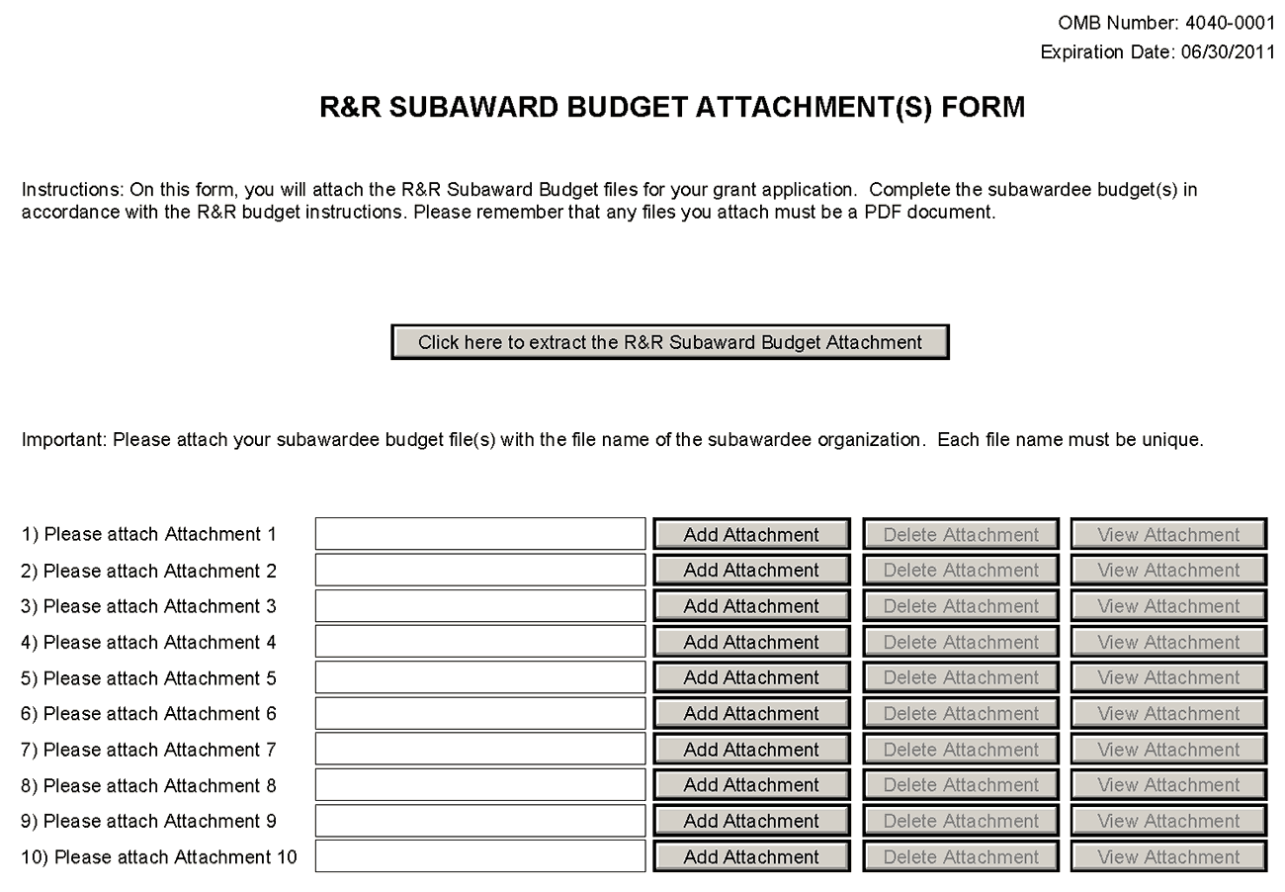
A complete subaward/consortium budget form (including the budget justification section) should be completed by each consortium grantee organization. Separate budgets are required only for subawardee/consortium organizations that perform a substantive portion of the project.
For any subaward or consortium sites, it is appropriate and expected that someone may be designated as the consortium lead investigator responsible for ensuring proper conduct of the project or program at that site. However, when completing the Project Role for the consortium lead investigator, the project role of “PD/PI” should only be used if the entire application is being submitted under the Multiple PI policy. Otherwise, this individual should be assigned some other project role in the senior/key personnel section of the application. Also, the role of Co-PD/PI is not currently used by NIH and other PHS agencies. Assigning an individual(s) the role of "Co-PD/PI" will not identify the application as a Multiple PD/PI application. Although NIH now recognizes the role of “Co-Investigator,” if applicants wish to use the role of “Consortium PI” or some other similar role, select “Other” for the Project Role field and then insert the appropriate role descriptor in the Other Project Role Category field.
NIH continues to support the policy established in April 2004, (revised in November 2004) regarding applications that involve consortium/contractual F&A costs (See NOT-OD-05-004). This policy allows applicants to exclude consortium/contractual F&A costs when determining compliance for any application where a direct cost limit applies. The use of the SF424 (R&R) application with separately submitted subaward/consortium budgets allows NIH to take advantage of a system validation for this policy. When an application is submitted in response to a program with a direct cost limit, the eRA system will perform the calculation by taking the total direct costs requested by the prime/parent organization in their detailed budget, and subtracting all subaward/consortium F&A from each and every subaward budget attached. When the validation calculation equals or exceeds the respective direct cost limit, the application will receive a warning.
This form accommodates a set number of separate subaward budgets (i.e., 10 or 30). If you are submitting an application with more subaward budgets than the form allows, the remaining budgets should be converted to PDF and included as part of Section K. Budget Justification of the parent budget. Reminder, the sum of all subaward budgets; e.g., those attached separately and those provided as part of the budget justification, must be included in Line F.5 Subawards/Consortium/Contractual Costs of the parent budget.
To start the process, the applicant organization should:
- Select the Subaward Budget Attachment Form from the Optional Documents in the Grant Application Package.
- Open the form, and click the Click here to extract the R&R Subaward Budget Attachment button in the middle of the form. A “SAVE” dialog box appears.
- Save the file locally using the first ten letters of the consortium organization’s name and use “.pdf” as the file extension. (The extracted file is an Adobe PDF file.) Once you have saved the file there is no need to extract another budget attachment. Doing so may cause you to lose any data already stored in the saved file.
- E-mail the extracted, saved form to the consortium grantee. Note: consortium grantees must have installed a compatible version of Adobe Reader before they can complete the form. The consortium grantee should complete all the budget information as instructed in the R&R Budget form instructions in Section 4.6. Note: Organizational DUNS and Name of Organization fields must reflect that of the subaward/consortium grantee.
- The consortium grantee must complete the budget form and e-mail it back to the applicant organization.
- A fee cannot be entered for a subaward/consortium budget. Fee is allowable only for the small business applicant organization budget page.
- Return to the Subaward Budget Attachment Form and attach the consortium grantee’s budget to one of the blocks provided on the form.
STTR: If more than one Subaward is included in the STTR application, identify the single, partnering research institution on the RI Subaward budget justification page.

Submitting Subaward Budgets that are not Active for all Periods of the Prime Grant
When submitting subaward budgets that are not active for all periods of the prime grant, fill out the subaward R&R Budget form and include only the number of periods for which the subaward is active. The budget period start/end dates reflected in each period should reflect the corresponding prime budget period start/end dates. This approach is the most workable solution to the limitations in existing forms that do not allow an “empty” budget period and do not allow submission of a subaward budget with zero effort to skip a budget period.
For example, suppose the prime has filled out a budget form with the following periods:
- period 1 Jan, 1 2008 – Dec, 31 2008
- period 2 Jan, 1 2009 – Dec, 31 2009
- period 3 Jan, 1 2010 – Dec, 31 2010
- period 4 Jan, 1 2011 – Dec, 31 2011
- period 5 Jan, 1 2012 – Dec, 31 2012
Now, suppose there is a subaward that performs in support year 1 and does not become active again until support year 4. The subaward can fill out the first two periods of their budget form as follows:
- period 1 Jan, 1 2008 – Dec 31, 2008 (dates correspond to prime period 1)
- period 2 Jan, 1 2011 – Dec 31, 2011 (dates correspond to prime period 4)
It is not necessary that the budget period numbers between the prime and subaward match; the correlation is reflected in the dates. Do be careful, however, that the dates exactly match what is listed for the period in the prime budget.
Note this approach may cause a validation warning regarding the NIH $500,000 per year limit on direct costs, therefore you should document in both the cover letter and the subaward budget justification that the subaward is only active for specific periods of the prime. Appropriate NIH staff has access to the cover letter and reviewers have access to the budget justification. This documentation will make the date correlation immediately apparent and will help avoid any confusion.

Once all data have been entered, use the scroll bar to scroll up. You will be returned to the Grant Application Package screen. To remove a document from the Submission box, click the document name to select it and then click the Move Form to Delete button. This will return the document to the Mandatory Documents Submission List or Optional Documents Submission List.

4.8 SBIR/STTR Information Form
In conjunction with the other SF424 (R&R) forms and PHS 398 forms, NIH, CDC, FDA, and ACF SBIR/STTR grant applicants must also complete and submit the “SBIR/STTR Information” form.
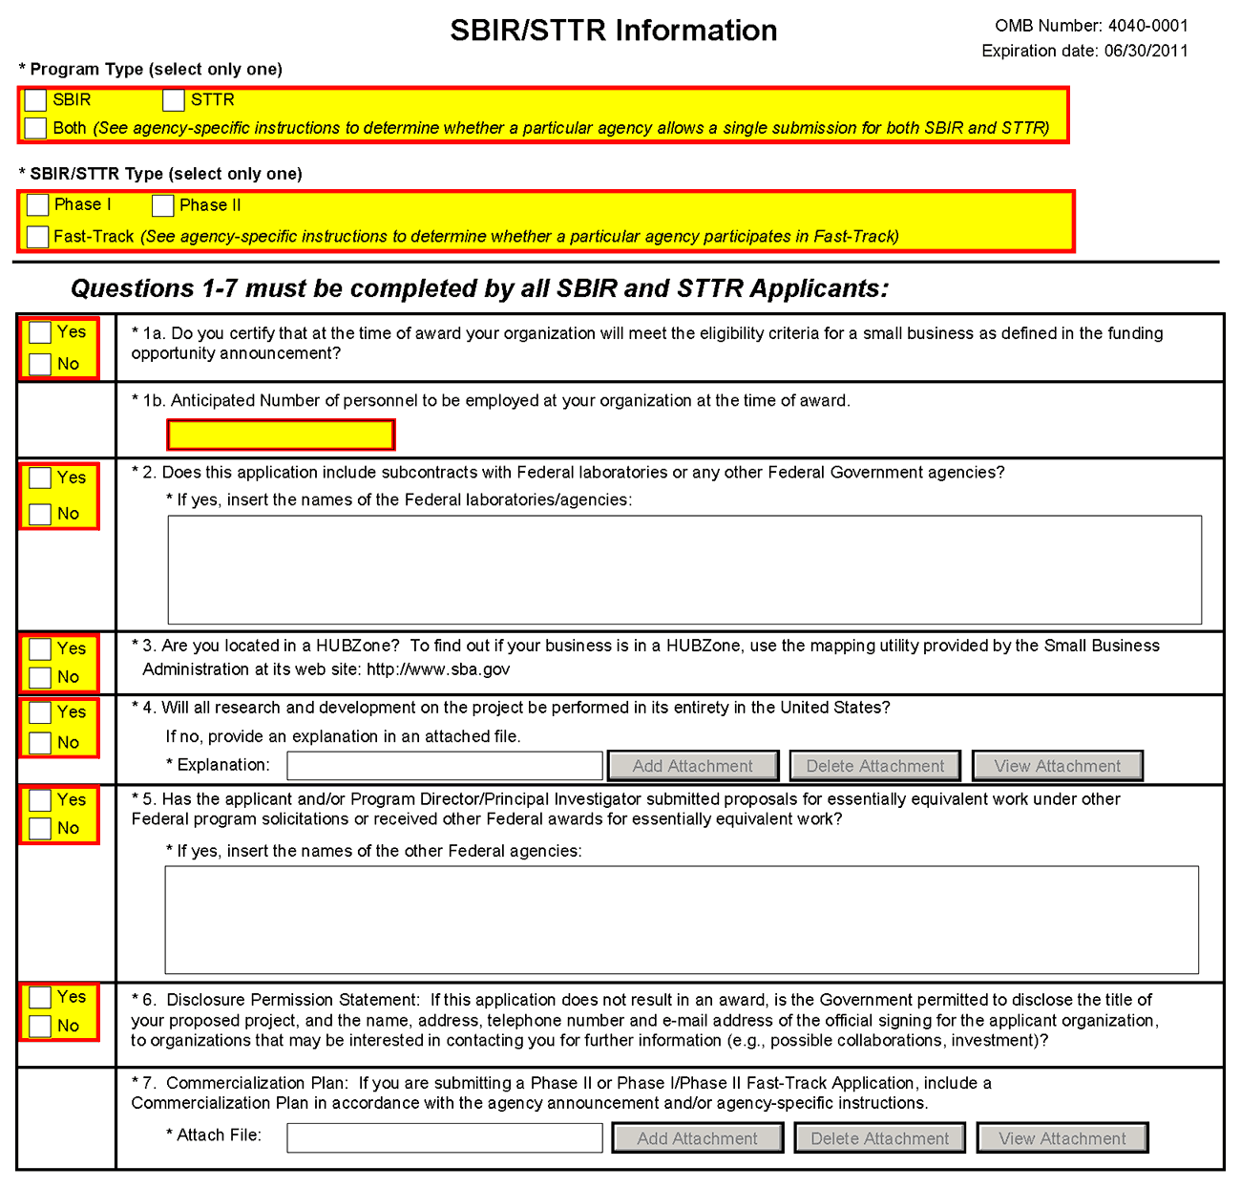
Program Type (select only one): SBIR / STTR / Both
If you are applying under the SBIR program, check the SBIR box. If you are applying under the STTR program, check the STTR box. If a particular agency allows a single submission for both STTR & SBIR, check the Both box. A selection is required.
SBIR/STTR Type (select only one): Phase I / Phase II / Fast-Track
If you are submitting a Phase I application, check the Phase I box. If you are submitting a Phase II application, check the Phase II box. When submitting a Phase II application, please include the Phase I SBIR/STTR grant number in Item #4a (Federal Identifier) on the SF424 (R&R) Cover Form. If you are submitting a Fast-Track application, check the Fast-Track box. A selection is required.
At this time you cannot apply for a SBIR or STTR Phase II if your Phase I award is an STTR or SBIR respectively (i.e. switching programs at Phase II).
At this time you cannot apply for a SBIR or STTR Phase IIB if your Phase II award is an STTR or SBIR respectively (i.e. switching programs at Phase II).
At this time you cannot apply for a “Direct Phase II” SBIR award.
This section will be amended, when these options from the SBIR/STTR Reauthorization Act of 2011 are implemented and available.
1a. Certification of Small Business Eligibility
If you certify that at the time of award, your organization will meet the eligibility criteria for a small business as defined in the FOA, check the Yes box. Otherwise, check the No box. A selection is required.
1b. Anticipated Number of personnel to be employed at your organization at the time of award.
Enter the number of personnel anticipated to be employed by the small business at the time of award.
2. Does this application include subcontracts with Federal laboratories or any other Federal government agencies?
If this application includes subcontracts with Federal laboratories or any other Federal Government agencies, check the Yes box and insert the name of the Federal laboratories/agencies in the space provided. Otherwise, check the No box. A selection is required.
3. Are you located in a HUBZone?
If you are located in a HUBZone, check the Yes box. To find out if your business is in a HUBZONE, use the mapping utility provided by the Small Business Administration at its Web site: http://www.sba.gov. Otherwise, check the No box. A selection is required.
4. Will all research and development on the project be performed in its entirety in the United States?
If all research and development on the project will be performed in its entirety in the United States, check the Yes box. Otherwise, check the No box and use the Add Attachment button below, to attach an explanation. A selection is required.
If you have answered "no" to question 4 above, please prepare an explanation of the research and development that is being performed outside the United States, in a separate file. Then use the Add Attachment button to the right of this field to attach the file and complete this entry. When you click Add Attachment, browse to where you saved the file, select the appropriate file and then click Open to complete the action.
5. Has the applicant and/or Program Director/Principal Investigator submitted proposals for essentially equivalent work under other Federal program solicitations or received other Federal awards for essentially equivalent work?
If the applicant and/or PD/PI has submitted proposals for essentially equivalent work under other Federal program solicitations or received other Federal awards for essentially equivalent work, check the Yes box and insert the names of the other Federal agencies in the space provided. Otherwise, check the No box. A selection is required.
6. Disclosure Permission Statement
If this application does not result in an award, and the Government is permitted to disclose the title of your proposed project, and the name, address, telephone number, and e-mail address of the official signing for the applicant organization, to organizations that may be interested in contacting you for further information (e.g., possible collaborations, investment), check the Yes box. Otherwise check the No box. A selection is required.
Your response will not affect any peer review or funding decisions.

7. Commercialization Plan
(Applicable to all Phase II and Phase IIB Applications and Phase I/Phase II Fast-Track Applications.)
If you are submitting a Phase II, Phase IIB or Phase I/Phase II Fast-Track application, include a Commercialization Plan in accordance with the agency announcement and/or agency-specific instructions. To attach a Commercialization Plan file, click the Add Attachment button to the right of this field, browse to where you saved the file, select the file, and then click Open.
All Phase II, Phase IIB and Fast-Track applications must include a succinct Commercialization Plan. The Commercialization Plan is limited to 12 pages. Be succinct. There is no requirement for applicants to use the maximum allowable pages allotted to the Commercialization Plan.
Create a document entitled, “Commercialization Plan,” and provide a description in each of the following areas:
a. Value of the SBIR/STTR Project, Expected Outcomes, and Impact. Describe, in layperson's terms, the proposed project and its key technology objectives. State the product, process, or service to be developed in Phase III. Clarify the need addressed, specifying weaknesses in the current approaches to meet this need. In addition, describe the commercial applications of the research and the innovation inherent in this application. Be sure to also specify the potential societal, educational, and scientific benefits of this work. Explain the non-commercial impacts to the overall significance of the project. Explain how the SBIR/STTR project integrates with the overall business plan of the company.
b. Company. Give a brief description of your company including corporate objectives, core competencies, present size (annual sales level and number and types of employees), history of previous Federal and non-Federal funding, regulatory experience, and subsequent commercialization, and any current products/services that have significant sales. Include a short description of the origins of the company. Indicate your vision for the future, how you will grow/maintain a sustainable business entity, and how you will meet critical management functions as your company evolves from a small technology R&D business to a successful commercial entity.
c. Market, Customer, and Competition. Describe the market and/or market segments you are targeting and provide a brief profile of the potential customer. Tell what significant advantages your innovation will bring to the market, e.g., better performance, lower cost, faster, more efficient or effective, new capability. Explain the hurdles you will have to overcome in order to gain market/customer acceptance of your innovation.
Describe any strategic alliances, partnerships, or licensing agreements you have in place to get FDA approval (if required) and to market and sell your product.
Briefly describe your marketing and sales strategy. Give an overview of the current competitive landscape and any potential competitors over the next several years. (It is very important that you understand and know the competition.)
d. Intellectual Property (IP) Protection. Describe how you are going to protect the IP that results from your innovation. Also note other actions you may consider taking that will constitute at least a temporal barrier to others aiming to provide a solution similar to yours.
e. Finance Plan. Describe the necessary financing you will require to commercialize the product, process, or service, and when it will be required. Describe your plans to raise the requisite financing to launch your innovation into Phase III and begin the revenue stream. Plans for this financing stage may be demonstrated in one or more of the following ways:
Letter of commitment of funding.
Letter of intent or evidence of negotiations to provide funding, should the Phase II project be successful and the market need still exist.
Letter of support for the project and/or some in-kind commitment, e.g., to test or evaluate the innovation.
Specific steps you are going to take to secure Phase III funding.
f. Production and Marketing Plan. Describe how the production of your product/process/service will occur (e.g., in-house manufacturing, contract manufacturing). Describe the steps you will take to market and sell your product/process/service. For example, explain plans for licensing, Internet sales, etc.
g. Revenue Stream. Explain how you plan to generate a revenue stream for your company should this project be a success. Examples of revenue stream generation include, but are not limited to, manufacture and direct sales, sales through value added resellers or other distributors, joint venture, licensing, service. Describe how your staffing will change to meet your revenue expectations.
Applicants are encouraged to seek commitment(s) of funds and/or resources from an investor or partner organization for commercialization of the product(s) or service(s) resulting from the SBIR/STTR grant. Place relevant letters following letters from consultants and collaborators in Item 14, Letters of Support in the PHS 398 Research Plan Form.
Your Phase III funding may be from any of a number of different sources including, but not limited to: SBIR/STTR firm itself; private investors or “angels”; venture capital firms; investment companies; joint ventures; R&D limited partnerships; strategic alliances; research contracts; sales of prototypes (built as part of this project); public offering; state finance programs; non SBIR-funded R&D or production commitments from a Federal agency with the intention that the results will be used by the United States government; or other industrial firms.

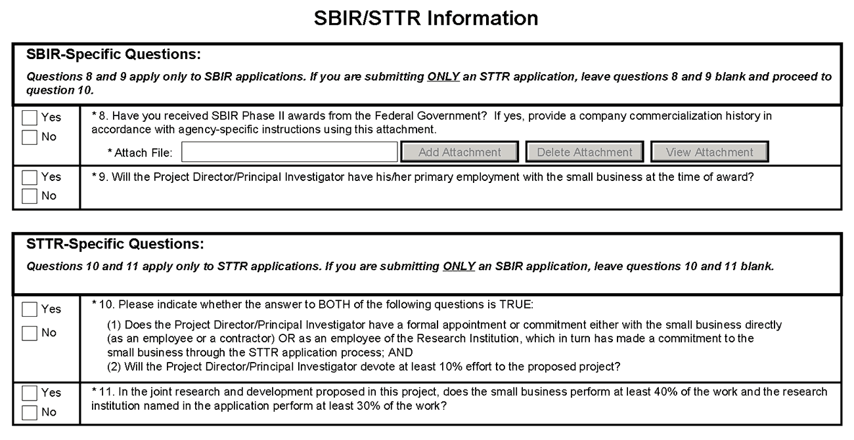
SBIR-Specific Questions:
8. Have you received SBIR Phase II awards from the Federal Government? If yes, provide a commercialization history in accordance with agency-specific instructions
If you have received SBIR Phase II awards from the Federal Government, check the Yes box and use the Add Attachment button below to attach a company commercialization history in accordance with agency-specific instructions. Otherwise check the No box.
If the applicant small business has received an SBIR Phase II awards issued by NIH or any other Federal Government agency, attach a file that includes either: (1) a statement indicating that the applicant small business has not received more than 15 SBIR Phase II awards from the Federal Government during the preceding five fiscal years; or (2) a company commercialization history if the applicant small business has received more than 15 Phase II SBIR awards from the Federal Government during the preceding five fiscal years. The history must document the extent to which the company was able to secure Phase III funding to develop concepts resulting from previous Phase II SBIR awards, and for each Phase II award the history must include: (1) name of awarding agency; (2) award number and date; (3) amount of award; (4) title of project; (5) source, date, and amount of Phase III funding agreement; and (6) commercialization status of each Phase II award.
9. Will the Project Director/Principal Investigator have his/her primary employment with the small business at the time of award?
If the PD/PI will have his/her primary employment with the small business at the time of award, check the Yes box. Otherwise, check the No box.
A selection is required for SBIR applications only.

STTR-Specific Questions:
10. Does the Project Director/Principal Investigator have a formal appointment or commitment either with the small business directly (as an employee or contractor) OR as an employee of the Research Institution, which in turn has made a commitment to the small business through the STTR application process, AND will the Project Director/Principal Investigator devote at least 10% effort to the proposed project?
Check the Yes box only if both of the following conditions is true:
(1) The PD/PI has a formal appointment or commitment either with the small business directly (as an employee or a contractor) OR as an employee of the Research Institution, which in turn has made a commitment to the small business through the STTR application process; and
(2) The PD/PI will devote at least 10% effort to the proposed project.
Check the No box if either of these two conditions (or both) is false.
11. In the joint research and development proposed in this project, does the small business perform at least 40% of the work and the research institution named in the application perform at least 30% of the work?
If in the joint research and development proposed in this project, the small business performs at least 40% of the work and the research institution named in the application performs at least 30% of the work, check the Yes box. Otherwise, check the No box.

Once all data have been entered, click the Close Form button at the top of the form or use the scroll bar to scroll up. You will be returned to the Grant Application Package screen. To remove a document from the Submission box, click the document name to select it and then click the Move Form to Delete button. This will return the document to the Mandatory Documents Submission List or Optional Documents Submission List.

5. Completing PHS 398 Forms

5.1 Overview
In conjunction with the SF424 (R&R) forms, NIH and other PHS agencies grants applicants should also complete and submit additional forms titled “PHS 398.” Note the PHS 398 forms include additional data required by the agency for a complete application. While these are not identical to the PHS 398 application form pages, the PHS 398 reference is used to distinguish these additional data requirements from the data collected in the SF424 (R&R) forms. A complete application to NIH and other PHS agencies will include SF424 (R&R) and PHS 398 forms. The PHS 398 forms include:
- PHS 398 Cover Page Supplement (this supplements the data requirements in the R&R Cover form)
- PHS 398 Research Plan Form
- PHS 398 Checklist Form
Complete each form using the instructions provided below.

5.2 Cover Letter Form
Applicants are encouraged to include a cover letter with the application. The cover letter is only for internal use and will not be shared with peer reviewers. The letter should contain any of the following information that applies to the application:
1. Application title.
2. Funding Opportunity (PA or RFA) title of the NIH initiative.
3. Request of an assignment (referral) to a particular awarding component(s) or Scientific Review Group (SRG). The PHS makes the final determination.
4. List of individuals (e.g., competitors) who should not review your application and why.
5. Disciplines involved, if multidisciplinary.
6. For late applications (see Late Application policy in Section 2.14) include specific information about the timing and nature of the cause of the delay.
7. When submitting a Changed/Corrected Application after the submission date, a cover letter is required explaining the reason for the Changed/Corrected Application. If you already submitted a cover letter with a previous submission and are now submitting a Changed/Corrected Application, you must include all previous cover letter text in the revised cover letter attachment. The system does not retain any previously submitted cover letters until after an application is verified; therefore, you must repeat all information previously submitted in the cover letter as well as any additional information.
8. Explanation of any subaward budget components that are not active for all periods of the proposed grant.
9. Statement that you have attached any required agency approval documentation for the type of application submitted.
To attach the approval documents to this submission, please append those referenced documents to your Cover Letter File, and upload as one attachment.
Suggested Cover Letter Format
The Division of Receipt and Referral (DRR), Center for Scientific Review (CSR) is responsible for assigning applications to ICs and to scientific review groups (SRGs). DRR will be utilizing knowledge management approaches as an adjunct to the work of referral experts as part of an overall plan to shorten the time from submission to review. Analysis has shown that requests made by investigators are a valuable source of information in this process. In order to facilitate the use of these requests in conjunction with knowledge management analysis of the content of the application, applicants are requested to use the following format when assignment requests are contained in a cover letter.
- List one request per line.
- Place institute/center (IC) and SRG review requests (if both are made) on separate lines.
- Place positive and negative requests (if both are made) on separate lines.
- Include name of IC or SRG, followed by a dash and the acronym. Do not use parentheses.
- Provide explanations for each request in a separate paragraph.
Examples:
Please assign this application to the following:
Institutes/Centers
National Cancer Institute - NCI
National Institute for Dental and Craniofacial Research – NIDCR
Scientific Review Groups
Molecular Oncogenesis Study Section – MONC
Cancer Etiology Study Section – CE
Please do not assign this application to the following:
Scientific Review Groups
Cancer Genetics Study Section – CG
The reasons for this request are [provide a narrative explanation for the request(s)].
Save this information in a single file in a location you remember and convert the file to PDF. Click Add Cover Letter File, browse to where you saved the file, select the file, and then click Open. The name of the file attached will automatically appear in the “Mandatory Cover Letter Filename” field.

Once all data have been entered, use the scroll bar to scroll up. You will be returned to the Grant Application Package screen. To remove a document from the Submission box, click the document name to select it and then click the Move Form to Delete button. This will return the document to the Mandatory Documents Submission List or Optional Documents Submission List.

5.3 Cover Page Supplement Form
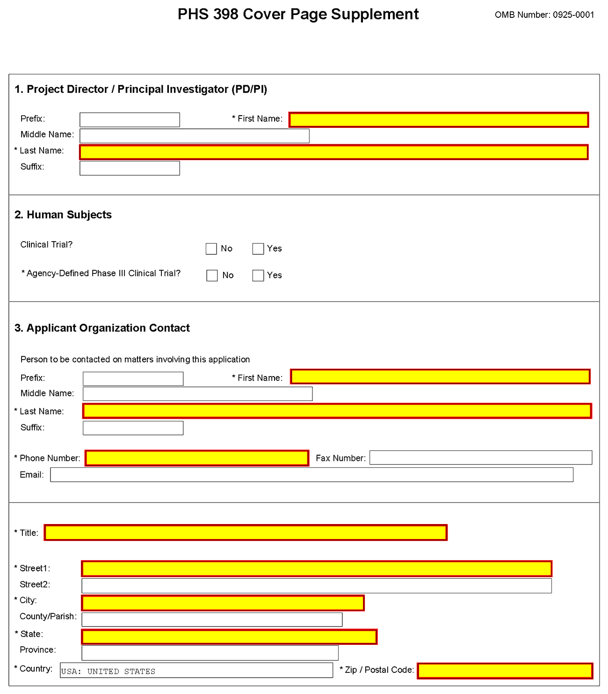
1. Program Director/Principal Investigator (PD/PI)
Field Name | Instructions
Prefix | Pre-populated from the SF424 (R&R). The prefix (for example, Mr., Mrs., Rev.) for the name of the PD/PI.
First Name | Pre-populated from the SF424 (R&R). The first (given) name of the PD/PI. This field is required.
Middle Name | Pre-populated from the SF424 (R&R). The middle name of the PD/PI.
Last Name | Pre-populated from the SF424 (R&R). The last (family) name of the PD/PI. This field is required.
Suffix | Pre-populated from the SF424 (R&R). The suffix (for example, Jr., Sr., PhD) for the name of the PD/PI.
2. Human Subjects
Field Name | Instructions
Agency-Defined Phase III Clinical Trial | Check the Yes or No box to indicate whether the project is an NIH-defined Phase III clinical trial.  An NIH-defined Phase III clinical trial is a broadly based prospective Phase III clinical investigation, usually involving several hundred or more human subjects, for the purpose of either evaluating an experimental intervention in comparison with a standard or control intervention or of comparing two or more existing treatments. Often the aim of such investigation is to provide evidence leading to a scientific basis for consideration of a change in health policy or standard of care. The definition includes pharmacologic, non-pharmacologic, and behavioral interventions given for disease prevention, prophylaxis, diagnosis, or therapy. Community trials and other population-based intervention trials are also included.
3. Applicant Organization Contact
Field Name |  | Instructions
Prefix |  | Pre-populated from the SF424 (R&R). The prefix (for example, Mr., Mrs., Rev.) for the name of the Applicant Organization Contact.
First Name |  | Pre-populated from the SF424 (R&R). The first (given) name of the Applicant Organization Contact. This field is required.
Middle Name |  | Pre-populated from the SF424 (R&R). The middle name of the Applicant Organization Contact.
Last Name |  | Pre-populated from the SF424 (R&R). The last (family) name of the Applicant Organization Contact. This field is required.
Suffix |  | Pre-populated from the SF424 (R&R). The suffix (for example, Jr., Sr., PhD) for the name of the Applicant Organization Contact.
 | Phone Number |  | Pre-populated from the SF424 (R&R). It is the daytime phone number for the Applicant Organization Contact. This field is required.
 | Fax Number |  | Pre-populated from the SF424 (R&R). It is the fax number for the Applicant Organization Contact.
 | Email |  | Pre-populated from the SF424 (R&R). It is the email address for the Applicant Organization Contact number for the Applicant Organization Contact.
 | Title |  | Enter the title of the Applicant Organization Contact.
 | Street1 |  | Enter the first line of the street address for the Applicant Organization Contact in the “Street1” field. This field is required.
 | Street2 |  | Enter the second line of the street address for the Applicant Organization Contact in the “Street2” field. This field is optional.
 | City |  | City for address of the Applicant Organization Contact. This field is required.
 | County/Parish |  | Enter the county or parish for address of the Applicant Organization Contact.
 | State |  | Enter the State where the Applicant Organization Contact is located. This field is required if the Applicant Organization Contact is located in the United States.
 | Province |  | Enter the Province for the Applicant Organization Contact.  If “Country” is not Canada, please leave blank.
 | Country |  | Select the country for the Applicant Organization Contact address.
 | Zip/Postal Code |  | Enter the nine-digit Postal Code (e.g., ZIP Code) of the Authorized Representative. This field is required if the Applicant Organization Contact is located in the United States.
Your response will not affect any peer review or funding decisions.

Once all data have been entered use the scroll bar to scroll up. You will be returned to the Grant Application Package screen. To remove a document from the Submission box, click the document name to select it and then click the Move Form to Delete button. This will return the document to the Mandatory Documents Submission List or Optional Documents Submission List.

5.4 PHS 398 Research Plan Form
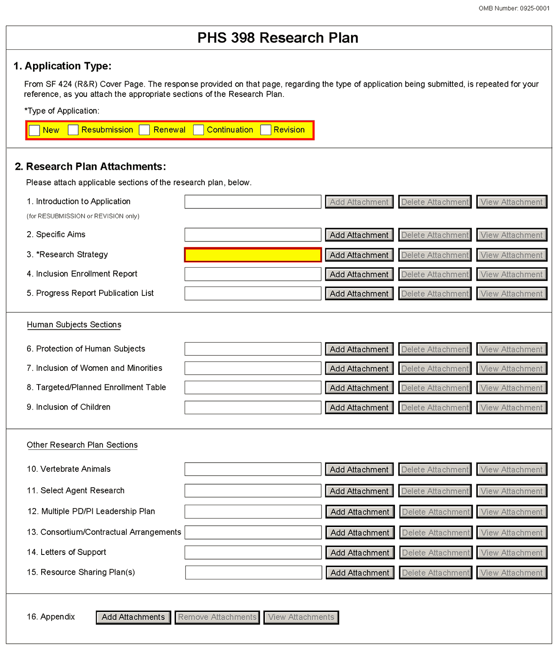
The Research Plan should include sufficient information needed for evaluation of the project, independent of any other document (e.g., previous application). Be specific and informative, and avoid redundancies.
Your SBIR/STTR application should represent a sound approach to the investigation of an important biomedical research, behavioral research, technological, engineering or scientific question, and be worthy of support under the stated criteria of this program solicitation. It should be self-contained and written with the care and thoroughness accorded to papers for publication. Review the application carefully to ensure that information essential for evaluation is included. The scientific and technical merit of the proposed research is the primary concern for all research supported by NIH, CDC, FDA, and ACF.
You are strongly encouraged to contact agency program staff for pre-application guidance and/or for more specific information on the research topics described in this solicitation.
A firm must not propose market research, patent applications, or litigation. The research may be carried out through construction and evaluation of a laboratory prototype, where necessary.
Research Plan Attachments (see also Section 2.3.2 Creating PDFs for Text Attachments)
Although many of the sections of this application are separate PDF attachments, page limits referenced in the instructions and/or funding opportunity announcement must still be followed. Agency validations will include checks for page limits (and use of appropriate font). Some accommodation will be made for sections that, when combined, must fit within a specified limitation.
Text attachments should be generated using word processing software and then converted to PDF using PDF generating software. Avoid scanning text attachments to convert to PDF since that causes problems for the agency handling the application. In addition, be sure to save files with descriptive file names.
Do not include any information in a header or footer of the attachments. A header will be system-generated that references the name of the PD/PI. Page numbers for the footer will be system-generated in the complete application, with all pages sequentially numbered.
Since a number of reviewers will be reviewing applications as an electronic document and not a paper version, applicants are strongly encouraged to use only a standard, single-column format for the text. Avoid using a two-column format since it can cause difficulties when reviewing the document electronically.
Full-sized glossy photographs of material such as electron micrographs or gels must only be included within the page limits of the Research Strategy. The maximum size of images to be included should be approximately 1200 x 1500 pixels using 256 colors. Figures must be readable as printed on an 8.5 x 11 inch page at normal (100%) scale.
Investigators must use image compression such as JPEG or PNG. Do not include figures or photographs as separate attachments either in the Appendix or elsewhere in the application.
Separate Attachments
Separate attachments have been designed for the Research Plan sections to maximize automatic validations conducted by the eRA system. When the application is received by the agency, all of the Research Plan sections will be concatenated in the appropriate order so that reviewers and agency staff will see a single cohesive Research Plan.
When attaching a PDF document to the actual forms, please note you are attaching an actual document, not just pointing to the location of an externally stored document. Therefore, if you revise the document after it has been attached, you must delete the previous attachment and then reattach the revised document to the application form. Use the View Attachment button to determine if the correct version has been attached.
Page Limits
Applicants must follow the page limits described in Table 2.6-1 unless the FOA specifies otherwise. All tables, graphs, figures, diagrams, and charts must be included within the Research Strategy page limit. If PAs or RFAs contain specific page limits, those instructions always supersede these instructions.
All applications and proposals for NIH funding must be self-contained within specified page limits. Agency validations will include checks for page limits. Note that while these computer validations will help minimize incomplete and/or non-compliant applications, they do not replace the validations conducted by NIH staff. Applications found not to comply with the requirements may be delayed in the review process. Unless otherwise specified in an NIH solicitation, Internet Web site addresses (URLs) may not be used to provide information necessary to the review because reviewers are not obligated to view the Internet sites. Moreover, reviewers are cautioned that they should not directly access an Web site (except to review publications cited in the Biographical Sketch or Progress Report publication list) as it could compromise their anonymity.
Applicants are prohibited from using the Appendix to circumvent page limitations in any section of the application for which a page limit applies. For additional information regarding Appendix material and page limits, please refer to the NIH Guide Notice NOT-OD-11-080, http://grants.nih.gov/grants/guide/notice-files/NOT-OD-11-080.html.
Notice of Proprietary Information
Applicants are discouraged from submitting information considered proprietary unless it is deemed essential for proper evaluation of the application. However, when the application contains information that constitutes trade secrets, or information that is commercial or financial, or information that is confidential or privileged, make sure you have checked the “Yes” box of question #3 in the “Other Project Information” form.
When information in the application constitutes trade secrets or information that is commercial or financial, or information that is confidential or privileged, it is furnished to the Government in confidence with the understanding that the information shall be used or disclosed only for evaluation of this application. However, if a grant is awarded as a result of or in connection with the submission of this application, the Government shall have the right to use or disclose the information to the extent authorized by law. This restriction does not limit the Government’s right to use the information if it is obtained without restriction from another source.
Although the grantee institution and the PD/PI will be consulted about any such release, the PHS will make the final determination. Any indication by the applicant that the application contains proprietary or privileged information does not automatically shield the information from release in response to a Freedom of Information Act (FOIA) request should the application result in an award (see 45 CFR Part 5). If an applicant fails to identify proprietary information at the time of submission as instructed in the application guide, a significant substantive justification will be required to withhold the information if requested under FOIA.
Begin each text section of the Research Plan with a section header (e.g., Introduction, Specific Aims, Research Strategy, etc).
Field Name | Instructions
1. Introduction to Application (for Resubmission or Revision only) | See specific instructions in Part I Section 2.7, Resubmission Applications and Part I Section 2.8, Revision Applications on the content of the Introduction. First time (new) applications should not include an Introduction unless specified in the FOA.  The Introduction is a required attachment for Resubmissions and Revisions.  A resubmission application must include substantial changes. Identify the changes in the Research Strategy section clearly by bracketing, indenting, or changing typography, unless the changes are so extensive as to include most of the text. This exception should be explained in the Introduction. Do not underline or shade changes.  Introductions for ALL SBIR or STTR applications are limited to one (1) page. This includes Phase I, Phase II, Fast-Track, and Phase IIB Competing Renewals applications.  Save this information in a single file in a location you remember. Click Add Attachment, browse to where you saved the file, select the file, and then click Open.
2. Specific Aims | The Specific Aims attachment is required unless otherwise specified in the FOA.  Phase I Applications: State the specific objectives of the Phase I research and development effort, including the technical questions you will try to answer to determine the Phase I feasibility of the proposed approach and the impact that the results of the proposed research will exert on the research field(s) involved. State concisely and realistically what the proposed research is intended to accomplish in terms of its potential for technological innovation and commercial application. Define the proposed product, process or service to ultimately be developed. Include milestones for each of the aims as these will be used in the evaluation process.  Phase II and Phase IIB Applications: State the specific objectives of the Phase II research and development effort including the impact that the results of the proposed research will exert on the research field(s). State concisely and realistically what the proposed research is intended to accomplish in terms of its potential for technological innovation and commercial application. Define the proposed product, process or service to ultimately be developed. Include milestones for each of the aims as these will be used in the evaluation process.  Fast-Track Applications: Create a heading titled “Phase I Specific Aims”, and follow the instructions above for “Phase I Applications.” Next, create a heading titled “Phase II Specific Aims” and follow the instructions above for “Phase II Applications.”  “Specific Aims” for ALL SBIR or STTR applications are limited to one (1) page. This includes Phase I, Phase II, Fast-Track, and Phase IIB Competing Renewals.  Save this information in a single file in a location you remember. Click Add Attachment, browse to where you saved the file, select the file, and then click Open.
3. Research Strategy | Organize the Research Strategy in the specified order and using the instructions provided below. Start each section with the appropriate section heading – Significance, Innovation, Approach. Cite published experimental details in the Research Strategy section and provide the full reference in the Bibliography and References Cited section (Part I Section 4.4.9).  Follow the page limits for the Research Strategy in the table of page limits (Table 2.6-1), unless specified otherwise in the FOA. Note that the page limit for this attachment will be validated as a single file.  - Significance  - Explain the importance of the problem or critical barrier to progress in the field that the proposed project addresses.  - Explain how the proposed project will improve scientific knowledge, technical capability, and/or clinical practice in one or more broad fields.  - Describe how the concepts, methods, technologies, treatments, services, or preventative interventions that drive this field will be changed if the proposed aims are achieved.  - Explain the project’s potential to lead to a marketable product, process or service.  - For Phase II, Fast-Track, and Phase IIB Competing Renewals, explain how the commercialization plan demonstrates a high probability of commercialization.  - Innovation  - Explain how the application challenges and seeks to shift current research or clinical practice paradigms.  - Describe any novel theoretical concepts, approaches or methodologies, instrumentation or interventions to be developed or used, and any advantage over existing methodologies, instrumentation, or interventions.  - Explain any refinements, improvements, or new applications of theoretical concepts, approaches or methodologies, instrumentation, or interventions.  - Approach  - Describe the overall strategy, methodology, and analyses to be used to accomplish the specific aims of the project. Provide a tentative sequence or timetable for the project. Unless addressed separately in Item 15 (Resource Sharing Plan), include how the data will be collected, analyzed, and interpreted as well as any resource sharing plans as appropriate.  - Discuss potential problems, alternative strategies, and benchmarks for success anticipated to achieve the aims.  - If the project is in the early stages of development, describe any strategy to establish feasibility, and address the management of any high risk aspects of the proposed work.  - Point out any procedures, situations, or materials that may be hazardous to personnel and precautions to be exercised. A full discussion on the use of select agents should appear in Item 11, below.  - If research on Human Embryonic Stem Cells (hESCs) is proposed but an approved cell line from the NIH hESC Registry cannot be identified, provide a strong justification for why an appropriate cell line cannot be chosen from the Registry at this time.  If an applicant has multiple Specific Aims, then the applicant may address Significance, Innovation and Approach for each Specific Aim individually, or may address Significance, Innovation and Approach for all of the Specific Aims collectively.  As applicable, also include the following information as part of the Research Strategy, keeping within the three sections listed above: Significance, Innovation, and Approach.  Preliminary Studies for Phase I Applications: Preliminary data are not required for Phase I applications; however, such results may assist reviewers in assessing the likelihood of success of the proposed project and may be included in the Research Strategy section.  Progress Report for Phase II and Phase IIB Competing Renewal and Revision Applications. For Phase II and Phase IIB Competing Renewal and Revision applications, provide a Progress Report. Provide the beginning and ending dates for the period covered since the last competitive review. Summarize the specific aims of the previous project period and the importance of the findings, and emphasize the progress made toward their achievement. Explain any significant changes to the previous specific aims and any new directions including changes resulting from significant budget reductions. Describe the technology developed from this SBIR/STTR, its intended use and who will use it. Describe the current status of the product (e.g., under development, commercialized, in use, discontinued). If applicable, describe the status of FDA approval for your product, process, or service (e.g., continuing pre-IND studies, filed on IND, in Phase I (or II or III) clinical trials, applied for approval, review ongoing, approved, not approved). List the generic and/or commercial names of products. A list of publications, patents, and other printed materials should be included in Item 5 (Progress Report Publication List); do not include that information here.  Progress Report for Fast-Track Applications. For Fast-Track applications, the Phase I Final Report is submitted to the awarding component after the Phase I research is completed so is not included in a Fast-Track application. Refer to your Notice of Award for instructions for preparing and submitting a Phase I Final Progress Report.
4. Cumulative Inclusion Enrollment Report | Phase IIB Competing Renewal applications: If the renewal or revision application involves clinical research, then you must report on the enrollment of research subjects and their distribution by ethnicity/race and sex/gender, race, and ethnicity.  See Supplemental Instructions Part II, Section 4.3 for more detailed instructions.
5. Progress Report Publication List (Renewal Applications Only) | Phase II and Phase IIB Applications: List the titles and complete references to all appropriate publications, manuscripts accepted for publication, patents, copyrights, trademarks, invention reports and other printed materials, if any, that resulted from the Phase I or describe patent status, trade secrets or other demonstration of IP protection, and other printed materials that have resulted from the Phase I effort. When citing articles that fall under the Public Access Policy, were authored or co-authored by the applicant and arose from NIH support, provide the NIH Manuscript Submission reference number (e.g., NIHMS97531) or the PubMed Central (PMC) reference number (e.g., PMCID234567) for each article. If the PMCID is not yet available because the Journal submits articles directly to PMC on behalf of their authors, indicate “PMC Journal – In Process.” A list of these journals is posted at: http://publicaccess.nih.gov/submit_process_journals.htm.  Citations that are not covered by the Public Access Policy, but are publicly available in a free, online format may include URLs or PubMed ID (PMID) numbers along with the full reference (note that copies of these publications are not accepted as appendix material).

Human Subjects Sections
Field Name | Instructions
6. Protection of Human Subjects | Refer to Part II, Supplemental Instructions for Preparing the Human Subjects Section of the Research Plan. This section is required for applicants answering “yes” to the question “Are human subjects involved?” on the R&R Other Project Information form. If the answer is “No” to the question but the proposed research involves human specimens and/or data from subjects applicants must provide a justification in this section for the claim that no human subjects are involved.  Do not use the protection of human subjects section to circumvent the page limits of the Research Strategy.  Save this information in a single file in a location you remember. Click Add Attachment, browse to where you saved the file, select the file, and then click Open.
7. Inclusion of Women and Minorities | Refer to Part II, Supplemental Instructions for Preparing the Human Subjects Section of the Research Plan. This section is required for applicants answering “yes” to the question “Are human subjects involved?” on the R&R Other Project Information form and the research does not fall under Exemption 4.  Save this information in a single file in a location you remember. Click Add Attachment, browse to where you saved the file, select the file, and then click Open.
8. Planned Enrollment Report | If this application involves the Inclusion of Women and Minorities, applicants must complete the Planned Enrollment Report for each study; see Part II, Supplemental Instructions for Preparing the Human Subjects Section of the Research Plan, Section 4.3. For applicants answering “Yes” to the question “Are human subjects involved?” on the R&R Other Project Information Form and the research does not fall under Exemption 4, complete the Planned Enrollment Report for each study.  Save this information in a single file in a location you remember. Click Add Attachment, browse to where you saved the file, select the file, and then click Open.
9. Inclusion of Children | Refer to Supplemental Instructions for Preparing the Human Subjects Section of the Research Plan, Sections 4.4 and 5.7. For applicants answering “Yes” to the question “Are human subjects involved” on the R&R Other Project Information Form and the research does not fall under Section 4, this section is required.  Save this information in a single file in a location you remember. Click Add Attachment, browse to where you saved the file, select the file, and then click Open.
Other Research Plan Sections
Field Name | Instructions
10. Vertebrate Animals | This section is required for applicants answering “Yes” to the question “Are vertebrate animals involved?” on the R&R Other Project Information form.  If Vertebrate Animals are involved in the project, address each of the five points below. This section should be a concise, complete description of the animals and proposed procedures. While additional details may be included in the Research Strategy, the responses to the five required points below must be cohesive and include sufficient detail to allow evaluation by peer reviewers and NIH staff. If all or part of the proposed research involving vertebrate animals will take place at alternate sites (such as project/performance or collaborating site(s)), identify those sites and describe the activities at those locations. Although no specific page limitation applies to this section of the application, be succinct. Failure to address the following five points will result in the application being designated as incomplete and will be grounds for the PHS to defer the application from the peer review round. Alternatively, the application’s impact/priority score may be negatively affected.  If the involvement of animals is indefinite, provide an explanation and indicate when it is anticipated that animals will be used. If an award is made, prior to the involvement of animals the grantee must submit to the NIH awarding office detailed information as required in points 1-5 below and verification of IACUC approval. If the grantee does not have an Animal Welfare Assurance, then an applicable Animal Welfare Assurance will be required (see Part III Section 2.2 Vertebrate Animals for more information).  The five points are as follows:  1. Provide a detailed description of the proposed use of the animals in the work outlined in the Research Strategy section. Identify the species, strains, ages, sex, and numbers of animals to be used in the proposed work.  2. Justify the use of animals, the choice of species, and the numbers to be used. If animals are in short supply, costly, or to be used in large numbers, provide an additional rationale for their selection and numbers.  3. Provide information on the veterinary care of the animals involved.  4. Describe the procedures for ensuring that discomfort, distress, pain, and injury will be limited to that which is unavoidable in the conduct of scientifically sound research. Describe the use of analgesic, anesthetic, and tranquilizing drugs and/or comfortable restraining devices, where appropriate, to minimize discomfort, distress, pain, and injury.  5. Describe any method of euthanasia to be used and the reasons for its selection. State whether this method is consistent with the recommendations of the American Veterinary Medical Association (AVMA) Guidelines on Euthanasia. If not, include a scientific justification for not following the recommendations.  Do not use the vertebrate animal section to circumvent the page limits of the Research Strategy.  Save this information in a single file in a location you remember. Click Add Attachment, browse to where you saved the file, select the file, and then click Open.
11. Select Agent Research | Select agents are hazardous biological agents and toxins that have been identified by DHHS or USDA as having the potential to pose a severe threat to public health and safety, to animal and plant health, or to animal and plant products. CDC and the Animal APHIS Select Agent Programs jointly maintain a list of these agents. See http://www.selectagents.gov/.  If the activities proposed in the application involve only the use of a strain(s) of select agents which has been excluded from the list of select agents and toxins as per 42 CFR 73.3, the select agent requirements do not apply. Use this section to identify the strain(s) of the select agent that will be used and note that it has been excluded from this list. The list of exclusions is available at http://www.selectagents.gov/Select%20Agents%20and%20Toxins%20Exclusions.html.  If the strain(s) is not currently excluded from the list of select agents and toxins but you have applied or intend to apply to DHHS for an exclusion from the list, use this section to indicate the status of your request or your intent to apply for an exclusion and provide a brief justification for the exclusion.  If any of the activities proposed in your application involve the use of select agents at any time during the proposed project period, either at the applicant organization or at any other performance site, address the following three points for each site at which select agent research will take place. Although no specific page limitation applies to this section, be succinct.  1. Identify the select agent(s) to be used in the proposed research.  2. Provide the registration status of all entities* where select agent(s) will be used.  - If the performance site(s) is a foreign institution, provide the name(s) of the country or countries where select agent research will be performed.  *An “entity” is defined in 42 CFR 73.1 as “any government agency (Federal, State, or local), academic institution, corporation, company, partnership, society, association, firm, sole proprietorship, or other legal entity.”  3. Provide a description of all facilities where the select agent(s) will be used.  - Describe the procedures that will be used to monitor possession, use and transfer of the select agent(s).  - Describe plans for appropriate biosafety, biocontainment, and security of the select agent(s).  - Describe the biocontainment resources available at all performance sites.  If you are responding to a specific funding opportunity announcement (e.g., PA or RFA), address any requirements specified by the FOA.  Reviewers will assess the information provided in this Section, and any questions associated with select agent research will need to be addressed prior to award.  Save this file in a location you remember. Click Add Attachment, browse to where you saved the file, select the file, and then click Open.
12. Multiple PD/PI Leadership Plan | For applications designating multiple PD/PIs, a leadership plan must be included. For applications designating multiple PD/PIs, all such individuals must be assigned the PD/PI role on the Senior/Key Profile form, even those at organizations other than the applicant organization. A rationale for choosing a multiple PD/PI approach should be described. The governance and organizational structure of the leadership team and the research project should be described, including communication plans, process for making decisions on scientific direction, and procedures for resolving conflicts. The roles and administrative, technical, and scientific responsibilities for the project or program should be delineated for the PD/PIs and other collaborators. Do not submit a leadership plan if you are not submitting a Multiple PD/PI application.  If budget allocation is planned, the distribution of resources to specific components of the project or the individual PD/PIs should be delineated in the Leadership Plan. In the event of an award, the requested allocations may be reflected in a footnote on the Notice of Grant Award.  Save this file in a location you remember. Click Add Attachment, browse to where you saved the file, select the file, and then click Open.
13. Consortium/Contractual Arrangements | Explain the programmatic, fiscal, and administrative arrangements to be made between the applicant organization and the consortium organization(s). If consortium/contractual activities represent a significant portion of the overall project, explain why the applicant organization, rather than the ultimate performer of the activities, should be the grantee. The signature of the Authorized Organization Representative on the SF424 (R&R) cover form (Item 17) signifies that the applicant and all proposed consortium participants understand and agree to the following statement:  The appropriate programmatic and administrative personnel of each organization involved in this grant application are aware of the agency’s consortium agreement policy and are prepared to establish the necessary inter-organizational agreement(s) consistent with that policy.  SBIR  Phase I SBIR Applications: Normally, a minimum of two-thirds or 67% of the research or analytical effort must be carried out by the small business concern. The total amount of all consultant and contractual arrangements to third parties for portions of the scientific and technical effort generally may not exceed 33% of the total amount requested (direct, F&A/indirect, and fee).  Phase II and Phase IIB SBIR Applications: Normally, a minimum of one-half or 50% of the research or analytical effort must be carried out by the small business concern. The total amount of consultant and contractual arrangements to third parties for portions of the scientific and technical effort generally may not exceed 50% of the total Phase II amount requested (direct, F&A/indirect, and fee).  The basis for determining the percentage of work to be performed by each of the cooperative parties in Phase I or Phase II will be the total requested costs attributable to each party, unless otherwise described and justified in Item 13, Consortium/Contractual Arrangements, of the PHS 398 Research Plan form.  Fast-Track SBIR Applications: Create two separate sections entitled “Phase I Consortium/Contractual Arrangements” and “Phase II Consortium/Contractual Arrangements”, and complete the sections following the instructions provided above for each phase.  STTR  Phase I, Phase II and Phase IIB STTR Applications: At least 40% of the work must be performed by the small business concern and at least 30% of the work must be performed by the single partnering research institution. The basis for determining the percentage of work to be performed by each of the cooperative parties will be the total of the requested costs (direct and F&A/indirect costs and fee) attributable to each party, unless otherwise described and justified in Item 13, Consortium/Contractual Arrangements, of the PHS 398 Research Plan form.  Certification showing the cooperative R&D arrangement between the small business concern and the research institution will be requested prior to an award.  The single partnering research institution must certify at the time of application that at least 30% of the work of the STTR project will be performed by the research institution. This 30% requirement applies to the single collaborating organization identified as the “research institution.” The requisite signature, printed name, title, and date of signature of the duly authorized representative of the research institution affirming certifications made by the research institution must be included in a letter stating: “The small business concern and the research institution certify jointly that: (1) the proposed STTR project will be conducted jointly by the small business concern and the research institution in which not less than 40 percent of the work will be performed by the small business concern and not less than 30 percent of the work will be performed by the research institution (“cooperative research and development”); (2) the proposed STTR project is a cooperative research or research and development effort to be conducted jointly by the small business concern and the research institution in which not less than 40 percent of the work will be performed by the small business concern and not less than 30 percent of the work will be performed by the research institution (“performance of research and analytical work”); and (3) regardless of the proportion of the proposed project to be performed by each party, the small business concern will be the primary party that will exercise management direction and control of the performance of the project.  If the research institution is a contractor-operated Federally Funded Research and Development Center (FFRDC), the duly authorized representative of the contractor-operated Federally funded research and development center certifies, additionally, that it: (4) is free from organizational conflicts of interests relative to the STTR program; (5) did not use privileged information gained through work performed for an STTR agency or private access to STTR agency personnel in the development of this STTR grant application; and (6) used outside peer review, as appropriate, to evaluate the proposed project and its performance therein.”  The applicant small business concern should convert the letter from the partnering research institution into a PDF attachment, and include it as part of Item 13, Consortium/Contractual Arrangements, of the PHS 398 Research Plan form.  Fast-Track STTR Applications: Create two separate sections entitled “Phase I Consortium/Contractual Arrangements” and “Phase II Consortium/Contractual Arrangements”, and complete the sections following the instructions provided above for each phase.  Save this information in a single file in a location you remember. Click Add Attachment, browse to where you saved the file, select the file, and then click Open.
14. Letters of Support  (e.g., Consultants) | Attach all appropriate letters of support, including any letters necessary to demonstrate the support of consortium participants and collaborators such as Senior/Key Personnel and Other Significant Contributors included in the grant application. Letters are not required for personnel (such as research assistants) not contributing in a substantive, measurable way to the scientific development or execution of the project. Letters should stipulate expectations for co-authorship, and whether cell lines, samples or other resources promised in the letter are freely available to other investigators in the scientific community or will be provided to the particular investigators only. For consultants, letters should include rate/charge for consulting services and level of effort/number of hours per year anticipated. In addition, letters ensuring access to core facilities and resources should stipulate whether access will be provided as a fee-for-service. Do not place these letters in the Appendix. Consultant biographical sketches should be in the Biographical Sketch section.  Phase I, Phase II, Phase IIB, and Fast-Track SBIR/STTR Applications: Involvement of consultants and collaborators in the planning and research stages of the project is permitted. Include with the application letters from each individual and/or collaborator confirming their role(s) in the project. Following is guidance for such documentation: The letter(s) should be prepared on the consultant or collaborator’s letterhead and addressed to the Small Business Concern (SBC). One page is recommended.  At a minimum, each consultant and collaborator letter should (1) verify their commitment to the project; (2) refer to the specific project by name, acknowledging the PD/PI as the lead on the project; and (3) specify what services /tasks the consultant or collaborator will contribute (e.g. expertise, number of hours/ percent of effort, summary of tasks to be completed). For consultants, the letter should also include the rate/charge for consulting services. Also include biographical sketches for each consultant.  For STTR projects, the single “partnering” research institution must provide a letter to the applicant small business concern certifying that at least 30% of the work of the STTR project will be performed by the research institution.  Letters of interest from potential commercial partners or investors and letters of commitment of funds or other resources that will enhance the likelihood of commercialization should be placed following the letters of support for consultants and collaborators.  Save this information in a single file in a location you remember. Click Add Attachment, browse to where you saved the file, select the file, and then click Open.
15. Resource Sharing Plan(s) | NIH considers the sharing of unique research resources developed through NIH-sponsored research an important means to enhance the value and further the advancement of the research. When resources have been developed with NIH funds and the associated research findings published or provided to NIH, it is important that they be made readily available for research purposes to qualified individuals within the scientific community. See Supplemental Instructions Part III, 1.5 Sharing Research Resources.  1. Data Sharing Plan: Investigators seeking $500,000 or more in direct costs (exclusive of consortium F&A) in any year are expected to include a brief 1-paragraph description of how final research data will be shared, or explain why data-sharing is not possible (for example human subject concerns, the Small Business Innovation Development Act provisions, etc.). Specific funding opportunity announcements may require that all applications include this information regardless of the dollar level. Applicants are encouraged to read the specific opportunity carefully and discuss their data-sharing plan with their program contact at the time they negotiate an agreement with the Institute/Center (IC) staff to accept assignment of their application. See Data-Sharing Policy or http://grants.nih.gov/grants/guide/notice-files/NOT-OD-03-032.html.  2. Sharing Model Organisms: Regardless of the amount requested, all applications where the development of model organisms is anticipated are expected to include a description of a specific plan for sharing and distributing unique model organisms or state why such sharing is restricted or not possible. See Sharing Model Organisms Policy, and NIH Guide NOT-OD-04-042.  3. Genome Wide Association Studies (GWAS): Applicants seeking funding for a genome-wide association study are expected to provide a plan for submission of GWAS data to the NIH-designated GWAS data repository, or an appropriate explanation why submission to the repository is not possible. GWAS is defined as any study of genetic variation across the entire genome that is designed to identify genetic associations with observable traits (such as blood pressure or weight) or the presence or absence of a disease or condition. For further information see Policy for Sharing of Data Obtained in NIH Supported or Conducted Genome-Wide Association Studies, NIH Guide NOT-OD-07-088, and http://gwas.nih.gov/.  Save this information in a single file in a location you remember. Click Add Attachment, browse to where you saved the file, select the file, and then click Open.
16. Appendix | Only one copy of appendix material is necessary. Use the Add Attachments button to the right of this field to complete this entry.  A maximum of 10 PDF attachments is allowed in the Appendix. If more than 10 appendix attachments are needed, combine the remaining information into attachment #10. Note that this is the total number of appendix items, not the total number of publications. When allowed there is a limit of 3 publications that are not publicly available (see below for further details and check the FOA for any specific instructions), though not all grant activity codes allow publications to be included in the appendix.  Do not use the appendix to circumvent the page limits of the research Strategy or any other section of the application for which a page limit applies. For additional information regarding Appendix material and page limits, please refer to the NIH Guide Notice NOT-OD-11-080, http://grants.nih.gov/grants/guide/notice-files/NOT-OD-11-080.html.  Appendix material may not appear in the assembled application in the order attached, so it is important to use filenames for attachments that are descriptive of the content. A summary sheet listing all of the items included in the appendix is also encouraged but not required. When including a summary sheet, it should be included in the first appendix attachment. Applications that do not follow the appendix requirements may be delayed in the review process.  New, resubmission, renewal, and revision applications may include the following materials in the Appendix (note, however, that some FOAs do not permit publications):  - Publications – No longer allowed as appendix materials except in the circumstances noted below. Applicants may submit up to 3 of the following types of publications:  - Manuscripts and/or abstracts accepted for publication but not yet published: The entire article should be submitted as a PDF attachment.  - Manuscripts and/or abstracts published, but a free, online, publicly available journal link is not available: The entire article should be submitted as a PDF attachment.  - Patents directly relevant to the project: The entire document should be submitted as a PDF attachment.  (Do not include unpublished theses, or abstracts/manuscripts submitted (but not yet accepted) for publication.)  - Surveys, questionnaires, and other data collection instruments; clinical protocols and informed consent documents may be submitted in the Appendix as necessary.  - For materials that cannot be submitted electronically or materials that cannot be converted to PDF format (e.g., medical devices, prototypes, DVDs, CDs), applicants should contact the Scientific Review Officer for instructions following notification of assignment of the application to a SRG. Applicants are encouraged to be as concise as possible and submit only information essential for the review of the application.  Items that must not be included in the appendix:  - Photographs or color images of gels, micrographs, etc., are no longer accepted as Appendix material. These images must be included in the Research Strategy PDF. However, images embedded in publications are allowed.  - Publications that are publicly accessible. For such publications, the URL or PMC submission identification numbers along with the full reference should be included as appropriate in the Bibliography and References cited section, the Progress Report Publication List section, and/or the Biographical Sketch section.  Phase I SBIR/STTR Applications: Do not include appendices unless specifically solicited by NIH.

Once all data have been entered, use the scroll bar to scroll up. You will be returned to the Grant Application Package screen. To remove a document from the Submission box, click the document name to select it and then click the Move Form to Delete button. This will return the document to the Mandatory Documents Submission List or Optional Documents Submission List.

5.5 Checklist Component
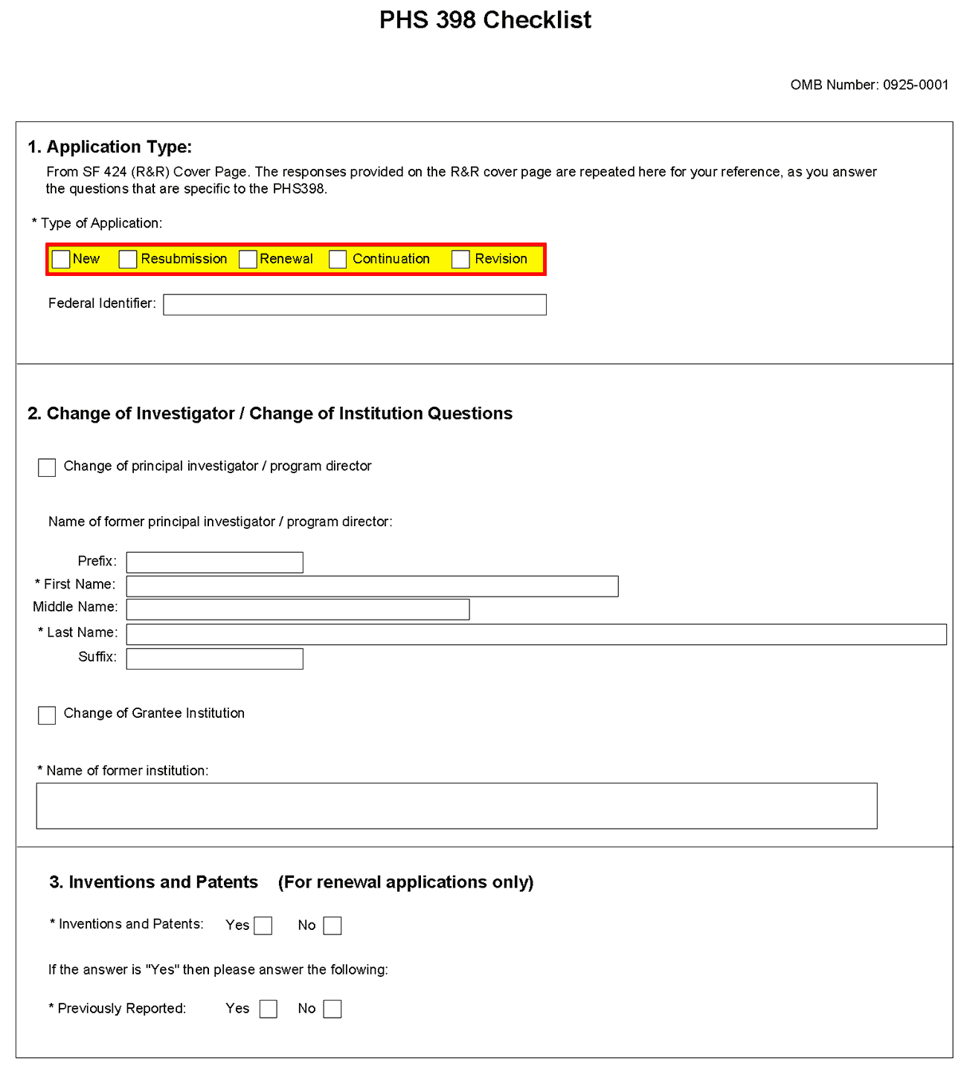
1. Application Type
Field Name | Instructions
Type of Application | This field is pre-populated from the SF424 (R&R) Cover Component. Corrections to this field must be made in that component.
Federal Identifier | This field is pre-populated from the SF424 (R&R). Corrections to this field must be made in that component. For New applications this field will be blank.
2. Change of Investigator/Change of Institution Questions
Field Name | Instructions
Change of Program Director/Principal Investigator | Check this box if this application reflects a change in PD/PI from the one who was indicated on a previous application. This is not generally applicable to a “New” application.
Prefix | If this application reflects a change in PD/PI, enter the name prefix (for example, Mr., Mrs., Rev.) of the former PD/PI.
First Name | If this application reflects a change in PD/PI, enter the first name of the former PD/PI.
Middle Name | If this application reflects a change in PD/PI, enter the middle name of the former PD/PI.
Last Name | If this application reflects a change in PD/PI, enter the last name of the former PD/PI.
Suffix | If this application reflects a change in PD/PI, provide the suffix (for example, Jr., Sr., PhD) of the former PD/PI.
Change of Grantee Institution | Check this box if this application reflects a change in grantee institution from the one that was indicated on a previous application. This is not generally applicable to a “New” application.
Name of Former Institution | If this application reflects a change in grantee institution, enter the name of the former institution.
3. Inventions and Patents (For renewal applications only)
Field Name | Instructions
Inventions and Patents | This block need only be completed if submitting an R&R “Renewal” application. If no inventions were conceived or reduced to practice during the course of work under this project, check “No”. The remaining parts of the item are then not applicable. If any inventions were conceived or reduced to practice during the previous period of support, check “Yes”.  Note: NIH recipient organizations must promptly report inventions to the Extramural Inventions and Technology Resources Branch of the Office of Policy for Extramural Research Administration, OER, NIH, Bethesda, MD 20892-2750, (301) 435-1986. Invention reporting compliance according to regulations at 37 CFR 401.14 is described at http://www.iedison.gov. The grantee is encouraged to submit reports electronically using Interagency Edison (http://www.iedison.gov).  SBIR and STTR Applications: This block needs to be completed for Phase II SBIR/STTR applications only (but not for Phase I or Fast-Track applications).
Previously Reported | If you checked “Yes” for Inventions and Patents, above, indicate whether this information has been reported previously to the PHS or to the applicant organization official responsible for patent matters.
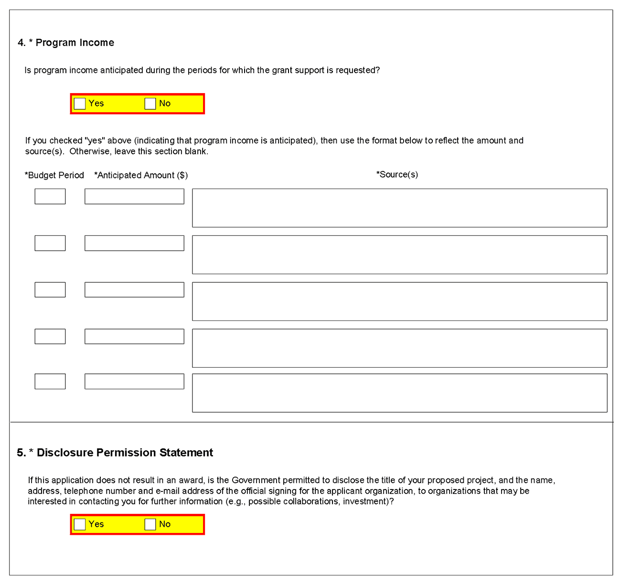
4. Program Income
NIH policy requires applicants for research grants to include in their grant applications an estimate of the amount and source of program income (defined below) expected to be generated as a result of the project for which funding is being sought. The specific policies that govern the treatment of program income under research grants are set forth in the NIH Grants Policy Statement (http://grants.nih.gov/grants/policy/policy.htm#gps).
Program Income is defined as gross income earned by the applicant organization that is directly generated by a supported activity or earned as a result of the award. The PHS Grants Policy Statement or NIH Grants Policy Statement contains a detailed explanation of program income, the ways in which it may be generated and accounted for, and the various options for its use and disposition.
Examples of program income include:
- Fees earned from services performed under the grant, such as those resulting from laboratory drug testing;
- Rental or usage fees, such as those earned from fees charged for use of computer equipment purchased with grant funds;
- Third party patient reimbursement for hospital or other medical services, such as insurance payments for patients when such reimbursement occurs because of the grant-supported activity;
- Funds generated by the sale of commodities, such as tissue cultures, cell lines, or research animals;
- Patent or copyright royalties (exempt from reporting requirements); and
- Registration fees generated from grant-supported conferences.
Generally, SBIR/STTR grantee organizations that earn program income are authorized to have such income added to the grant account and used to further the objectives of the research project under the expanded authorities stated in the Notice of Award.
Field Name | Instructions
Is program income anticipated during the periods for which the grant support is requested? | If program income is anticipated during the periods for which the grant support is requested, check the Yes box, and then complete the section below. If no program income is anticipated, check the No box and leave the following section blank.
Budget Period | If program income is anticipated, enter the budget periods. If the application is funded, the Notice of Award will provide specific instructions regarding the use of such income.
Anticipated Amount ($) | If program income is anticipated, enter the amount anticipated for each budget period listed.
Source(s) | If program income is anticipated, enter the source for each budget period listed.
5. Disclosure Permission Statement
If this application does not result in an award, and the Government is permitted to disclose the title of your proposed project, and the name, address, telephone number, and e-mail address of the official signing for the applicant organization, to organizations that may be interested in contacting you for further information (e.g., possible collaborations, investment), check “Yes”. Otherwise check “No”. A selection is required.
Your response will not affect any peer review or funding decisions.

Once all data have been entered, use the scroll bar to scroll up. You will be returned to the Grant Application Package screen. To remove a document from the Submission box, click the document name to select it and then click the Move Form to Delete button. This will return the document to the Mandatory Documents Submission List or Optional Documents Submission List.

5.6 (Reserved)

5.7 Planned Enrollment Report and Cumulative Inclusion Enrollment Report
NOTE: These report formats should NOT be used for collecting data from study participants. To ensure proper performance, please save frequently.

5.7.1Planned Enrollment Report
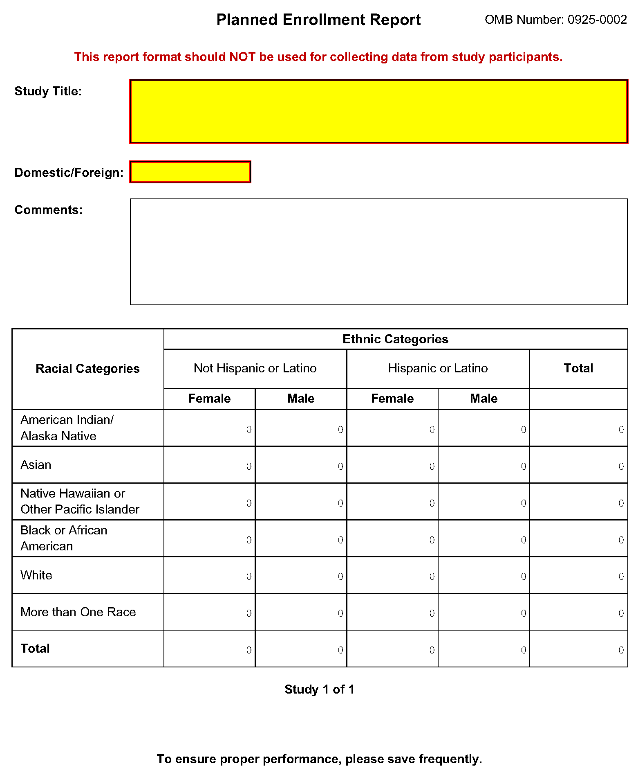
Field Name | Instructions
Study Title | Enter a unique title that describes the study that the participants will be involved in. If there is more than one study, provide a separate Study Title for each. Follow the instructions provided in the Application Guide and the FOA regarding the Inclusion of Women and Minorities. Maximum 250 characters. This is a required field.
Domestic/Foreign | Select whether the participants described in the planned enrollment report are domestic or foreign. At a minimum, domestic and foreign participants must be reported separately even if for the same study. This is a required field.
Comments | Enter information you wish to provide about this planned enrollment report. This includes but is not limited to addressing information about distinctive subpopulations if relevant to the scientific hypotheses being studied and/or a study that will have a delayed onset. Maximum 500 characters.
American Indian/Alaska Native | Enter the expected number of females and males (in the respective fields) who are American Indian/Alaska Native and Not Hispanic or Latino, and; enter the expected number of females and males (in the respective fields) who are American Indian/Alaska Native and Hispanic or Latino. These are required fields.
Asian | Enter the expected number of females and males (in the respective fields) who are Asian and Not Hispanic or Latino, and; enter the expected number of females and males (in the respective fields) who are Asian and Hispanic or Latino. These are required fields.
Native Hawaiian or Other Pacific Islander | Enter the expected number of females and males (in the respective fields) who are Native Hawaiian or Other Pacific Islander and Not Hispanic or Latino, and; enter the expected number of females and males (in the respective fields) who are Native Hawaiian or Other Pacific Islander and Hispanic or Latino. These are required fields.
Black or African American | Enter the expected number of females and males (in the respective fields) who are Black or African American and Not Hispanic or Latino, and; Enter the expected number of females and males (in the respective fields) who are Black or African American and Hispanic or Latino. These are required fields.
White | Enter the expected number of females and males (in the respective fields) who are White and Not Hispanic or Latino, and; enter the expected number of females and males (in the respective fields) who are White and Hispanic or Latino. These are required fields.
More than One Race | Enter the expected number of females and males (in the respective fields) who identify with more than one racial category and are Not Hispanic or Latino, and; enter the expected number of females and males (in the respective fields) who identify with more than one racial category and are Hispanic or Latino. These are required fields.
Total | The total fields at the bottom are auto-calculated to total all racial categories for females and males who are Not Hispanic or Latino and all racial categories for females and males who are Hispanic or Latino. The total fields at the right are auto-calculated to total all males and females of both Not Hispanic or Latino and Hispanic or Latino ethnicity in each racial category.

5.7.2 Cumulative Inclusion Enrollment Report
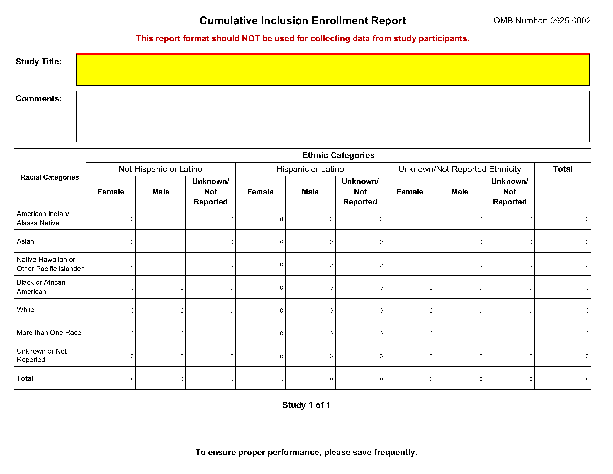
Field Name | Instructions
Study Title | Enter a unique title that describes the study that the participants will be involved in. The title should be the same as submitted on the original Planned Enrollment form for this study. Follow the instructions provided in the Application Guide and the FOA regarding the Inclusion of Women and Minorities. Maximum 250 characters. This is a required field.
Comments | Enter information you wish to provide about this Cumulative Inclusion Enrollment Report. This includes but is not limited to information if distinctive subpopulations are relevant to the scientific hypotheses being studied. Maximum 500 characters.
American Indian/Alaska Native | Enter the number of females, males, and individuals of unknown/not reported sex/gender (in the respective fields) who are American Indian/Alaska Native and Not Hispanic or Latino, and; enter the number of females, males, and individuals of unknown/not reported sex/gender (in the respective fields) who are American Indian/Alaska Native and Hispanic or Latino; and enter the number of females, males, and individuals of unknown/not reported sex/gender (in the respective fields) who are American Indian/Alaska Native and of unknown/not reported ethnicity. These are required fields.
Asian | Enter the number of females, males, and individuals of unknown/not reported sex/gender (in the respective fields) who are Asian and Not Hispanic or Latino, and; enter the number of females, males, and individuals of unknown/not reported sex/gender (in the respective fields) who are Asian and Hispanic or Latino; and enter the number of females, males, and individuals of unknown/not reported sex/gender (in the respective fields) who are Asian and of unknown/not reported ethnicity. These are required fields.
Native Hawaiian or Other Pacific Islander | Enter the number of females, males, and individuals of unknown/not reported sex/gender (in the respective fields) who are Native Hawaiian or Other Pacific Islander and Not Hispanic or Latino, and; enter the number of females, males, and individuals of unknown/not reported sex/gender (in the respective fields) who are Native Hawaiian or Other Pacific Islander and Hispanic or Latino; and enter the number of females, males, and individuals of unknown/not reported sex/gender (in the respective fields) who are Native Hawaiian or Other Pacific Islander and of unknown/not reported ethnicity. These are required fields.
Black or African American | Enter the number of females, males, and individuals of unknown/not reported sex/gender (in the respective fields) who are Black or African American and Not Hispanic or Latino, and; enter the number of females, males, and individuals of unknown/not reported sex/gender (in the respective fields) who are Black or African American and Hispanic or Latino; and enter the number of females, males, and individuals of unknown/not reported sex/gender (in the respective fields) who are Black or African American and of unknown/not reported ethnicity. These are required fields.
White | Enter the number of females, males, and individuals of unknown/not reported sex/gender (in the respective fields) who are White and Not Hispanic or Latino, and; enter the number of females, males, and individuals of unknown/not reported sex/gender (in the respective fields) who are White and Hispanic or Latino; and enter the number of females, males, and individuals of unknown/not reported sex/gender (in the respective fields) who are White and of unknown/not reported ethnicity. These are required fields.
More than One Race | Enter the number of females, males, and individuals of unknown/not reported sex/gender (in the respective fields) who identify with more than one racial category and are Not Hispanic or Latino, and; enter the number of females, males, and individuals of unknown/not reported sex/gender (in the respective fields) who identify with more than one racial category and are Hispanic or Latino; and enter the number of females, males, and individuals of unknown/not reported sex/gender (in the respective fields) who identify with more than one racial category and of unknown/not reported ethnicity. These are required fields.
Unknown or Not Reported | Enter the number of females, males, and individuals of unknown/not reported sex/gender (in the respective fields) whose race is unknown/not reported and who are Not Hispanic or Latino, and; enter the number of females, males, and individuals of unknown/not reported sex/gender (in the respective fields) whose race is unknown/not reported and who are Hispanic or Latino; and enter the number of females, males, and individuals of unknown/not reported sex/gender (in the respective fields) who are of unknown/not reported race and of unknown/not reported ethnicity. These are required fields.
Total | The total fields at the bottom are auto-calculated to total all racial categories for females, males, and individuals of unknown/not reported sex/gender who are Not Hispanic or Latino; all racial categories for females, males, and individuals of unknown/not reported sex/gender who are Hispanic or Latino, and all racial categories for females, males, and individuals of unknown/not reported sex/gender who are of unknown/not reported ethnicity. The total fields at the right are auto-calculated to total all individuals in a given racial category.

6. Peer Review Process
Overview
NIH policy is intended to ensure that applications for funding submitted to the NIH are evaluated on the basis of a process that is fair, equitable, timely, and conducted in a manner free of bias. The NIH dual peer review system is mandated by statute in accordance with section 492 of the Public Health Service Act and federal regulations governing "Scientific Peer Review of Research Grant Applications and Research and Development Contract Projects" (42 CFR part 52h).
The first level of review is carried out by a Scientific Review Group (SRG) composed primarily of non-federal scientists who have expertise in relevant scientific disciplines and current research areas. The second level of review is performed by Institute and Center (IC) National Advisory Councils or Boards. Councils composed of both scientific and lay members are chosen for their expertise, interest, or activity in matters related to health and disease. Only applications that are favorably recommended by both the SRG and the Advisory Council (or the IC in the case of fellowships) are considered for funding. Only the NIH Institute or Center may make funding decisions.
A detailed description of what happens to a research project grant application at NIH after it is received for peer review can be found at the following location: http://grants.nih.gov/grants/peer_review_process.htm. Additional information about charters and membership of SRGs, Councils, and Boards can be obtained from the appropriate Institute, Center, or Office. Information on CDC review procedures is located at http://www.cdc.gov/phpr/science/erp_policies.htm.
Discussed and Nondiscussed Applications
The initial scientific peer review of most applications will also include a process in which only those applications deemed by the reviewers to have the highest scientific and technical merit, generally the better half of the applications under review, will be discussed at the SRG meeting, assigned an impact score, and receive a second level review. Applications in the lower half are reviewed by SRG members but they are not discussed or assigned overall impact scores at the SRG meeting. This process allows the reviewers to focus their discussion on the most meritorious applications.
Before the review meeting, each reviewer and discussant assigned to an application will give a separate score for each of (at least) five review criteria and a preliminary impact score for that application (see below). The preliminary impact scores help the SRG to determine which applications will be discussed.
Scoring
SRG members are instructed to evaluate research applications by addressing the five scored review criteria (see below) and additional review criteria as applicable for the application. However, Requests for Applications (RFAs) and other types of funding opportunities (e.g., construction grants and fellowship applications) may list different and/or additional review criteria and considerations.
For each application that is discussed, a final overall impact/priority score will be given by each eligible committee member (without conflicts of interest) following the panel discussion. Each member’s impact score will reflect his/her evaluation of the potential overall impact of the project in its entirety, rather than an arithmetic formula applied to the reviewer’s scores given to each criterion. The final impact score for each discussed application will be determined by calculating the arithmetic average of all the eligible members’ impact scores, and multiplying the average by 10.
As part of the initial merit review, and regardless of whether an application is discussed or not discussed (streamlined), all applicants will receive a written critique, called a Summary Statement. Unless stated otherwise in the FOA, the Summary Statement represents a combination of the reviewers' written comments and scores for individual criteria. The Summary Statement for discussed applications includes the Scientific Review Officer's summary of the members' discussion during the SRG meeting; the final impact score; the recommendations of the SRG, including budget recommendations; and administrative notes of special considerations. For applications that are not discussed by the full committee, the scores of the assigned reviewers and discussants for the five scored criteria will be reported individually on the Summary Statement. Final, numerical impact scores are not given for applications that are not discussed.
Research Project Evaluation Criteria
Overall Impact: Reviewers will provide an overall impact/priority score to reflect their assessment of the likelihood for the project to exert a sustained, powerful influence on the research field(s) involved, in consideration of the following five scored review criteria, and additional review criteria (as applicable for the project proposed).
Scored Review Criteria: Reviewers will consider each of the five review criteria below in the determination of scientific and technical merit, and give a separate score for each. An application does not need to be strong in all categories to be judged likely to have major scientific impact. For example, a project that by its nature is not innovative may be essential to advance a field.
Significance. Does the project address an important problem or a critical barrier to progress in the field? If the aims of the project are achieved, how will scientific knowledge, technical capability, and/or clinical practice be improved? How will successful completion of the aims change the concepts, methods, technologies, treatments, services, or preventative interventions that drive this field? Does the proposed project have commercial potential to lead to a marketable product, process or service? (In the case of Phase II, Fast-Track, and Phase IIB Competing Renewals, does the Commercialization Plan demonstrate a high probability of commercialization?)
Investigator(s). Are the PD/PIs, collaborators, and other researchers well suited to the project? If Early Stage Investigators or New Investigators, or in the early stages of independent careers, do they have appropriate experience and training? If established, have they demonstrated an ongoing record of accomplishments that have advanced their field(s)? If the project is collaborative or multi-PD/PI, do the investigators have complementary and integrated expertise; are their leadership approach, governance and organizational structure appropriate for the project?
Innovation. Does the application challenge and seek to shift current research or clinical practice paradigms by utilizing novel theoretical concepts, approaches or methodologies, instrumentation, or interventions? Are the concepts, approaches or methodologies, instrumentation, or interventions novel to one field of research or novel in a broad sense? Is a refinement, improvement, or new application of theoretical concepts, approaches or methodologies, instrumentation, or interventions proposed?
Approach. Are the overall strategy, methodology, and analyses well-reasoned and appropriate to accomplish the specific aims of the project? Are potential problems, alternative strategies, and benchmarks for success presented? If the project is in the early stages of development, will the strategy establish feasibility and will particularly risky aspects be managed?
If the project involves human subjects and/or NIH-defined clinical research, are the plans for (1) Protections for Human Subjects, and (2) inclusion (or exclusion) of individuals on the basis of sex/gender, race, and ethnicity, as well as the inclusion (or exclusion) of children, justified in terms of the scientific goals and research strategy proposed?
Environment. Will the scientific environment in which the work will be done contribute to the probability of success? Are the institutional support, equipment and other physical resources available to the investigators adequate for the project proposed? Will the project benefit from unique features of the scientific environment, subject populations, or collaborative arrangements?
Additional Review Criteria. As applicable for the project proposed, reviewers will consider the following additional items in the determination of scientific and technical merit, and in providing an overall impact/priority score, but will not give separate scores for these items.
For Phase II and Phase IIB Applications Only. When reviewing Phase II applications, how well did the applicant demonstrate progress toward meeting the Phase I objectives, demonstrating feasibility, and providing a solid foundation for the proposed Phase II activity?
For Phase I/Phase II Fast-Track Applications Only. When reviewing Phase I/Phase II Fast-Track applications, reviewers will consider the following:
1. Does the Phase I application specify clear, appropriate, measurable goals (milestones) that should be achieved prior to initiating Phase II?
2. To what extent was the applicant able to obtain letters of interest, additional funding commitments, and/or resources from the private sector or non-SBIR/STTR funding sources that would enhance the likelihood for commercialization?
Protections for Human Subjects. For research that involves human subjects but does not involve one of the six categories of research that are exempt under 45 CFR part 46, the committee will evaluate the justification for involvement of human subjects and the proposed protections from research risk relating to their participation according to the following five review criteria: (1) risk to subjects, (2) adequacy of protection against risks, (3) potential benefits to the subjects and others, (4) importance of the knowledge to be gained, and (5) data and safety monitoring for clinical trials.
For research that involves human subjects and meets the criteria for one or more of the six categories of research that are exempt under 45 CFR part 46, the committee will evaluate: (1) the justification for the exemption, (2) human subjects involvement and characteristics, and (3) sources of materials. For additional information on the review of the Human Subjects section, please refer to the Human Subjects Protection Guidelines.
Inclusion of Women, Minorities, and Children. When the proposed project involves human subjects and/or NIH-defined clinical research, the committee will evaluate the proposed plans for inclusion (or exclusion) of individuals on the basis of sex/gender, race, and ethnicity, as well as the inclusion (or exclusion) of children to determine if it is justified in terms of the scientific goals and research strategy proposed. For additional information on review of the Inclusion section, please refer to the Human Subjects Inclusion Guidelines.
Vertebrate Animals. The committee will evaluate the involvement of live vertebrate animals as part of the scientific assessment according to the following five points: (1) proposed use of the animals, and species, strains, ages, sex, and numbers to be used; (2) justifications for the use of animals and for the appropriateness of the species and numbers proposed; (3) adequacy of veterinary care; (4) procedures for limiting discomfort, distress, pain and injury to that which is unavoidable in the conduct of scientifically sound research including the use of analgesic, anesthetic, and tranquilizing drugs and/or comfortable restraining devices; and (5) methods of euthanasia and reason for selection if not consistent with the AVMA Guidelines on Euthanasia. For additional information, see http://grants.nih.gov/grants/olaw/VASchecklist.pdf.
Biohazards. Reviewers will assess whether materials or procedures proposed are potentially hazardous to research personnel and/or the environment, and if needed, determine whether adequate protection is proposed.
Resubmission Applications. When reviewing a Resubmission application (formerly called an amended application), the committee will evaluate the application as now presented, taking into consideration the responses to comments from the previous scientific review group and changes made to the project.
Renewal Applications. When reviewing a Renewal application (formerly called a competing continuation application), the committee will consider the progress made in the last funding period.
Revision Applications. When reviewing a Revision application (formerly called a competing supplement application), the committee will consider the appropriateness of the proposed expansion of the scope of the project. If the Revision application relates to a specific line of investigation presented in the original application that was not recommended for approval by the committee, then the committee will consider whether the responses to comments from the previous scientific review group are adequate and whether substantial changes are clearly evident.
Additional Review Considerations. As applicable for the project proposed, reviewers will address each of the following items, but will not give scores for these items and should not consider them in providing an overall impact/priority score.
Select Agents Research. Reviewers will assess the information provided in this section of the application, including 1) the select agent(s) to be used in the proposed research, 2) the registration status of all entities where select agent(s) will be used, 3) the procedures that will be used to monitor possession use and transfer of select agent(s), and 4) plans for appropriate biosafety, biocontainment, and security of the select agent(s).
Resource Sharing Plans. Reviewers will comment on whether the following Resource Sharing Plans, or the rationale for not sharing the following types of resources, are reasonable: 1) Data Sharing Plan (http://grants.nih.gov/grants/policy/data_sharing/data_sharing_guidance.htm); 2) Sharing Model Organisms (http://grants.nih.gov/grants/guide/notice-files/NOT-OD-04-042.html); and 3) Genome Wide Association Studies (GWAS) (http://grants.nih.gov/grants/guide/notice-files/NOT-OD-07-088.html).
Budget and Period of Support. Reviewers will consider whether the budget and the requested period of support are fully justified and reasonable in relation to the proposed research.
Dual-Level Peer Review
The second level of review will usually be performed by the Advisory Council or Board of the potential awarding component (Institute, Center, or other unit). Council or Board recommendations are based not only on considerations of scientific merit, as judged by the SRGs, but also on the relevance of the proposed study to an Institute/Center’s mission, programs and priorities.

